Kentucky DCBS
Continuous Quality Improvement
State Plan

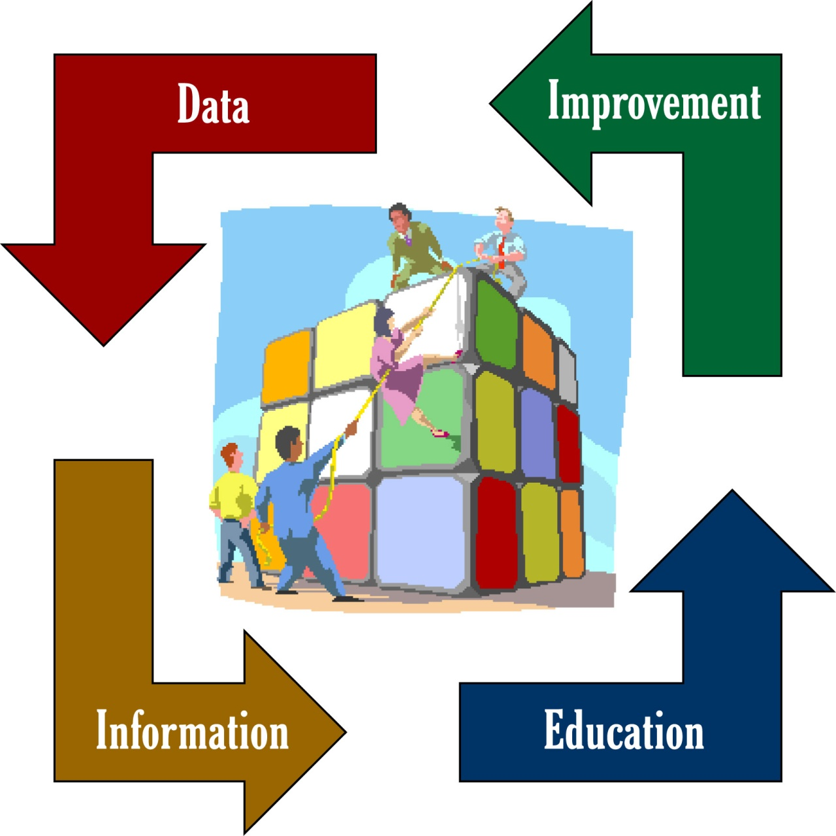

Making Ideas Happen
Catalyst for Change

Version 2.0

In Effect November 5, 2007

1.0 Background

The Continuous Quality Improvement (CQI) origin in Kentucky dates from 1998, when cabinet leaders decided to seek national accreditation of all state child and adult protective services and foster care and adoption programs. Requirements set by the Council on Accreditation for Children and Family Services (COA) included:
- intensive self-study and case reviews by Protection and Permanency (P&P) staff ;
- a means for all employees to regularly review service quality and identify ways to improve; and
- a means for clients and community partners to influence cabinet decision-making.

To prepare for these challenges, the cabinet launched the Continuous Quality Improvement initiative in the summer of 2000. Soon thereafter, CQI specialists, one in each of the 16 then-existing service regions, were hired through the cabinet’s contract with Eastern Kentucky University. These specialists were to play a key role in ensuring their regions’ compliance with the state CQI Plan. The plan developed by the cabinet mirrored the COA standards in specifying a case review process, a process for meetings that involve all agency staff and general standards for involving customers and the community in quality improvement.

P&P case reviews were instituted at the peer-to-peer, supervisor and regional levels. Each month, for every P&P team, four cases were randomly designated for review, first by caseworkers from a separate team, then by supervisors not involved in the case. Within each region, 10 of the cases reviewed at the peer-to-peer and supervisory levels were randomly designated for review at the regional office level. The ratings assigned at each level were shared with the other levels. Local P&P teams were expected to use the results of the case reviews to improve casework. Case reviews in Family Support, which administers federal public aid programs, were and are conducted by a separate process that reflects federal mandates but is parallel to the P&P process. CQI specialists are involved in using the data from both P&P and Family Support case reviews in the CQI process, and they coordinate case reviews in some regions.

During 2000-2001, CQI teams were established at all levels of the cabinet. Each region could structure its teams as it saw fit, so long as every employee had a place on a CQI team. All teams were expected to resolve their own quality-related issues if possible. If they could not, and the issue had broad or vital implications, they were to forward the concern to a CQI team at a higher level that might be able to address it. At each level, teams dealt both with their own issues and with any sent forward to them from a lower level. Once an issue was resolved or declared incapable of resolution, the team that reached that conclusion was to report and explain its decision to the team that first raised the issue.

The DCBS commissioner’s office coordinated all aspects of CQI, but regions could adapt the process to the needs and preferences of their personnel, so long as they met the minimum requirements of the DCBS CQI Plan. One region, for example, supplemented its basic set of CQI committees with standing committees that dealt with issues of cabinet-wide importance, such as employee recognition, workload and customer service. Some regions authorized separate county-level CQI teams for P&P and Family Support, while other regions opted for unified teams.

As CQI took root and matured within the cabinet, it became apparent that key cabinet partners merited focused input and attention through CQI. Several DCBS regions took a step in that direction by experimenting with foster parent CQI groups, which gave foster and adoptive parents a formal process for input within DCBS that they had never had before. In December 2003, the cabinet’s Program Improvement Plan (PIP) was revised to require that each service region have a CQI group that includes foster parents and convenes quarterly to discuss and resolve foster care issues.

In January 2006, the DCBS commissioner directed that a preexisting state-level panel of cabinet partners – the Child and Family Services Community Stakeholders Advisory Group – also met quarterly as a CQI team. This group advises the commissioner, central office staff and service region administrators, and it includes foster and adoptive parents, health professionals and a wide range of child welfare advocates. A co-chair from this group now attends meetings of the CQI Coordination and Steering Committee.

Atop the CQI hierarchy was a state team consisting of the 16 CQI specialists, the DCBS commissioner and DCBS division heads or their designees. This state-level team, which met at least quarterly, developed processes for use at all levels of CQI, including a tool for reviewing P&P cases and a format for recording CQI meeting minutes.

To broaden cabinet customers’ influence on cabinet decisions and to comply with COA standards, the regional CQI specialists designed and conducted surveys of clients, community partners and cabinet employees. Lacking region-to-region uniformity, these surveys rarely yielded statistically meaningful results. That changed after the cabinet retained a child welfare researcher in July 2001. The researcher designs customer satisfaction surveys that are administered in uniform fashion statewide. Results of these surveys are used in quality improvement efforts.

Improvement efforts also draw heavily on management reports. Generated from the automated systems for handling P&P and Family Support data, these reports have increased greatly in number since CQI’s inception. Consequently, they have placed a growing responsibility on CQI specialists who help regional personnel interpret and apply the findings. The CQI specialists have in turn provided information vital to the completeness and accuracy of the management reports and have contributed greatly to the reports’ quality and usefulness. Over the years, CQI specialists have had increased access to data from other systems, such as child care, training and judicial data, to augment the quality improvement process.

The Cabinet achieved full COA accreditation in late 2002. With CQI now embedded in the cabinet’s business practice, the CQI specialists’ employment status was changed to that of state merit system employees. Over the following two years, as the cabinet prepared to renew its accreditation, all elements of the CQI process remained essentially intact, except for the case reviews in P&P, which changed in two key respects:
- The three-tiered review process for P&P cases shifted upward one level, as peer-to-peer review was dropped and a cabinet-level review was added; and
- The case review tool was expanded to include rating elements required for the Child and Family Services Review (CFSR).

The change in levels of case review resulted from a consensus among CQI specialists and others closely involved with CQI that peer-to-peer reviews had proven largely unproductive. Scores assigned by fellow caseworkers bore little relation to those assigned by supervisors and regional review teams. The shift to a system of supervisor, regional and cabinet-level reviews was negotiated with the Council on Accreditation, which approved the change in February 2004.

The case review tool was revised in late 2003 to include quality-of-casework indicators required for CFSR compliance. While this revision added to the time and effort required for case reviews at all levels, it also provided DCBS with a case review process accepted by the federal Administration for Children and Families as legitimate for tracking progress on the Program Improvement Plan (PIP).

As leadership and agency needs have changed, so has CQI. Cabinet-level CQI team meetings were suspended in late 2003, and feedback to issues raised at the local and regional levels diminished as a result. Still, from 2003 through 2005, CQI remained central to the cabinet’s process for implementing its PIP. In September 2005, in an effort to streamline CQI and make it less time-consuming, the DCBS commissioner removed the requirement that every cabinet employee belong to a CQI team. He instead instituted county-wide teams, with limited membership, as the basic CQI unit. While this conforms to a COA standard that only requires “representatives” of employees and other stakeholders to participate in CQI, it also reduced CQI’s role as a widely utilized forum for addressing service quality and providing feedback on issues directly to every worker.

In 2005, CQI specialists designed a web-based system for entering minutes of CQI meetings and tracking CQI issues. In September 2006, DCBS realigned the state into nine service regions. The realignment expanded CQI specialists’ geographic areas of responsibility and increased the number of cases regional teams must review monthly. Two CQI specialists, instead of just one, serve in each of these nine regions.

Interest in strengthening CQI led to the creation of a CQI Coordination and Steering Committee, which convened in October 2006. This panel serves as a leadership group for CQI, with these initial priorities:
- implementing a Web-based system to efficiently record issues raised and solutions proposed by CQI teams;
- reconvening the state CQI team at the DCBS central office;
- strengthening feedback to issues sent forward for resolution;
- ensuring that issues are screened before they are forwarded to the central office; and
- enhancing training for CQI specialists.

Members of the Coordination and Steering committee took note of the pivotal role that CQI specialists would play in efforts to reorganize and revitalize the CQI process. They also noted the key contributions the CQI specialists had made in the past, including:
  - improvement in data integrity for both family support and P&P
  - a shift in DCBS culture toward data-driven decisions;
  - vital contributions toward the achievement of the PIP and development of the Dynamic Family Assessment; and
  - solving staff related problems in Family Support, P&P, Child Care, and regional management.

(This background summary was current as of June 2007)

1.1 DCBS Vision and Mission
The DCBS CQI Process implements the Department’s vision and mission.

Vision
To provide leadership in building high quality, community based human services systems that enhance safety, permanency, well-being and self-sufficiency for Kentucky’s families, children and vulnerable adults.

Mission
A nationally recognized department comprised of a highly skilled workforce that:
- Provides services to enhance the self-sufficiency of families;
- Improves safety and permanency for children and vulnerable adults;
- Engages families and community partners in a collaborative decision-making process;
- Utilizes innovative technological resources to improve outcomes and efficiencies;
- Creates information systems and uses evidence-based practice to guide management decisions;
- Practices system-wide continuous quality improvement and shared accountability;
- Fosters a dynamic learning organization; and
- Adapts to changing community needs and challenges.

1.2 CQI Definition and Purpose
In Kentucky, the Continuous Quality Improvement (CQI) process is designed to empower staff in leading the agency toward improved quality through three fundamental processes. The first process is one of identifying and solving barriers to service delivery and achieving outcomes. The second process builds knowledge through data and reports on how each individual’s and each group’s performance contributes to achieving outcomes for families and children and then creates action plans for improvement. And finally, case reviews and the use of the review results to improve practice are fundamental CQI processes and support quality assurance.

CQI is a philosophy and set of techniques that allow service providers in many agencies and industries to look at their activities, task performance and outcomes to create plans for improvement. The concept is based on a Japanese principle, kaizen, which means progress through small, continuous steps toward a goal. CQI differs from traditional quality assurance in that its focus is self-directed, self-determined change rather than change imposed by an external entity. CQI is a process model of staff empowerment, creativity and responsibility that also assists local staff on issues they cannot resolve.

CQI is a process, not an event, by which all staff (front line and support staff to management and leadership) are involved in evaluating the effectiveness of services provided to customers of the Department for Community Based Services. The DCBS CQI process involves: the examination of internal systems, procedures and outcomes; and the examination of relationships and interactions between DCBS and other stakeholders.

- CQI evaluates the effectiveness and efficiency of services provided.
- CQI determines whether services meet predetermined expectations of quality and outcomes.
- CQI attempts to correct observed deficiencies identified through the CQI process.
- CQI is intended to be a process that is:

• Creative | • Structured
• Inclusive | • Solution-focused
• Recurring | • Efficient
• Empowering | • Action-oriented
• Common Sense Driven

Through the CQI process, problem issues can be addressed by those most directly affected by and knowledgeable of the need and the possible solutions. CQI teams are decision-making teams. CQI meetings result in the identification of needs, goals, available resources and the strengths of the program, the staff and community partners. Areas needing improvement are identified and discussed, action plans are developed and strategies are implemented to improve service delivery. While CQI focuses on solving issues in P&P and Family Support, CQI team members should remain mindful that those issues have implications throughout the broad spectrum of public and private child-centered services. CQI teams are expected to implement local action plans to resolve most issues they identify. Unresolved issues are forwarded to the Regional CQI team for possible resolution.

CQI specialists develop, prepare and disseminate to CQI teams, regional management and front-line staff the data and other information needed to support data-driven decisions. CQI specialists also facilitate action and improvement by:
- assisting, as needed, in the conduct of local CQI meetings and case reviews;
- coordinating, facilitating and recording regional CQI meetings;
- serving as a liaison between management and staff;
- coordinating case reviews; and
- mentoring and guiding staff toward the use of best practices.

Beyond their direct service to CQI teams, CQI specialists act in other ways to advance the core mission of service improvement. They:
- coordinate the implementation of special initiatives and projects;
- advocate for statewide system changes that will improve results;
- gather ideas from staff, synthesize these and present them to management; and
- read trends, anticipate barriers and identify strengths.

1.3 CQI and Supervision
- The CQI process is intended to complement the existing agency administrative structure.

- CQI is NOT intended to replace supervision.
As Fotena Zirps, an expert on the CQI process, stated, “CQI and Supervision provide complementary functions to the Agency. The supervisor’s charge is to provide personal feedback to staff and to work with employees on remediating weaknesses and building strengths.”

“The CQI Process looks at a different piece of the work environment. Its job is to look at the processes and programs and to remove barriers that exist in doing the work. The specific work of the individual is not the focus, but rather the system that all workers function within.” In other words, supporting and improving the system will improve our outcomes.

- CQI uses case-related data in an aggregate, non-identifying way to provide feedback and accountability to staff in a timely fashion. Worker and supervisory units can then use the information to go back and look at their individual and unit strengths and weaknesses.

- CQI provides a time to reflect on events and processes that have occurred since the last CQI meeting. Staff should have time set apart from their day-to-day activities to consider what works, what does not and how to improve the system.

- CQI process is NOT a quick fix for all problems. No matter what level within the agency looks at a problem, successful resolution of the issues requires careful and thoughtful consideration of all possible solutions. Some problems may lend themselves to immediate resolution once identified, while others may require research, evaluation and careful development of solutions within different levels of the agency.

- CQI provides a chance to create and look at new and unique ways of resolving one-time or ongoing problems and to build on agency and program strengths.

- CQI provides a chance to learn and develop by identifying training needs and possible changes in policy and procedures.

- CQI is NOT a replacement for existing methods of agency communication or the line of authority within the agency. It simply provides an additional method for systematically investigating, documenting and correcting all types of issues that affect the effective operation of the agency.

2.0 CQI Issue Identification and Screening

CQI is designed to improve the quality of outcomes for clients. A CQI issue is one that:
- constitutes a barrier to outcomes;
- requires teamwork for its resolution; and
- is not addressed by existing guidelines.

Barrier

The CQI process focuses on barriers to the achievement and improvement of programs, services and results for clients. To be appropriate for consideration through CQI, an issue must constitute a barrier to one or more of the following:
- the functioning of operations that influence the agency's capacity to deliver services;
- the quality of service delivery;
- program results;
- client satisfaction; and/or
- client outcomes.
Barriers in any of these areas may become apparent to CQI team members in a variety of ways, including their own and their colleagues’ casework, direct experiences with service delivery, interaction with community partners, trends in data or issues identified at the state or regional level.
Requires Teamwork
The barrier posed by a CQI issue must exist for multiple workers, clients or community partners. Its removal must require joint effort by the members of a team, rather than individual initiative or routine administrative action.
Not Addressed by Existing Guidelines
An issue is suited for CQI if policies, procedures and regulations:
- are unavailable or insufficient to resolve it; or
- need clarification or changes that require a work group or team effort for their development; or
- cannot be solved by simple methods such as placing a phone call to central office for clarification.

2.1 Formulation of CQI Issues
Having identified a CQI issue, the CQI team should formulate the issue to focus on potential solutions at any of three levels:
- Client Level
- Are there ways to solve the problem by changing how we interact with the client?
- Program Level
- Are there ways to solve the problem by modifying the program that serves the client?
- Community Level
- Are there ways to solve the problem by posing it to the local community as a social problem that merits the community’s attention and resources?

2.2 Forwarding CQI Issues
A CQI team at any level should forward an issue to another level only if it has first:
- determined that the issue meets all criteria for issue identification;
- tried to resolve the issue, without success;
- determined that resolving it would require a regulatory, policy or process change, rather than a clarification;
- tried and failed to identify an individual or group able to resolve the issue at the local or regional level;
- concluded that the issue cannot be resolved in any forum other than CQI;
- described the issue in writing in sufficient detail to enable those unfamiliar with it to understand its essential elements; and
- proposed, also in writing, a solution or ideas that might help in forming a solution.

A CQI team should give heightened consideration to forwarding an issue to another level if the issue:
- clearly requires resolution at the regional or state level;
- overlaps boundaries between programs (such as Protection and Permanency, Family Support and Child Support) that are ordinarily treated as distinct; or
- appears to be a new issue – one that is likely without precedent within the agency.

A team should NOT forward an issue within CQI if it constitutes an emergency. Such issues should be brought to the attention of the service region administrator or other official(s) who can take prompt remedial action.

2.3 Screening CQI Issues at the State Level
Before a regional CQI team forwards a CQI issue to the state level, it must first determine that the issue either:
- is a statewide issue for which a statewide resolution is necessary; or
- is local or regional in scope, but local and regional resources are insufficient to resolve it.

CQI issues forwarded to the cabinet’s central office will be managed and screened. They will be assigned:
- to the appropriate department(s) or division(s) for resolution or clarification if the issue affects only one or two departments; or
- to the CQI Coordination and Steering Committee if the issue is cabinet-wide in nature. The steering committee will then determine whether to forward the issue to the state-level CQI team or to some other forum within CQI.

3.0 CQI Meeting Teams and Process
It is vital to the continued success of the CQI process for all staff to use their knowledge, vision and skills in working together. CQI is to be as inclusive as possible in involving staff and representing every staff member. CQI allows us to work in teams to explore new and better ways to deliver services. CQI teams can be both work-oriented (focusing on how our service teams can do a better job) and function-oriented (focusing on an issue or a coordinated program). The benefits of CQI are numerous, including, foremost, the continuous quality improvement in our service delivery to Kentucky families and children. Additionally, CQI provides a better way to identify and solve problems, strengthen peer relationships, improve the work environment and communication, and develop leadership skills for all.

The DCBS CQI process is implemented through a team structure at the local, regional, central office and department levels, supplemented by foster parent teams at the regional level and a Community Partner CQI Team at the department level. The multi-level team process allows for solutions to be generated and implemented by all levels of staff within the organization. It also allows problems that require input from multiple levels of the agency to be advanced through the system in an orderly way that assures a commitment to problem-solving and feedback (see CQI Process Flowcharts - Attachment 3). Additionally, the interactive nature of the process allows give and take and the presentation of data from the local level to the state level. The process and interaction of teams is displayed in the following diagram.

3.1 Local CQI Teams
The local CQI teams consist of approximately 8-12 staff members from within the county. Because of vast county differences in Kentucky, a variety of configurations are possible to meet county-specific needs. Teams could consist of supervisors and workers within one program or include representation from two or more programs. The goal is for every staff member, including county support staff, child care workers and others, to have a voice in decisions and access to performance data. Decisions about team configuration will be made by the regional leadership.

Local CQI teams are designed to consist only of agency staff to allow for free-flowing discussion and decision-making on local issues. In addition, they may identify policies or issues that impact local operations and require resolution at the succeeding level (or levels). The internal nature of this level is intended to focus on internal issues rather than other agencies or community partners.

3.2 Regional CQI Teams
At a minimum, regional CQI teams consist of representatives from each of the local teams or counties within the region. Optional members of regional CQI teams may include community partners, foster parents CQI team representatives, regional office staff (e.g., Regional Training Coordinators, secretaries, MSW consultants) regional leadership (SRA, SRAAs, SRCA, specialists), and representative Independent Living youth(s). Regional CQI teams meet at least quarterly with representation of all or most of the team members. They may provide resolution and feedback to issues advanced from the local level. Regional teams may identify policies or issues that impact local or regional operations. Regional issues are resolved by the regional CQI team and/or regional management if possible. If issues remain unresolved, the regional team may forward the issue to the succeeding level or return issues to the local level for further clarification and resolution. The CQI specialist or scribe enters minutes and both resolved and unresolved issues into the CQI Minutes/Issues Tracking system.

3.3 Central Office CQI Teams
Central office CQI teams provide employees with a voice in agency management and leadership. CQI team meetings at the central office level can be configured and operate using several team formats. Standing central office CQI teams at the division and branch levels convene at least quarterly to address their own issues in service delivery and quality. In addition, central office CQI teams may be formed to address specific practice or service delivery issues identified either by regional or local teams or by internal quality assurance processes. These central office teams are formed to solve specific problems using a time-limited workgroup structure. A scribe enters the minutes and both resolved and unresolved issues into the CQI Minutes/Issues Tracking system. Central office teams use the same screening criteria for CQI issue identification as all other teams. In addition to identifying issues, central office CQI teams provide employees with a voice in the agency leadership.

3.4 Department CQI State Team
The Department CQI State Team consists of the commissioner, the deputy commissioners, commissioner’s office staff, all central office division directors or their designees, the Training Branch manager and regional representation. The Department CQI State Team meets at least quarterly to provide resolution and feedback to issues addressed at all previous levels, as well as any issues that originate at the department level. Ideally, representatives on this state team would also attend meetings of the CQI Specialists Team and/or the Coordination and Steering Committee, as appropriate, to ensure consistency.

3.5 CQI Coordination and Steering Committee
The CQI Coordination and Steering Committee consists of key DCBS representatives involved in the conduct of CQI and the supervision of CQI specialists and regional CQI representation. The committee guides the CQI process both regionally and at the state level, sets a strategic plan for CQI and coordinates and disseminates information essential to the CQI process. The committee meets as needed to guide the CQI process.

3.6 CQI Specialist Team
Two CQI specialists serve on the regional staff in each service region. They assist CQI teams at all levels and in varied other ways work to improve services. The CQI specialists meet once per quarter to conduct business, discuss issues, share knowledge and develop skills. The DCBS commissioner, deputy commissioners, commissioner’s office staff, division directors, the Training Branch manager and other directors of special programs often discuss issues or provide leadership to the CQI Specialists Team at this quarterly meeting.

3.7 Foster/Adoptive Parent CQI Team
Each region is expected to operate one or two regional foster/adoptive parent CQI teams to help foster parents resolve problems. These teams meet quarterly and send representation as appropriate or possible to the regional level team.

3.8 Statewide Community Partner CQI Team
The Statewide Community Partner CQI Team (formerly the Child and Family Services Community Stakeholder Advisory Group) includes representatives from other state agencies, advocacy organizations and service agencies. Team members include: university faculty; DCBS administrators and supervisors; health agencies; child advocacy groups; domestic violence prevention programs; Kentucky courts and law enforcement and juvenile justice agencies; education agencies; local governments; and housing and economic development agencies. The group has met quarterly as a CQI team since early 2006. It advises the commissioner, central office staff and service region administrators. A co-chair participates in the CQI Coordination and Steering Committee.

The chart on the following page shows the lines of direct interaction and information flow between teams at all levels of CQI.

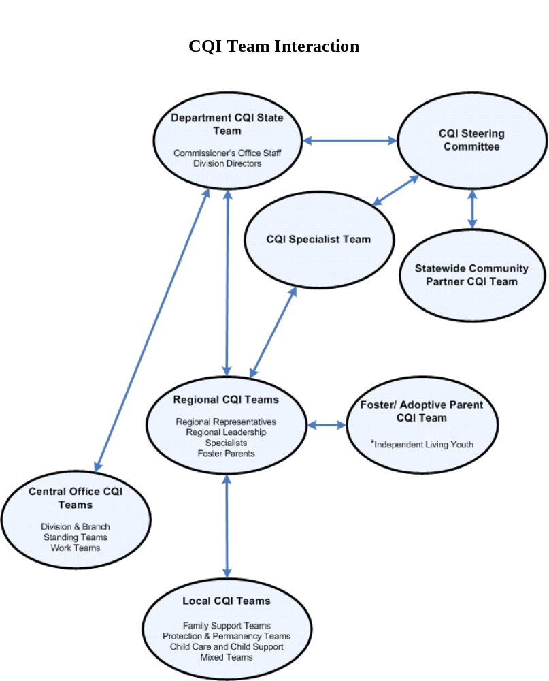

3.9 CQI Minutes Format
At each level, agency CQI teams use the same basic format for their recording of minutes, as required by DCBS. This helps facilitate consistency of minutes across the state. By 2008, the CQI minutes structure should be embedded within a web-based interface (CQI Issues/Minutes Tracking System) with electronic storage and search capacity. The minutes format is printable from this website for guidance during the meeting or minutes can be directly inputted into the system.

The minutes for CQI team meetings at the local and regional levels identify issues in need of resolution and proposed action plans to address them. The minutes include entries for the following topics:
- Review of Previous Minutes: Provide an overview update on ALL unresolved issues.
- Safety Incidents/Issues: Record any “critical incidents,” such as a worker being seriously threatened or attacked or an incident where the police had to be called. Report the number of incidents and give a basic summary of each. Discuss and assess any common trends and brainstorm ways to reduce or eliminate the incidents. Review issues related to workplace safety, such as tornado drills, building maintenance, etc.
- Service Complaints: Review the number of service complaints and basic content of each. There are formal complaints that may include items completed on Form 1300, Form 154 and/or verbal or written items submitted to management (SRA, associates, FSS/FSOS). Discuss and assess any common trends and brainstorm ways to reduce or eliminate the complaints.
- Community Partnerships: Report on any activities and meetings that have occurred with community partners, including foster youth, foster parents, providers, courts and others.
- Case Review Summary:
➢ P&P: Discuss the actual number of reviews completed, the percentage of reviews that were required to be completed compared to the actual number reviewed and the overall compliance found in the reviews. NOTE: Any brainstorming and action planning developed to improve your case review data is to be included in the action planning documentation rather than the summary.
➢ Family Support: Discuss the number of reviews completed for each program over the prior three months and the error rate. Discuss in action planning how you plan to bring your error rate down.
- Employee Recognition: Discuss any employee recognition, formal or informal, by the agency, community partners or customers. Formal recognition would include certificates, awards, employee of the month, etc. Informal recognition includes items like thank-you cards, letters of appreciation, etc.

3.10 The CQI Meeting Agenda
Each team meeting should have an agenda. The minutes format discussed above can serve as the agenda format. This will assure the meetings are productive and focused. The agenda items listed below should always be considered, yet may not be pertinent at every meeting. The local level team should include as many of the following as are relevant. At all levels, the agenda is set and prioritized by the facilitator and the scribe, who seek input from other team members as needed.

Meeting agendas should include some or all of the following:
- Summary and analysis of all case record reviews. Discussions on the local teams to be led by the FSOS and on the regional team by the specialists or their designees.
- Review of incidents, accidents, participant grievances, and safety. The purpose of
including the review of this material is to determine specific immediate action that may be necessary at the level of the incident, accident or grievance to prevent further occurrences. Trends may also be identified so action plans on the local or other levels may be developed to prevent further occurrence. Discussions on the local teams are initiated by the FSOS and on the regional team by the SRAAs or a designee.
- Review of data regarding participant and stakeholder satisfaction (as data is available). Discussion initiated by FSOS on local team and by SRA or designee on regional team.
- Summary of management report data. Discussion initiated by FSOS on local teams and by CQI or person responsible for regional reports on regional team.
- Identification of any new issues. Discussion initiated by facilitator on local team and CQI specialist on regional team.
- Updates on unresolved past issues. Discussion initiated by facilitator on local team and by CQI specialist on regional team.
- Updates on CQI projects or system. Discussion initiated by facilitator on local team and by CQI specialist on regional team.
- Employee recognition. To be initiated by any team member.
- Other discussion.

3.11 Roles and Duties for CQI Meetings
Each team, at every level, must have a facilitator/leader and scribe. Roles should generally rotate to allow other members of the CQI team a chance to participate. It is recommended that alternates also be selected to serve in the role if the designated person can’t attend the meeting.

Facilitator/Leader: The facilitator/leaders will have advanced knowledge of the CQI process. They will facilitate their local CQI teams and help make them effective and efficient. They must:

- Represent their local CQI team as a member of the regional CQI team and report on necessary items as identified in their local CQI team minutes.
- Possess a clear understanding of the issues to be taken to the regional level team.
- Report back on the regional level team’s discussion of those issues.
- Support and strengthen team productivity and idea sharing.
- Develop local CQI team agenda with scribe.
- Assist in solution-building related to agenda.
- Negotiates with team members on which issues to forward to next level.
- Facilitate local CQI team meeting.
- Pay attention to time limits and point them out to team members.
- Draw out quiet members.
- Gently curb members who tend to run on.
- Maintain focus on tasks and redirect distractions.
- Ensure that the scribe accurately reflects the meeting in the minutes.
- Encourage the scribe to read back minutes at the conclusion of each topic, or after several brief topics, and ensure that the team members agree the minutes accurately reflect the work done prior to the close of each meeting.
- Ensure a means of ready access to the minutes.
- Train the next facilitator/leader upon leaving the role.

Helpful Qualities of a Facilitator/Leader:
- Maintaining a positive attitude.
- Willing to praise good efforts.
- Able to be assertive in presenting issues.
- Committed to Continuous Quality Improvement.
- Actively supportive of team members.
- Watchful and observant of process.
- Inclusive and respectful of all team members
- Ability to maintain awareness of time parameters during meetings.
- Able to draw out quiet members.
- Mindful of diversions and distractions.
- Knowledgeable of tools for facilitating a meeting.
- Willing to redirect discussions and individuals as needed to maintain focus.

Scribe: The scribe is the individual who will take the meeting minutes on the form designated by DCBS. The CQI minutes must be detailed enough that someone reading them can follow the process and discussion as if they were at the meeting. The scribe must also document an action plan for every issue discussed at the meeting in which someone was assigned to take action. The action plan should include a time frame for completion.

Helpful Qualities of a Scribe

- Ability to separate from the discussion to listen objectively and capture the wisdom, ideas and comments from team members while also participating in the meeting.
- Be a good, active listener.
- Learn to separate the “wheat from the chaff” in discussion.
- Willing to ask for clarification when needed.
- Ability to use a computer to record the minutes in the required format.
- Ability to organize information and documents while maintaining neat and orderly records.
- Distribute completed minutes to local staff and to regional CQI specialists.
- Assist facilitator/leader in maintaining CQI notebook.

3.12 CQI Meeting Schedule and Specifics
Generally CQI Meetings occur at least quarterly at all levels. Minutes are taken by the scribe and recorded in the CQI Issues/Minutes Tracking System (See section 3.13). Issues identified at each level can travel several routes. They can remain pending at the local, regional or departmental level until a solution is identified. Issues can be advanced to the next level for resolution or returned to the previous level for additional information or solution. Some issues may be deemed “irresolvable” for a variety of reasons and be held as unresolved or pending for any period of time. The managers of the CQI process (specialists and central office leads) will review these pending issues periodically and resolve them as possible.

Local CQI team meetings

Issues are discussed and both resolved and unresolved issues are recorded and entered by the scribe into the CQI Minutes/Issues Tracking system. The minutes and issues are then accessed by a regional CQI specialist for review and approval in the Tracking System. Note: Until the CQI Specialist has approved the minutes, the minutes and issues are not viewable by anyone else. Once the regional CQI specialist has reviewed and approved the minutes, the specialist will pull together all local-level unresolved issues for the region, to be discussed at the regional meeting.

Regional CQI team meetings

A regional scribe records the minutes and can add new issues that originate at the regional meeting or an unresolved issue that originated at the local level. The origin of the issue is retained in the CQI Issues/Minutes Tracking System and the team that identified the issue is automatically notified when the issue is resolved or updated.

Department CQI State team

This team is guided by the CQI state leads (the researcher that heads the Information and Quality Improvement Unit and the assistant director of services regions). As issues are advanced to this state level, the leads screen and compile similar issues, send them to the appropriate divisions for solutions or prepare the issues for discussion at the quarterly meeting of the state Team. They enter solutions into the Tracking System or return an issue to a previous level for more information or action. The state leads also facilitate and run the state team meetings and the CQI Coordination and Steering Committee.

Central Office Teams

Leads and scribes are appointed for central office teams and record the minutes both in the CQI Tracking System for division or branch meetings or return the solutions from workgroups to the CQI state leads. State leads enter solutions from workgroups into the CQI Tracking System.

Foster/adoptive Parent CQI team and the Statewide Community Partner CQI Team

Issues identified by foster/adoptive team are shared during the regional team meetings. The Statewide Community Partner CQI team brings issues to the CQI Coordination and Steering Committee meetings and participates in that team. The scribes for the regional meetings or the state meetings enter any issues into the tracking system.

3.13 CQI Minutes/Issues Tracking System (Appendix A)
In November 2007, DCBS launched an automated, centrally located, web-based system for capturing, updating and viewing CQI meeting minutes and tracking the status, progress and resolution of issues raised through the CQI process. This system – developed by the CQI specialists, other DCBS staff and the CHFS Office of Information Technology – replaced the previous manual process for recording meeting minutes and tracking and assigning issues from one level to another. Compared with the manual method, the automated system allows for faster and more accurate resolution of issues. It provides a central repository of all data pertaining to CQI, enabling authorized staff at locations throughout the state to retrieve and present CQI minutes and issues. The automated system can be expanded to meet future requirements.

The CQI Minutes/Issues Tracking System makes it possible for CQI minutes and issues to be tracked through all levels to completion. Users of the system include all DCBS employees within each department, administrative division and branch at the local, regional and statewide levels. All employees can search for issues and view their resolution, action steps or status. Scribes with authorization can enter minutes or issues into the system. CQI specialists and others have administrative access for entering scribes, editing minutes or issues, approving minutes and entering issues and minutes from local or regional meetings.

Important features of the automated system include:
- A standardized format for meeting minutes, with text boxes for attendees, meeting notes, attachments, CQI issues and action plans;
- A mechanism to advance issues from one to another of the three levels of the CQI system (local, regional and state) with an automated notification system when issues are resolved or updated to those that identified the issue.
- The capacity to track issues by date, description, identification number, minute identification number, current level, original level, category and status;
- Reports functions that produce written, printable documents useful for meetings and for tracking pending and resolved issues; and
- The capacity to record and update action plans.

4.0 Stakeholder Participation in the CQI Process

DCBS works with numerous types of stakeholders, such as the children or families we serve, foster/adoptive parents and community partners (schools, mental health, community action and other related human service or advocate organizations). DCBS embraces these stakeholders’ opinions, suggestions and recommendations through numerous avenues, including but not limited to public hearings, surveys and foster parent CQI meetings.

4.1 Public Hearings
The DCBS, in numerous public hearings, embraces all stakeholders. From the legislative process as required in Kentucky Revised Statute (KRS) 13A to the development of the numerous federal plans, such as Child and Family Services Plan (CFSP), Title IV-E, Title IV-B and the Chafee Independent Living plan, DCBS seeks the input and recommendations of all stakeholders to improve service to the children and families of the Commonwealth.

4.2 Policy/Procedure
Stakeholders include not only community partners but also our employees. Each region’s employees are provided opportunities to comment on draft policy and procedures. Every attempt is made to incorporate their suggestions into policy and procedure.

4.3 Other Participation
Other participation will vary from region to region, but may include involvement in advisory boards, focus groups, task forces, community planning groups and family team meetings (FTM)

4.4 Measuring Customer Satisfaction/Outcomes (Appendix C)
As described in the customer satisfaction portion of this plan, DCBS annually seeks input from a variety of stakeholders. Surveys are developed and distributed from the central office. When possible, analyses of the results are completed by region and reports on the findings are provided to each region. Survey findings may prompt further assessment through the CQI system and, where necessary, corrective steps. For example, a survey of all circuit, district and family court judges in Kentucky, conducted in 2004-2005, informed efforts to enhance partnerships between DCBS and courts. Results of a pair of surveys conducted in 2006 – one directed at physicians and one at P&P field staff – guided efforts to improve physicians’ awareness of the signs of child abuse and neglect and to strengthen the relationship between community medical providers and DCBS.

5.0 Data Analysis and Measuring Outcomes

The CQI process relies on data to inform decisions, to identify best practices and opportunities for improvement, and to spur action for change. The CQI specialists assist the regions in using a variety of management reports generated for all programs. They also assist at times with program evaluation design, data collection and dissemination of information.

5.1 Customer Surveys (see Appendix C)
Since State Fiscal Year 2001-2002, DCBS has employed a systematic, statewide survey process to measure satisfaction with services among its clients, employees and community partners. Surveys have been conducted by a variety of methods (mailed surveys, web-based surveys, surveys handed out at meetings and mailed in, and face-to-face interviews). Each survey employs the best practices in survey methods to ensure reliable, valid and representative findings. The survey process is designed and implemented at the central office level with assistance from the regions. Results of customer satisfaction surveys have provided rich information to guide program improvements, the federal Child and Family Service Reviews and a number of key program initiatives.

5.2 Management Information Systems (MIS) (see Appendix D)
DCBS relies on automated systems for the management of case-specific data:
- The Worker Information SysTem (TWIST) for child and adult protection cases;
- The Kentucky Automated Management System (KAMES) for the TANF Program, Kinship Care cases, Food Stamps and Medicaid; and
- The Kentucky Automated Support Enforcement System (KASES) for Child Support cases.

5.3 Outcome Measurement (See Attachment sections 6.0 – 6.6)
The data-management systems identified in section 5.2 are used in generating data reports that aid in tracking and analyzing outcomes at the regional and state levels.

Attachment 1- P&P Reports/Outcomes Crosswalk
Attachment 2- Family Support Outcomes
Attachment 3- CQI Process Flowchart
Attachment 4- CQI Case Review Tool
Attachment 5- NCANDS
Attachment 6- AFCARS

6.0 Quality Assurance

Each region is responsible for tracking incidents, accidents and trends from the Ombudsman’s Justified Complaint reports. These issues are discussed and assessed no less than quarterly at the regional level. Unresolved issues or problems may be forwarded to the Department CQI State Team. Note: the Commonwealth of Kentucky has a personnel grievance system, as well as a formal mediation system. Due to federal and state confidentiality laws, the content of grievances is not discussed or assessed in the CQI process.

DCBS continually conducts risk management reviews to assess its overall risk. In making these assessments and in developing and revising policy and procedures, DCBS analyzes data from numerous sources (NCANDS, AFCARS, TWIST, CQI, Mock CFSR, etc.). Dr. Ruth Huebner, the DCBS child welfare researcher, directs much of this work and brings advanced data-analysis skills to the task.

6.1 Case Reviews in P and P (see appendix B)
Each month, an automated, random selection of all types of cases is selected for review from TWIST. A specified number of cases per supervisor are selected. The reviews are completed using the CQI case review instrument. Each region is responsible for coordinating this review process. Three levels of case review are currently implemented. The cases are reviewed and the findings of the reviews – both areas of compliance and areas needing improvement – are identified and used to improve case quality through the supervisor and worker. Trend analysis is maintained statewide and by each region and is used for program improvement.

6.2 Family Support
Family support has had a case review process in place for several years. The results are used to identify opportunities to improve the quality of casework. Family Support is developing a new, automated system for reviewing case quality. This new data system will replace the previous manual process of data entry. It will improve staff’s ability to aggregate and compare case quality work and enhance improvement efforts.

7.0 Summary of Responsibility

7.1 Local Responsibilities
Local offices are required to adhere to the regional and department CQI plans, including the following essentials:
- Methods are developed to ensure all staff members can remain engaged in the CQI process.
- CQI meetings are held no less than quarterly.
- During the CQI process, management data and outcomes are discussed and steps are taken to improve outcomes are documented.
- Local CQI minutes are maintained.
- Local CQI minutes are submitted in a timely manner to the regional CQI specialist.

7.2 Regional Responsibilities
The SRA in each region is ultimately responsible for ensuring that local teams meet and the CQI process is followed. Regions are required to fulfill the items outlined in the DCBS CQI plan, including:
- A regional CQI plan is developed that addresses the region’s CQI system.
- CQI meetings are held no less than quarterly.
- Incidents and complaints are tracked and identified problems are solved.
- Management data and outcomes are discussed; steps taken to improve outcomes are documented.
- CQI minutes are maintained at the local and regional levels.
- Regional CQI minutes are submitted to the department in a timely manner.

7.3 Department Responsibilities
- Maintain the department’s CQI plan.
- Provide consistent information and data to regional and local teams.
- Provide the resources and tools needed by local and regional teams to effectively analyze services and outcomes.
- Maintain CQI minutes at all levels.
- Provide timely feedback on issues submitted by regional teams.

7.4 CQI Specialist Responsibilities (see Appendix E)
The CQI specialist reports to the SRA of the Service Region and performs duties that contribute to the efficient functioning of CQI at the local and regional levels. The specialist will:
- Manage the local and regional CQI process;
- Manage the analysis, evaluation and synthesis of data related to all service areas;
- Manage the regional level review of cases, including entering scores into state databases or systems;
- Coordinate, facilitate and ensure proper recording of regional CQI meetings;
- Assist, as needed, in the conduct of local CQI meetings and case reviews; and
- Collaborate with staff members through the CQI process to analyze policies, procedures and practices that influence the achievement of desired outcomes for families and children.

Specific expectations for the position of CQI specialist are:

- Prepares the analysis/ evaluation/synthesis of data related to CQI meetings for Family Support, Protection and Permanency, and regional teams.
- Collaborates with staff members through the CQI process in the analysis of policies, procedures and practices that influence the achievement of safety, permanency, well-being and self-sufficiency outcomes.
- Trains staff on related CQI processes and procedures.
- Supports and monitors the completion of local and regional meetings to fulfill policy expectations.
- Updates the regional CQI plan and communicates the plan to all staff.
- Generates management reports and displays that support best practices in teams and regional decision making in the time frames specified by the SRA.
- Coordinates the data entry for CQI case review scores.
- Monitors progress toward achieving state, federal, program and special project goals and provides feedback to staff.
- Analyzes, prepares, interprets and disseminates data from case reviews, administrative sources and data systems, or from other research/information systems.
- Identifies patterns of excellence or deficiencies in achieving state, federal or program compliance.
- Coordinates with state, regional and local professional staff on self-assessment processes.
- Writes, recommends and assists with implementation of action plans to promote improvements based on information from CQI meetings
- Records CQI minutes in tracking system and participates in local and regional resolution of issues and provides feedback to local and regional teams on issue resolution.

