Supervisory Training:
Putting the Pieces Together

Unit II
Educational Supervision:
Supervisor as Coach

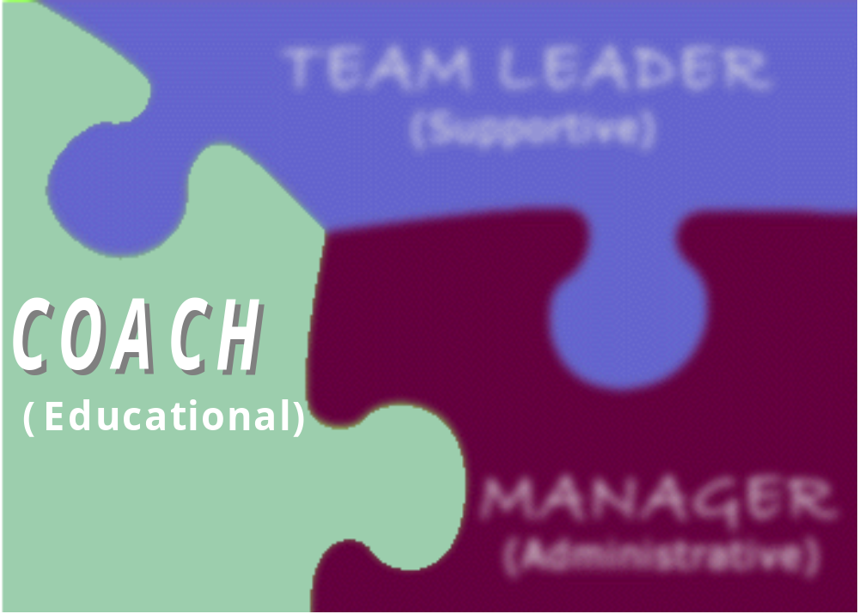

Supervisor’s Guide

Agenda

Day 1
Introductions and Housekeeping

Learning Styles

Individual Training Needs Assessment

Orientation for New Case Managers

Stages of Case Manager Development

Transfer of Learning

Personal Reflection

Day 2
Supervisor as Mentor

Supervisor as Practice Expert

Casework Jeopardy

Constructive Feedback

Coaching

Personal Reflection

Day 3
Understanding Emotional Responses

Supervisor as Clinical Consultant

Supervision Land

Personal Reflection, Wrap-Up, & Evaluation

Training Competencies & Learning Objectives

Competency 1
Understands and values diversity and different styles of perceiving, learning, communicating, and operating.

- Identifies characteristics of the adult learner.
- Lists principles of adult learning.
- Describes factors that influence learning styles.
- Understands application of learning style principles to own learning style.
- Applies learning styles to the development of learning plans.
- Describes the new worker orientation modules.

Competency 2
Understands how to administer an Individual Training Needs Assessment (ITNA) with workers.

- Defines a competency-based training system.
- Describes the role of the ITNA within the larger training and agency context.
- Knows how to discuss the ITNA with a worker.
- Knows how to complete a portion of the ITNA in a practice session.

Competency 3
Knows the components of the state’s training program for new workers.

- Describes the new worker CORE series training.
- Describes the role of the supervisor in providing orientation to new workers.

Competency 4
Understands the value of a developmental approach to supervision and can adapt supervision style to worker’s stage of development.

- Lists the significant factors within each stage of worker development.
- Assesses staff for stage of worker development.
- Describes supervision strategies for each stage of worker development.

Competency 5
Knows how to improve the transfer of learning from the classroom to the field.

- Lists the significant people and time frames that participate in the transfer of learning process.
- Describes driving and restraining forces that inhibit or contribute to the transfer of learning.
- Applies transfer of learning strategies to a plan for workers who attend CORE training.

Competency 6
Understands the value and components of a mentoring program.

- Describes the impact of mentoring on the mentor and the mentee.
- Identifies the components of a mentoring relationship.

Competency 7
Knows, can model, and teach necessary elements of statutes, rules, policies, assessment, decision making, case planning, and case process to staff to facilitate the best possible case outcomes.

- Differentiates between compliance and best practice standards.
- Identifies pertinent best practice and best policy issues for the outcomes of safety, permanency, and well-being.

Competency 8
Able to provide constructive feedback.

- Distinguishes constructive feedback from praise or criticism.
- Describes the components of constructive feedback.
- Defines the formula for providing constructive feedback.
- Demonstrates constructive feedback.

Competency 9
Able to apply coaching techniques to supervision situations.

- Describes coaching techniques.
- Lists appropriate coaching questions for various situations.
- Applies coaching techniques to a case scenario.

Competency 10
Knows and can recognize when a worker’s emotional responses and/or judgment interfere with the casework process and can empower the worker to identify and examine these issues.

- Identifies the rationale for templates.
- Identifies their own and their workers’ templates that may impact case interactions.

Competency 11
Knows the value and components of proactive, structured supervision.

- Differentiates between visual assessment tools.
- Identifies major components of ecomaps, genograms, and family maps.
- Describes the value of group case conferences.
- Identifies the format for group case conferences.
- Identifies the format for one-on-one case conferences.
- Describes the supervisor’s role in applying proactive, structured supervision.

Scavenger Hunt

Directions:
Walk around the room and obtain a signature from other training participants for as many of the descriptions below as possible.

Have put a reference to my mgmt theory on my desk/in office  _____________ | Have re-read the agency vision/mission statement  _____________ | Read my journal  _____________ | Helped celebrate a transition differently  _____________
Reviewed the agency mission with staff  _____________ | Checked a reference differently  _____________ | Did some outside reading on management/  leadership styles and/or theories  _____________ | Reviewed the reports for information about my office  _____________
Applied progressive levels of discipline with an employee  _____________ | Used new interview questions  _____________ | Tried to mend a conflictual relationship with a community partner  _____________ | Introduced a change in my office differently  _____________
Trained my staff on something I learned at the training  _____________ | Applied an intervention to improve retention  _____________ | Interacted with a colleague differently because of training  _____________ | Wrote in my journal since the training  _____________

Test Your Knowledge of Adult Learning
DIRECTIONS: Circle the correct answer.

1. T or F If you “catch” your staff member in the act of doing something “right” and acknowledge it in some way it is likely that they will repeat that behavior.

2. T or F A policy memorandum given to staff to read is all that is necessary for all staff members to learn a new process.

3. T or F What happens out in the field when case managers are working with families with intense crisis issues creates long-lasting learning.

4. T or F If you tell a staff member to do a new skill once they should be able to perform it without assistance.

5. T or F It is good for a supervisor to go out into the field with new case managers, coaching and supporting them while they are working with the client, to facilitate learning.

6. T or F Asking case managers to mentor other case managers with less experience facilitates the learning of both and builds the capacity of the unit.

7. T or F It is important that new case managers recognize that child welfare is unlike any other job that they have ever had so they should listen to new information like a “blank slate” and not try to apply it to other experiences or jobs that they have had.

8. T or F Case Managers learn best when the supervisor tells them what they should do and how they should do it.

Inspired by Sivasailam Thiagarajan’s 14 Things to Know

Principles of Learning: Supervisory Techniques

Principle 1:

Workers learn best if they are highly motivated to learn.
- Explain the usefulness of the content. Workers’ motivation to learn increases if they know how the content will help them perform their child welfare tasks effectively.
- Make learning meaningful in terms of the worker’s motives and needs. However useful or significant the material is generally, workers may not be motivated to learn unless shown its usefulness and importance to a problem or situation that is meaningful to them. For example, showing workers how they could have gathered more thorough and appropriate information during a recent investigation if they had a surer grasp of the dynamics of sexual abuse will be more effective in increasing motivation than lectures on the general importance of such knowledge.
- Link the areas of low motivation to areas of high motivation. Workers may be highly motivated to help clients, but may be indifferent to the content that you are trying to teach, such as case recording. If you can show the ways in which case recording can assist workers in being more helpful to their clients, then they may be motivated to learn it.
- Motivation must be safeguarded and stimulated where it exists and instilled where it does not. Workers may lack motivation to learn content if they feel they have no need for it. They may be satisfied with what they are doing and how they are doing it. They may feel they have no problems that require additional learning. If you believe that a worker does, in fact, have much to learn, then you should confront the worker about the gap between what he/she is doing and what he/she is capable of. So you have to act as a catalyst for change. You need to create the tension that must be resolved through learning.

Principle 2:

Workers learn best when they devote most of their energy in the learning situation to learning.
- Rules regarding the time, place, roles, limits, expectations, and objectives of the learning should be clearly established. If workers are not clear about what is expected of them, they will not be able to devote their full attention to learning.
- Workers’ rights to determine their own solutions should be respected (within limits). In your supervision, you should allow your workers the greatest amount of independence possible, without causing any danger to clients. Visible respect for your worker’s autonomy will ensure that the energy necessary for learning is not discharged in defense of autonomy.
- An atmosphere of acceptance, safety, and security should be established. Since learning implies making mistakes and risk of failure, acceptance allows freedom to take risks and admit ignorance, and allows for concentration on learning rather than self-defense.
- Acknowledge and use what the worker already knows and can do.
- Move from the familiar to the unfamiliar. Attempt to relate new material to that which is familiar. New information will then seem less strange and less difficult to learn.
- Demonstrate confidence in worker’s ability (if warranted). If you communicate confidence in worker’s ability, you will help allay feelings that take away from the learning. Communicating confidence is likely to increase motivation for learning.
- Know your content and be ready, willing, and able to teach it. Since not knowing what they need to know makes workers anxious, it is important for you to be able to answer as many of their questions as possible. Knowledge and trust in your capability, and willingness to help, will reduce worker’s anxiety.

Principle 3:

Workers learn best when learning is followed by satisfaction.
- Ensure a high probability of success in the learning situation. Make sure the learning demands presented to workers are within their capabilities. However, the tasks must be sufficiently challenging to engage the workers’ interest and involvement.
- Satisfaction in learning is increased if praise for success in professional accomplishment is provided. Remember that praise reinforces behavior, but indiscriminate praise is counterproductive. If you praise performance that is substandard, workers may feel unable to trust your future judgment.
- Praise by giving positive feedback. The praise should be closely tied to the specific behavior.
- Periodic formal evaluation of worker performance (for example, at six-month intervals) further ensures learning, because it provides a perspective on long-range progress.
- Identify the components that will result in a greater probability of success. Offer learning in digestible doses.
- Content should be presented from simple to complex, from obvious to obscure. This is more likely to ensure success and satisfaction. For example, a situation in which cause and effect relationships are clear and in which the problem is clearly defined presents less difficulty to a worker.
- Satisfaction in learning is more likely to occur if we prepare workers for some failure. Since it is generally impossible in child welfare to prevent workers from being exposed to complex situations for which they may be unprepared, it is helpful to clearly discuss with the worker the possibility of failure in the encounter.

Principle 4:

Workers learn best if they are actively involved in the learning process.
- Workers will be more involved in the learning process if they are encouraged and provided with the opportunity to question, discuss, object, and express doubt.
- Workers should be given the opportunity to use and apply the knowledge you teach.

Principle 5:

Workers learn best if the content is meaningfully presented.
- Be selective in what you teach. Remember that some content requires more attention, emphasis, and repetition than other content.
- Learning is more meaningful if repetition is imaginative. You should use as many different ways to teach the same ideas as possible, because it is easier to grasp and accept. For example, the same content can be more meaningfully presented through the use of contrast and comparison, and through illustration of similarities and differences.
- Practice of skills is critical, but it should not be haphazard. The best repetition involves more than just practicing old skills; new elements or skills should be included as well.
- Teaching that is planned in terms of continuity (repetition of important content), sequence (built from simple to complex), and integration (content is related to each other) is more likely to be presented in a useful fashion.
- Learning is more meaningful if it can be made conscious and explicit. Since we are not always aware of what we have learned, it is best to ensure that periodic recapitulation and summarization of content take place.
- It is advisable to have workers verbalize and label what they have learned. This is likely to result in more meaningful and transferable learning.

Principle 6:

Workers learn best if their uniqueness as a learner is taken into consideration.
- Individualizing learning requires conducting a learning needs assessment. To conduct a needs assessment you determine what the worker already knows well; what he/she needs to learn; what he/she wants to learn; and how he/she wants to learn it. You also need to observe how your workers learn.
- What is their level of motivation?
- How flexible are they?
- How prepared are they for supervisory conferences?
- What is their level of participation in conferences?
- What is their general attitude toward the content presented and the learning situation?
- Do they learn best in highly structured or loosely structured situations?
- Do they learn best by listening or reading?
- Do they learn best through action in a practice situation?
- Do they like to have a thorough understanding of something before they take action?
- Do they learn best in group settings or one-on-one?
- Do they learn best inductively or deductively?
- Do they learn fast, or do they need more time to integrate information?
- You should engage your workers in an assessment of what they already know and what they would like to learn.
- You should continually review each worker’s learning assessment. This will allow you to:
- Prepare for supervisory conferences.
- Determine what each worker needs to learn at a particular time.
- Determine the best approach to teaching each worker.
- Determine how each worker is likely to react to the content presented.

Kolb Learning Inventory, Quick Activity
Directions: Complete the questionnaire by ranking each possible ending of each of the 4 sentences. They will rank each ending by considering how well each ending describes the way that they learn. 4=most like you, 1=least like you…rank each response.

  - When I learn:
____ I like to deal with my feelings. (CE) _____ I like to think about ideas. (AC)

____ I like to be doing things. (AE) _____ I like to watch and listen. (RO)

  - I learn best when:
____ I listen and watch carefully. (RO) _____ I rely on logical thinking. (AC)

____ I trust my hunches and feelings. (CE) _____I work hard to get things done. (AE)

  - When I am learning:
____ I tend to reason things out. (AC) _____ I am responsible about things. (AE)

____ I am quiet and reserved. (RO) _____ I have strong feelings & reactions. (CE)

  - I learn by:
____ feeling. (CE) _____ doing. (AE)

____ watching. (RO) _____ thinking. (AC)

  - When I learn:
____ I get involved. (CE) _____ I like to observe. (RO)

____ I evaluate things. (AC) _____ I like to be active. (AE)

AE- Active Experimentation Score: _____ Dominant Processing Mode
RO- Reflective Observation Score: _____ Which score is your Highest? _______
CE- Concrete Experience Score: _____ Dominant Perceiving Mode
AC- Abstract Conceptualization Score: _____ Which score is your Highest? _______

Experiential Learning Model∗

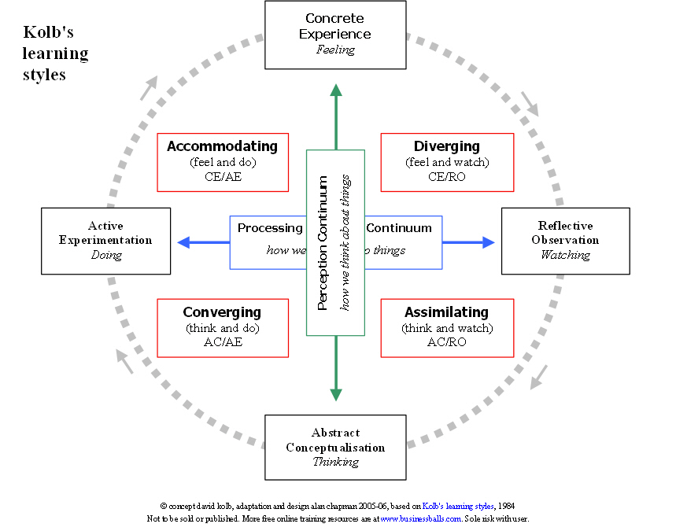

Dimensions of the Learning Process∗

Dimension #1
How we perceive new information — the concrete-abstract dimension. In new situations, some people prefer to sense and feel their way, while others think their way through.

- Concrete Experience
People who emphasize this mode of learning find the tangible, felt qualities of the world as their favored means of perceiving, grasping, or taking hold of new information. They perceive the world through their own senses, immerse themselves in the concrete reality, and rely heavily on their intuition, rather than step back and think through the elements of the situation analytically.
- Abstract Conceptualization
People who emphasize this mode of learning tend to grasp new information through symbolic representation. They tend to think about, analyze, or systematically plan rather than use intuition or sensation as a guide.

Dimension #2
How we process what we perceive — the active-reflective dimension. This dimension refers to how we process or transform new information and experience, how we incorporate information.

- Active Experimentation
In processing new information some people would prefer to jump right in and try it out. These people are the doers.
- Reflective Observation
In processing new information some people prefer to carefully watch others who are involved in the experience and reflect on what happens. These people are the watchers.

Learning Styles∗
Converger
This person’s dominant learning abilities are abstract conceptualization and active experimentation. This person likes to start with a general theoretical approach, quickly put it in practical terms, and then apply it. This person prefers to process information through hypothetical-deductive reasoning. This person prefers to have a basic understanding before applying. This person uses self or other feedback to identify what worked, what didn’t, and determine new strategies. This person likes to solve problems/find solutions and make decisions.
4
Diverger
This person has the opposite strengths of the Converger. This person is best at concrete experience and reflective observation. This person likes to brainstorm ideas and consider all the options. This person draws from past experience when problem solving or learning and works more on intuition than facts.

Assimilator
This person’s dominant learning abilities are abstract conceptualization and reflective observation. This person excels in inductive reasoning and assimilating disparate observations into an integrated explanation. This person is more concerned with abstract concepts than with the practical use of the theories. This person prefers to sit back, watch, and take notes. This person likes to gather information from different sources and experts and is good at generating theories, but may have trouble applying the theory into practice.

Accommodator
This person has the opposite learning strengths of the Assimilator. This person is best at concrete experience and active experimentation. People with this learning style are very active learners; they prefer “hands-on” experience. This person likes to do before thinking. They tend to solve problems in an intuitive and trial-and-error fashion. This person relies heavily on other people for information, rather than his/her own analytical ability.
Learning Styles: Strengths and Weaknesses

 | Strengths | Weaknesses
Converger | - Problem-solving  - Decision-making  - Deductive reasoning | - Impulsive decision-making  - Solving the wrong problem
Diverger | - Imagination/creativity  - Understanding People  - Tuning into others | - May be paralyzed by alternatives  - Indecisiveness
Assimilator | - Planning  - Creating models and theories  - Inductive reasoning | - Ivory tower approach  - No practical applications
Accomodator | - Getting tasks done  - Leadership  - Risk-taking | - Trivial improvements  - Meaningless activity

Learning Styles & Legos

Observer Notes

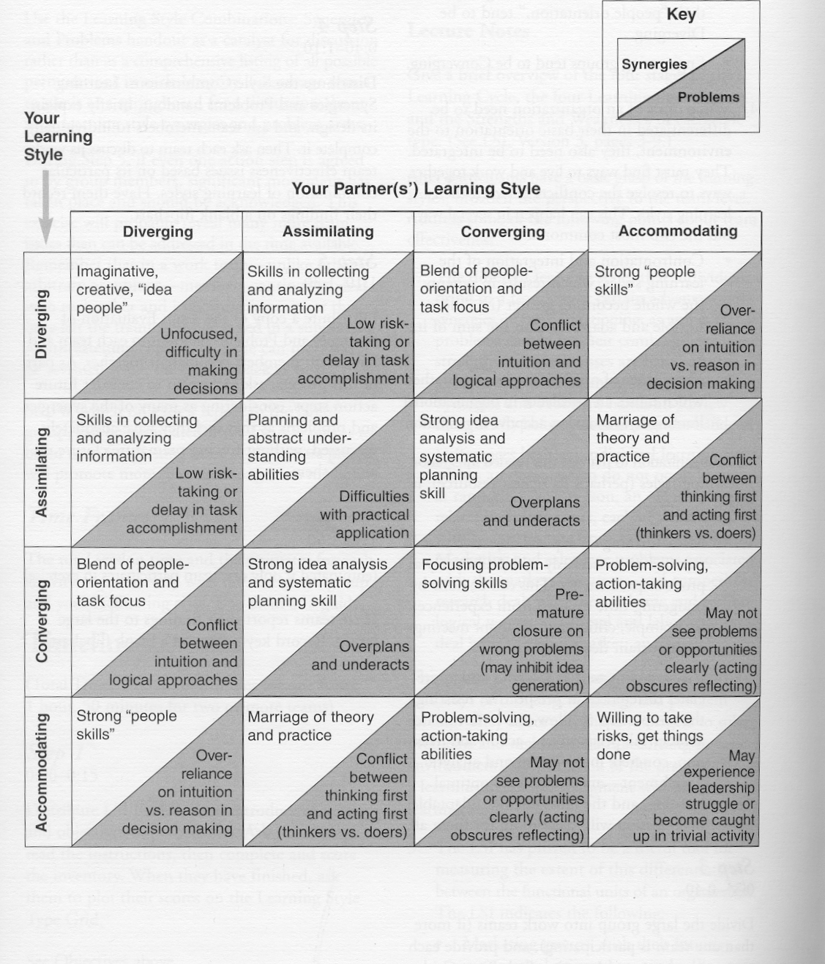
Learning Style Combinations:
Synergies and Problems∗

Preferred Learning Situations∗

Stages of Learning | Preferred Learning Situations
Concrete Experience | - Learning from new experience, games, role-plays, etc.  - Peer feedback and discussion  - Personalized counseling
Reflective Observation | - Lectures  - Opportunities to take an observer role, to see different perspectives on an issue  - Objective tests of one’s knowledge about an issue
Abstract Conceptualization | - Theory reading  - Study time alone  - Clear, well-structured presentation of ideas
Active Experimentation | - Opportunities to practice and receive feedback  - Small group discussion  - Projects and individualized, self-paced learning activities

Factors That Shape Our Learning Style∗

- Personality Type or Dispositions
For example, if you tend toward introversion or extroversion, you will likely tend toward reflection or action respectively.

- Academic Training
This is an important influence on your learning style, because in school you not only learn facts, you also learn how to learn. Traces of this early influence last well past young adulthood and may occur in the form of your learning style.

- Career Choice
This can shape your learning style in one of two ways: through exposure to a specialized learning environment in which you acquire habits of behavior; and through the influence on your behavior of "norms" and standards of conduct peculiar to your career field.

- Current Job
The task demands and pressures of a job tend to shape a person's adaptive orientation. For example, if the job demands that we engage in more active experimentation, then we may become more oriented toward that mode of learning.

- Current Tasks/Activities
Each task we face requires a corresponding set of skills for effective performance. Each time we meet these demands, we further develop our adaptive competence. So, the more we develop a certain set of skills (e.g., thinking skills), the more pronounced our learning style becomes.

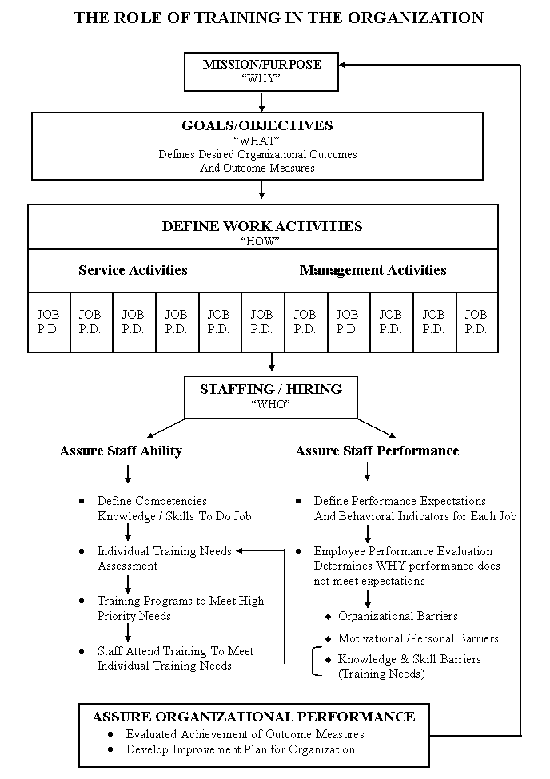
JOB P.D.- Job Performance Descriptions

Components of the ITNA

Skill Set Assessent
Identifies the specific knowledge or skill competencies in which a staff member needs further development

Competency Assessment
Targets the skill set areas in which staff need further development

Which skill sets to complete:

- Importance to the job

- Level of current knowledge/skill.

Tips for Using the ITNA*

- The ITNA contains the “universe of competencies,” the sum total of knowledge and skills needed by workers. If the competency isn’t here, then it has been determined as not essential or appropriate to achieve the agency’s goals, objectives, or mission; it therefore isn’t taught at training.
- A standardized numbering system is used throughout the system. The competencies are organized into a hierarchy: CORE, specialized, and related skills.
- The purpose of ITNA is to determine in which of these competencies each worker should be trained.
- A training need must be:
- Job related; and
- A competency in which the worker needs improvement in the knowledge and skill to do it.
- The instrument contains two rating scales, one for each criterion.
- To evaluate the competency, multiply the two scales. The highest priority training need is a competency that is very important to the trainee’s job and in which the worker needs considerable development to achieve proficiency.
- All CORE competencies have a pre-rating of “3” as they are defined as fundamental and essential for all workers, regardless of job assignment.
- Curriculum for Keys/Track is standardized to teach all the competencies listed in the ITNA for that area. Therefore, the ITNA is not normally administered for workers prior to Keys/Track, as that information is trained anyway. It can be used to prepare them to go to Keys/Track (so they know what they will learn) and as a follow-up to determine what they did not get or need additional work on to sufficiently transfer to the job.
- Once workers complete Keys/Track, the ITNA will determine additional specialized and related skills training needed.
- The Non-Training Barriers Column: Training needs and non-training barriers to performance (such as organizational or personal barriers) can co-exist. This column flags the supervisor to use other management strategies in addition to training to resolve other types of performance problems.
- The supervisor uses the ITNA to select training in which to send workers.

Checklist for Supervisors during New Staff First Week

Do – Prior to First Day
 Provide key written material, such as an employee handbook and other relevant information
 Arrange for office furnishings, equipment and essential supplies to be in place prior to the arrival of the new staff
 Consider taking the new person to lunch on or prior to the first day on the job
 Plan how you want the person to spend their first day
 Arrange for person-to-person meetings with one or more of your team
 Make sure to let all staff know when the new staff is expected and ask them to make her/him feel welcome
 Consider having a welcoming party, breakfast, potluck lunch, etc.
 Pair up the new staff person with a respected co-worker “buddy” for the first month to help them learn the ropes and to ask such questions as: How are you? How is it going? Do you need any help?

Do – First Day
 Meet with the staff person early in the first day to:
○ Affirm the importance of the staff person’s job to the agency’s mission
○ Review job expectations
○ Set expectations and schedule for the first week, including at least two additional supervisory sessions, one mid week and the other at the end of the first week
 Provide an orientation checklist that will enable the staff person to take charge of her/his own orientation (Making Connections)
 Introduce the staff person to as many team members and key agency staff as possible and let them form their own opinions of people
 Have someone show the person around the facility and make sure they know who to go to for what

Do – First Week
 Make sure the new person is oriented to the computer, fax machine, copy machine, phone system, where to get supplies, etc.
 Introduce the staff person in a group meeting with enthusiasm and use the time to introduce staff members and their specialties, interests, etc.
 Encourage the person to meet with co-workers throughout the first week to get their perspectives on things
 Give appropriate and challenging assignments in the first week and the first month
 Schedule the person for relevant in-house and external training and prepare him/her for what he/she should be getting out of training
 Hold an end of the week meeting with the staff person to set objectives for the first month on the job and review the organization’s mission

New Case Manager Orientation

The Education and Training Services Section (ETS) has developed an enhanced field component to the existing training sequence for new case managers. This component is designed to provide a sequence of activities and online training which will provide the new employee with a foundation of knowledge, observations and experiences to prepare him/her for the classroom training experience.
Making Connections
Minimum of 20 work days in the county office
Stage 1 – Making connections in your DFCS office
Day 1- Orientation with Regional HR
Day 2 – County office orientation - County Office
Day 3 – Training Orientation – WebEx Meeting
Days 4 – 7 Connection Activities - County Office
Stage 2 – Making connections in your community
Days 8 – 12 Connection Activities - County Office

Stage 3 – Making connections with the families serve
Days 13 – 20 Connection Activities - County Office

How to Get Started.
Making Connections Master Checklist
The Master Checklist provides by Stage, a comprehensive overview of all the activities required, an anticipated time to complete the activity, the actual hours to complete, and the date of completion. Please review this document carefully as it identifies activities for Day 1.
The Master Checklist tracks the successful completion of each activity and requires signatures by the following:
- Trainee
- Field practice advisor
- Supervisor/training coordinator
- Field program specialist
A signed Master Checklist is maintained in the case manager’s personnel file.

Training Plan
Supervisors will complete a Training Plan on the FIRST DAY with each new case manager prior to attending training to ensure that ALL field/on-line activities are complete. Using the Master Checklist in conjunction with the Training Plan will ensure that the New Case Manager has a specific assignment for each day.
Program Area Master Checklist
A separate Master Checklist exists for each of the program area courses. This Master Checklist will identify the required On-line and Field Practice Activities completed by the case manager prior to Certification approval.
The Master Checklist is available on the Education and Training Website.
Who’s responsible
Every county has a unique process for guiding the training plan.
The key participants will be:
- The Supervisor/Training Coordinator
- The Field Program Advisor
- The New Case Manager
Supervisor/Training Coordinator
The responsibility for providing a quality, relevant field practice rests primarily with the supervisor/training coordinator.
The Supervisor/Training Coordinator’s responsibility is to:
- become familiar with the activities to assist the you in planning your activities
- review each activity worksheet with you and sign off certifying the you have successfully completed the activity
- meet regularly with the field practice advisor and you to assess your progress and provide input to the certification decision
Field Practice Advisor
Many counties have experienced veteran case managers that are pre-selected to be a mentor and coach during the training period.
The Field Practice Advisor’s responsibility is to:
- serve as a mentor to you
- provide opportunities for you to shadow them in conducting various case manager duties
- collaborate with the Supervisor and Field Program Specialist
- specific responsibilities should be indentified in your training plan

New Case Manager
Responsible to:
- take the time to carefully read the guide
- fully engage in the field practice experience
- complete the field activities as outlined in the Master Checklist and Training Plan.
- document the field practice activity on the designated worksheets
If a veteran case manager is changing program areas, the field practice activities, completion of the online instruction must be complete prior to taking classroom training.
During the Making Connections course the new case manager will be demonstrating strengths in being flexible, organized, ability to assess, and taking the initiative to get the job done.

Stages of Worker Development

Beginning Stage Middle Stage End Stage

Time

Beginning Stage
Characterized by:

- Supervisee needs high levels of instruction, structure, and support.
- Variable sense of professional identity.
- Supervisees tend to be dependent, anxious, and insecure.
- Possibly over-involved with clients.
- Highly motivated to acquire new skills.
- A hierarchical relationship between the supervisee and supervisor exists.
- Didactic, one-on-one instruction most common.
- Workers will imitate supervisee or other mentors.
- Lack of confidence.
- Performance awkward or unnatural.
- Insecurity leads to risk-adverse behaviors.
- Asks many questions.
- Naively optimistic about impact on clients.
- Supervisor focuses on worker performance.

Middle Stage
Characterized by:

- Comfortable with job tasks.
- Expresses increasing confidence.
- Learning about the importance and impact of self.
- Anticipates behaviors and plans accordingly.
- Recognizes patterns and makes intuitive decisions.
- Less need for structured learning experiences.
- Learning occurs through identification and internalization.
- Supervisee may revert to earlier dependent behaviors.
- Supervisee may become somewhat disillusioned and more accepting that not all clients can be helped.
- Supervisor-supervisee relationship is mutually respectful.
- Supervisor may use more confrontation and self-disclosure when providing supervision.
- Often the time when workers question their commitment to field/job and quit.

End Stage
Characterized by:

- Boundaries are fully developed.
- Can use a flexible style.
- Developed a fully integrated understanding, can take appropriate action without seeming to consider alternatives, and possesses strong theoretical knowledge and analytical skills.
- More accepting of client participation in problem solving.
- Greater acceptance of the complexity, ambiguity, and multi-causality of human behavior.
- Supervisee-supervisor relationship much more informal, increasingly collegial.

Stages of Worker Development Exercise

Part A
Please list your workers and assign each a stage.

Worker | Stage

Part B
Please list strategies for each stage of worker development.

Stage 1: Beginning | Stage 2: Middle | Stage 3: End

Transfer of Learning∗

Three people influence whether staff apply what they’ve learned in training on the job: the trainee, the supervisor, and the trainer. Each can facilitate the use of knowledge and skills on the job or can discourage it. Each has an impact on the transfer of learning before, during, and after training.

In the matrix below, these three people are shown in relationship to the three periods of time that affect the transfer of learning to actual job situations. There are nine squares in the matrix, each representing a period of possible influence. Please rank these points of influence from 1 to 9, using all 9 numbers, with 1 being “most influential” to 9 being “not as influential.”

 | Before | During | After
Trainee
Supervisor
Trainer

Driving and Restraining Forces∗

CPS Questions

- No one from the supervisory or administrative level has ever attended the training. A. RESTRAINING FORCE B. DRIVING FORCE

- Supervisor meets with trainee before the workshop to discuss training expectations. A. RESTRAINING FORCE B. DRIVING FORCE

- Trainee makes a plan with supervisor and co-workers to cover cases while in training. A. RESTRAINING FORCE B. DRIVING FORCE

- Due to “emergencies,” the supervisor interrupts the training session to conference with workers. A. RESTRAINING FORCE B. DRIVING FORCE

- Trainer points out the relationship of training to the agency mission. A. RESTRAINING FORCE B. DRIVING FORCE

- Trainees come to the workshop with specific cases/situations in mind. A. RESTRAINING FORCE B. DRIVING FORCE

- Trainees try out new ideas but are not very successful with the first two clients (e.g., one client cusses at the trainee and calls the agency administrator to complain). A. RESTRAINING FORCE B. DRIVING FORCE

- After the training, the worker is reassigned to a position where the training is not emphasized. A. RESTRAINING FORCE B. DRIVING FORCE

- Supervisor meets with worker within a week after the training to discuss how they will apply the learning. A. RESTRAINING FORCE B. DRIVING FORCE

- Worker formally provides an overview of the training for other staff during the next unit meeting. A. RESTRAINING FORCE B. DRIVING FORCE

Stop! Do not go to the next page!

Restraining Forces Before Training
- Trainee hears negative messages about the training before attending (e.g., the training is terrible; you won’t be able to use it on the job).
- Trainee thinks training is a vacation away from the job. Trainee does not come prepared to learn.
- Trainee does not have a choice in attending the training session; the trainee is signed up by the training department. The supervisor is not involved in the decision, either.
- Trainee does not see the connection between training and increasing work effectiveness with clients.
- Trainee is the only one from his/her unit sent for training.
- No one from the supervisory or administrative level has ever attended the training.
- Supervisor notifies trainee about workshop one hour before the training begins.
- Training is developed by the training department without involvement from line or supervisory staff. The training is of special interest to the administrator.

Driving Forces Before Training
- Training developed with input from all levels of staff (line, supervisory, administrative, etc.).
- Accurate needs assessment is performed (right trainee to the right training at the right time).
- Supervisor meets with trainee before the workshop to discuss training expectations.
- Supervisor engages the trainee before the workshop to think about the level of self-competence pertaining to upcoming training.
- Trainee makes a plan with supervisor and co-workers to cover cases while in training.
- Importance of training to job effectiveness and subsequent promotions is conveyed to all newly hired staff.
- Work unit goes as a team to training prepared to bring back new ideas to the unit.
- Trainer meets before training with line workers, supervisors, and administrators to help make the training as relevant as possible.

Restraining Forces During Training
- Due to “emergencies,” the supervisor interrupts the training session to conference with workers.
- Trainer inflexibility adheres to the workshop agenda without adjusting to specific case examples generated by the trainees.
- Several workers are disruptive during the training.
- Trainer is not able to relate personal expertise to child welfare practice.

Driving Forces During Training
- Trainer points out the relationship of training to the agency mission.
- Trainees come to the workshop with specific cases/situations in mind.
- Trainer uses techniques that facilitate retention (relating information to what the workers already know, multimedia, observation, practice, attention getting techniques, etc.).
- Trainer stresses the importance of transfer at the beginning, middle, and end of the training.
- Trainer involves the workers and their supervisors in the action planning process.
- Trainer engages trainees to set three action plan objectives to apply new ideas on the job.
- Trainer helps trainees identify barriers and facilitative forces to their action plans.
- Trainer provides tools (handouts, visual aids, reminder cards) that trainees can take with them to the job (office, car, home).
- Trainer brings the work environment into the training (e.g., uses actual cases of workers, uses agency and state forms, and brings in a client willing to be interviewed).
- Trainer periodically stops the training and asks trainees to think about how they will use the information discussed up to this point. Trainer asks trainees to “cognitively rehearse” the application of new skills in the work environment.

Restraining Forces After Training
- Trainees try out new ideas but are not very successful with the first two clients (e.g., one client cusses at the trainee and calls the agency administrator to complain).
- After the workshop, other workers convey to the trainee, “If you want to survive in this business, you had better forget about what you just learned; there is no time for it.”
- After the training, the worker is reassigned to a position where the training is not emphasized.

Driving Forces After Training
- Training personnel send a reminder notice about action plans to trainees one week after the training.
- Training personnel send a transfer summary to trainees after the workshop to assess their transfer efforts.
- Supervisor meets with worker within a week after the training to review their action plan.
- Supervisor and worker make a plan of implementation for the action plan, which includes ongoing review of the action plan by the worker and supervisor.
- Worker formally provides an overview of the training for other staff during the next unit meeting.
- Supervisor arranges for worker to shadow another worker who has previously attended the training in an effort to observe implementation of workshop ideas.
- Trainee attends a “booster shot” review session of the training workshop one month after the workshop.
- Worker attends an alumni meeting of previous workshop graduates who discuss application of the training.
- Agency provides a small bonus to workers who successfully complete the training and attend a “booster shot” review and application session.
- Training personnel publish the names and stories of trainees who apply the training to the job.
- Supervisor provides immediate and intermittent reinforcement and supports worker transfer efforts after the workshop.

Things Trainees, Co-Workers & Supervisors Can Do to Help Transfer Training Back To The Job
 | BEFORE | DURING | AFTER
Trainees | - Work with supervisors to plan coverage of cases/unit while in training.  - Identify cases to keep in mind.  - Begin to formulate objectives for action plan.  - Foster mind-set of getting involved in the learning and transfer process | - Identify barriers and facilitative forces for application.  - Ask, “How can I apply this to my caseload?”  - Identify key individuals who can have an impact on barriers and facilitators.  - Make a commitment with co-trainees to support each other | - Hold a timely meeting with supervisor to discuss importance and application.  - Share information with co-workers.  - Follow through with action plan.  - Place visual reminders where easily seen.
Co-Workers | - Involve teams in the needs assessment process.  - Have teams identify the impact of training on specific cases.  - Encourage active involvement in the learning and transfer process as a group norm.  - Identify how training relates to team goals. | - Sit together to reinforce learning and application behavior of other team members.  - Review team members’ action plans.  - Make plans to reinforce teammates’ action plans.  - Develop a team action plan. | - Review training content and application in team meetings  - Remind team members of action plans  - Provide team recognition for transfer.  - Integrate training team plans and decisions.
Supervisors | - Be involved in the planning and development of training.  - Stress the importance of self-development from the start of employment. Encourage development of self-monitoring skills.  - Convey training and application as a priority. Help workers see the need for training (connection to improved performance, self-development, agency mission and goals) as well as both learning and doing.  - Decide when there is a need for training, and only send learners with an identified training need, so that t they’re the right learners at the right training at the right time.  - Conduct pre-training conference with the trainee, and discuss workshop expectations.  - Assess prior learning experiences, and identify what helped or hindered learning and application.  - Clarify goals, roles, and interpersonal expectations. Consider developing a learning contract or action plan.  - Help workers identify cases and situations relevant to an upcoming training. | - Ensure that there are not distractions and cover for the trainee if necessary.  - Convey that training is a priority.  - Discuss training and application with worker between sessions, if multiple-day training  - Attend training. | - Reduce barriers to application of new skills.  - Provide worker opportunity to try out new skills, and reinforce usage.  - Observe the use of new skills and provide performance feedback or coaching.  - Provide support during the time when results are reduced because of new skills.  - Meet with supervisee within a week to review key points in training and action plan. In this supervisory conference, use questions to help the worker integrate learning, plan for application, promote greater depth in processing, attach new learning to previous learning and future application, use labels and general rules as well as identify exceptions, and see underlying principles of child welfare work. Ask the following:  - What were the three most important learning points?  - How is this learning similar to what you already know?  - How is it different?  - What cases and situations does it apply to? Why?  - What ideas do you have for application?  - When should this not be used?  - How can you adapt the ideas to fit a new situation?  - Have worker present learning at a team meeting.  - Encourage other team members to think of possible applications.  - Provide continuous then intermittent reinforcement.  - Help worker plan for using retrieval cues.  - Encourage the worker to do memory work and reflect on interaction with clients.  - Continue to monitor the learning and application process.
GA Social Services New Case Management Training

Training consists of three components:
  - On-line Courses
  - Field Practice Activities and
  - Classroom Training
All three components are necessary to have a complete learning experience!
On-line Courses
On-line courses introduce program policy and practice. Some courses require an assessment or certification of completion for verification to Education and Training.
Field Practice Activities
While in your county office, the case manager will complete activities and worksheets designed to enhance their learning experience. The worksheets guide the case manager through the activity and identify critical learning points. The Training Coordinator and/or Supervisor will review and sign off on each worksheet. All field activities are to be brought to classroom training for review by the trainer.
Classroom Training
The classroom training brings together the knowledge gained through the on-line training, the observations and experiences from the Field Practice through an interactive classroom environment. The participants will complete an assessment at the completion of the classroom training.
A score of 70% or better must be obtained to successful complete the course.

Summary of Keys to Child Welfare Training Content
This course will continue the learning experience from the Making Connections Course through an interactive classroom environment.

Days 1 – 10 Classroom – Training Site
Module 1 – Introduction to Child Welfare Services
- Know the instructor
- Know general housekeeping issues
- Engage effectively with fellow case managers
- Explain the attendance requirements and training expectations
- Construct an overview of how child welfare developed and historical events that have shaped the Georgia child welfare system.
- Locate and explain both Federal and Georgia laws that impact child welfare
- Identify the impact of these laws on the design of Georgia policy and child welfare practice.
- Explain how Child Protective Services, Foster Care Services, and Adoption Services in the Division of Family and Children Services are related
- Demonstrate the differences in the program areas as well as how they interrelate
Module 2 – Values and Culture
  - Analyze the alignment of personal goals and expectations with realities and requirements of the job.
  - Analyze how personal values influence perceptions and decisions
  - Articulate, through class activities and discussion, an understanding that personal values and ethics will differ between individuals and cultures.
  - Understands cultural differences in communication styles and the impact of word choice on intercultural communication.
  - Demonstrates knowledge and understanding of key cultural diversity concepts and terms.
  - Demonstrates multicultural awareness -- is aware that cultural differences exist and may affect how different people think and behave.
  - Demonstrate an awareness and understanding of how words can be used to create either a favorable or unfavorable impression of a person, especially with regard to cultural differences
  - Demonstrate multicultural sensitivity -- appreciates a variety of cultural perspectives and values diversity.
  - Utilize the Ethnographic Interview to discover another’s cultural values
Module 3 – Assessing Families: Decision Making in Child Welfare
- Define assessment and identify the key decision points in assessing families
- Examine the underlying conditions leading to or sustaining behavior when performing an assessment
- Identify aspects of critical thinking and the importance for providing quality case management services

- Recognize the need to monitor the safety of the child by initial and ongoing assessment of risk
- Delineate the difference between safety and risk
- Define family violence and identify indicators and signs of family violence
- Direct clients to resources for family violence
Module 4 – Child Maltreatment
- Describe the prevalence of child maltreatment, and the legal definitions of maltreatment
- List the categories of abuse
- Define child and caretakers
- Determine the importance of remaining objective and determine the difference between poverty issues and neglect
- Recognize physical and behavioral indicators of child neglect
- Recognize physical and behavioral indicators of physical abuse.
- Recognize family indicators of sexual abuse and use the indicators when assessing potential sexual abuse of children.
- Given a scenario, identify indicators of maltreatment presented in the Turcotte family.
Module 5 – Impact of Maltreatment on Child Development
- Identify age appropriate behavior stages, processes and milestones of normal physical, cognitive, social and emotional development of children from birth through adolescence
- Identify potential negative outcomes of abuse and neglect on the physical, cognitive, social, and emotional development.
- Identify why infants and toddlers are at particularly high risk of abuse and neglect, with potentially severe consequences
- Recognize strategies to provide services to promote healthy development
- Explain the process and dynamics of normal, reciprocal attachments of children with their families and other significant caregivers
- Describe the potentially traumatic outcomes of the separation and placement experience for children and their families, including precipitation of psychological crisis, serious disruption of family relationships, and disturbances in the child’s cognitive, emotional, social, and physical development
- List the stages of grief, and understand how grief manifests in children.
- Comprehend the serious negative effects on children of changing and inconsistent living arrangements
Module 6 – Education for Children in Care
- Articulate the importance of educational success for children and youth
- Identify educational services, laws and supports for children and youth
- Identify the supports that schools can provide to case managers and youth in care
- Identify Educational Outcomes from the CFSR
- Determine information be documented in the case record
Module 7 – Placement Authority and Court
- Describe how a case enters the court system.
- Identify the perspectives and roles of the various participants in a child abuse /neglect court case.
- Summarize the juvenile court process.

- Gain a general overview of placement authorities, be able to identify various court hearings, define how a case enters the court system, and summarize the juvenile court process.
- Describe proper court appearance
- Be prepared to appear in court.
Module 8 – Focusing on Strengths and Change
- Identify the six principles of strength based Practice
- Identify the four factors critical for positive change behavior
- Identify family strengths and the impact of the use of case manager authority
- Define the circles of strength and supports found within families and work with families to identify and promote these resources and strengths.
- Practice positive and strength based ways to give directions, advice or suggest a change of behavior
- Use family strengths as benchmarks to assess the status of a family over the course of time
- Define characteristics of each stage of change in the Prochaska/DiClemente model of Trans-Theoretical Change
- Learn strategies to engage the families and reduce the levels of resistance.
- Recognize the stages of change and be able to motivate the client at each stage.
- Recognize that sometimes clients use traps, lies and deception and apply skills to deter these behaviors.
- Define family team meeting and how it is used to promote strengths and build relationships with the family
Module 9 – Introduction to Interviewing
- Define respect and distinguish behaviors that communicate respect.
- Define empathy and differentiate empathy from sympathy.
- Define facilitative genuineness.
- Demonstrate the behavioral characteristics of the core helping conditions.
- Explain the role of interpersonal helping skills in the development of effective helping relationships.
- Explain barriers to effective communication, including difficulties in encoding and decoding.
- Explain the functions and characteristics of effective attending behaviors and demonstrate.
- Describe the elements of non-verbal communication.
- Demonstrate congruence between verbal and non-verbal expression
- Describe the purpose for and construction of open, closed, indirect, circular, solution-based, and scaling questions.
- Explain the difference between effective and ineffective questions.
- Demonstrate purposeful use of questions.
- Define the components of reflecting and distinguish between effective and ineffective reflections.
- Describe communication strategies that can enhance child welfare work with children.
- Obtain or convey important information about child welfare issues to children and youth.
- Explain steps involved in conducting an information-gathering interview.
- Identify strategies of casework interviewing and demonstrate skills in interviewing methods.
Module 10 – Introduction to Documentation
- Identify and use the CFSR guidelines for recording documentation
- Identify what information needs to be documented in case records and demonstrate awareness of the value of quality case documentation
- Use correct spelling, grammar, and sentence and paragraph structure within case documentation.
- Use terminology appropriately and consistently throughout case documentation
- Recognize how cultural background may affect case documentation
- Differentiate between pertinent detail and verbosity and demonstrate the ability to record information in a clear, concise and efficient way
- Identify and state case facts instead of worker opinion
- Use the Tablet to take notes and complete documentation

Strengthening Families to Mitigate Safety and Risk Factors Course (CPS)
Course is required for all CPS Case Managers and consist of a blended training delivery of online training, field practice activities and classroom instruction.
This CPS classroom instruction incorporates Georgia SHINES. You will also have an on-line training and field practice components.
Days 1 – 5 Field Activities – County Office
Days 5 – 10 Classroom – Training Site
Days 11 – 15 Field Activities – County Office
Days 16 – 20 Classroom – Training Site
Classroom Training Summary
Family-Centered Case Management Practice Model
- In 2008, DFCS embraced the Family-Centered Case Management Practice Model for services to families. In prior years, Family-Centered Services was emphasized (and taught) as “good practice” with mixed county adherence to the ideals. As caseloads grew, staff in the field struggled doing anything they considered “extra” in overwhelming circumstances.
Providing “good practice” to families is beyond an ideal state that we strive to reach “one day” if chaos subsides. “Good” practice should be “everyday” practice. The services that can help mitigate the identified safety and risk factors. By incorporating Family-Centered services in our daily work in CPS, we have incorporated the theory as a practice model
Additionally:
  - There is discussion of why some counties cross train staff
  - Insight is shared on the “calling” of child welfare work
  - Policy is reviewed that is used in unique situations
  - Concept of “critical Thinking is introduced
Assessing Safety, Assessing Risk
    - Assessment skills are foundational to all case managers. Child Protective Service Case managers begin the assessment process with little information to base decisions on. This module explores how to gather information and use critical thinking skills to draw accurate conclusions. Case Managers will learn that drawing conclusions based on identified safety/risk factors is more challenging than completing an assessment tool.
Additionally:
        - Clarification of CPS policy for making family contacts
        - Discussion of multiple sources of collateral information including the acquisition of medical and mental health records
        - Explanation of family dynamics that make children unsafe and how family strengths and resources can be used to mitigate safety
        - Practice through a case scenario seeking information to identify safety factors
        - Discussion of incident-based and risk based decisions
        - Discussion of the risk assessment process used in GA
        - Identification of what information is needed to make risk decisions in each of the seven areas of concern.
What Are YOU Doing HERE?
          - Some families are overwhelmed and in disbelief that a government Agency exists where case managers interview children without parental permission and strangers come to the door asking personal questions. Families get irate when the person who appears to be causing the chaos in their lives is unsure of what mandates are in place and why there is policy. Families are often scared of the ramifications of non-compliance with the strangers at the door.
New case managers will clarify their role, their primary tasks of interviewing and documenting and under what authority they have the right to intervene. Case managers promote respect for the family and gain an understanding of the family’s challenges.
Additionally:
              - Discussion of the three most difficult interview (Substance Abuse, Family Violence, and Sexual Abuse)
              - Steps to take when seeking the truth about family “secrets”
              - Discussion of the importance of well-written documentation
              - Relate that CFSR errors are evidence of poor documentation skills
              - Define Targeted Case management Services, the case manager’s role, and the value to Agency funding
Intake Stage
                - Intake is the front door to receiving help from CPS. Here families and the community form first impressions about the validity of our work and the professionalism in which it is handled. Often, case management error can be found happening in Intake Stage: Inadequate/incomplete information gathered, incorrect case dispositions, lost opportunities from anonymous callers, GA SHIENS systemic errors. There is more to receiving reports of maltreatment than simply writing down the conversation and entering in GA SHINES. Intake Case Managers must be skillful at probing for more information than provided.
Additionally:
              - A review of Intake Policy and the Intake tool in GA SHINES>
              - Discussion oh how/when to relate/merge people WITHIN the GA SHINES system
              - Discussion on how/when to gather information from the IDS system, the SUCCESS system, and the ACCURINT system
              - Demonstrations of the Sexual Abuse Offender Registry, Department of Pardons, and Parole and the Department of Corrections
The Assessment Stage
                - Assessors make critical front-line decisions in the filed every day as to whether allegations of maltreatment are true, whether children are safe, whether there is a likelihood of future maltreatment, and what motivates families to change. Family members, including fathers, relatives and fictive kin, play a pivotal role in keeping children safe. Case managers should help families cultivate both informal and formal support systems.
Case managers complete the Assessment steps using the Culhane Family case record. The class makes safety and risk decisions for the child, Heather. Case managers document the Culhane family case scenario into GA SHINES.
Additionally:
                - Differentiate between formal and informal supports
                - Identify funds available to provide services to families
                - Demonstrate how to write narrative descriptions in a case scenario
                - Identify safety issues, reasonable efforts, and safety decisions in a case scenario
                - Differentiate goals form steps in a Safety Plan
                - Discussion of why case managers identify/utilize family strengths in the Assessment process
                - Differentiate the five Risk Findings
                - Determine the likelihood of future maltreatment for a child
                - Identify when Supervisory input is needed
                - Identify initial steps to take when placing a child in DFCS custody
                - Discussion of specific language needed in initial court orders.
Family Preservation Services Stage
Case Managers work to strengthen families. At this point, a case manager identified child safety or future risk.
The FPS Case Manager provides services, accesses support systems and resources, and motivates families to make changes. A key component of providing FPS is to remember that Agency involvement is voluntary. Families do not have to let DFCS in the door, do not have to talk about the needs of the children, and do not have to be receptive to well-intentioned interventions. Knowing this, an FPS Case Manager must be skilled at motivating families to accept services, trust strangers, and start over if things do not go right. It is a privilege for Case Managers to intervene on behalf of families.
Case managers are not always able to redirect behaviors. Some children end up placed in DFCS custody after employing supports to prevent separation. The reasonable efforts presented in court indicate what did and did not work with a family to reduce risk. DFCS “plants a seed” of change that may not grow until after the involvement with the family ends. Visible results may not occur for many years. FPS Case Managers should strive for families to remember that they came to help. The hope and plan is that FPS will be the family’s last interaction with the Agency.
Additionally
                - Discussion of the case manager’s role if illegal activity is suspected in a family’s home
                - Define the purpose of the Joint Initial Family Meeting
                - Discussion of challenges in working with children (and their parents) who have mental health needs.
                - Identify interview techniques that help the case manage build rapport with a family
                - Differentiate how to interview children from adults
                - Discussion of the difference between a FTM and family meeting
                - Differentiate the difference between a Safety Plan and a Family Plan
                - Discussion of how to write Family Plans that motivate change
                - Discussion of how and when to close and FPS case
GA SHINES Application
                - Case Managers will apply the knowledge to enter case information in GA SHINES. Case managers will learn to:
                - Navigate GA SHINES
                - Stage progress a case through the system from both the Case Manager and Supervisor views
                - Apply skills learned of CPS process, practice, and policy and identify the fields and tabs to complete at various stages of the CPS continuum.

Promoting Permanency through Foster Care Services Course
Course is required for all Foster Care, Adoption and Resource Development and consist of a blended training delivery of online training, field practice activities and classroom instruction.
Days 1 – 10 Field Activities – County Office
Days 11 – 15 Classroom – Training Site
Days 16 – 20 Field Activities – County Office
Days 21 – 25 Classroom – Training Site
Classroom Training Overview

- Purpose of Foster Care
- Legal Basis of Foster Care
- Federal Laws
- Permanency Options
- Placement Authority
- Juvenile Court Process
- Funding Sources, IV-E and Medicaid
- Types of Placement Resources
- Placement
- Impact of palacement
- Meeting the Family
- CCFA
- Requesting the CCFA
- Case Planning
- Visitation Planning
- Case Management
- Adjusting to placement
- Case Manager Child Visitation
- Activities of Case Management
- Foster Care Reunification
- Preparing for Reunification
- After Reunification
- GA SHINES Application

Adoption Training for Case Managers
Course is required for all Adoptions Case Managers. Certification in Foster Care is a pre-requisite for this course.
Days 1 – 5 Field Activities – County Office
Days 5 – 10 Classroom – Training Site

Classroom Training Overview
Introduction to Adoption
- Strengths and Collaboration
Recruiting, Preparing, Assessing Adoptive Parents
- Demonstrate an understanding of the requirements for local and national recruitment and the federal laws that impact recruitment and adoption policy
- Become familiar with the process and policy involved in responding to inquiries from people expressing an interest in adoption.
- Become familiar with the adoption policy pertaining to the initial interview with prospective adoptive parents and the appropriate forms to complete after conducting an interview.
- interested in adopting their foster child
- Gain knowledge of the general requirements for adoption in Georgia and how to conduct an initial interview.
- Understand the basics of IMPACT training and demonstrate an awareness of the ongoing process of assessment that occurs until the department is no longer involved with the child and family.
- Recognize key characteristics of successful adoptive families
- Become familiar with all policies related to the pre placement-family stage.
- Understand how to assess a foster family
Module 3 – Working with the Birth Family
- Understand the two ways in which children becoming legally available for adoption and learn how to address the parental rights of all involved.
- Understand how loss affects birth parents that voluntarily release their child or who have their parental rights terminated and learn how to support them through the adoption process.
- Understand the different types of post adoption contacts that may occur between birth family and adopted family/child.
Module 4 – Preparing and Supporting Children
  - Identify your role as an adoption case manager during the pre-placement child stage
  - Develop an understanding of the impact of trauma, separation and cultural factors on child development and assessment
  - Complete the assessment of the child and any sibling attachments
  - Support and prepare the child
  - Support and involve foster parents in the preparation of children
  - Select an appropriate adoptive family
  - Follow adoption exchange procedures and all policy related to preparing and supporting children correctly
Module 5 – Family preparation and Planning: Children with families
- Identify and execute the steps in preparing for the adoptive placement including:
- Present the child’s life history to the prospective family
- Participate in a staffing and develop a visitation plan
- Prepare the child, adoptive parents and foster parents for the specific placement
- Move the child to the new home
Module 6 – Post Placement Supervision, Services and Adoption Finalization
- Demonstrate an understanding of post-placement supervision policy
- Identify core issues facing adoptees and families following placement
- Identify the effects of attachment interruption on the growth and development of a child
- Recognize survival behaviors in children and their underlying emotional issues
- Appropriately handle crises in the adoptive family
- Recommend supports to families that will help in preventing disruptions and dissolutions
- Document the finalization of the adoption
- Maintain adoption records

Mentoring Definitions

Mentoring (Shea, 1999)
A developmental caring, sharing, and helping relationship where one person invests time, know-how, and effort in enhancing another person’s growth, knowledge, and skills.

Mentor (Shea, 1999)
Anyone who has an important, long-lasting beneficial life- or style-enhancing effect on another person, generally as a result of personal one-on-one contact (regardless of the media used).

Mentee (Shea, 1999)
A person being mentored by another person or persons, especially one who makes an effort to assess, internalize, and use effectively the knowledge, skills, insights, perspective, or wisdom offered by the mentor(s).

From: Shea, G. (1999). Making the most of being mentored. Boston, MA: Thomson Course Technology.

My Mentoring Experience
Think about someone with whom you developed a mentoring relationship and answer the following questions.

What were the positive aspects of this relationship?

Was it a formal or informal relationship? How?

What made the experience memorable?

What kind of impact did it have on your life?

What wisdom did you learn from your mentor(s)?

How might this experience affect you as a mentor?
Constructing a Journey Timeline∗

Instructions: The line in the box below represents your journey as an adult from the past to today. Draw a journey timeline like this horizontally on a sheet of paper.

            - Using words, symbols, or drawings, sketch your journey on the timeline. In the space above the timeline, note significant life events that influenced you the most, as well as milestones and transitions along the way. Do not feel constrained to stick to work-related events or even those that have to do with mentoring. Focus on events, milestones, and transitions (positive and negative) that have had an impact on your development.

            - Turn your attention next to the space below the timeline:
              - Identify opportunities that made a difference in your life and helped you grow and develop.
              - Identify obstacles that got in the way of your journey.
              - Note “unexpected delights”—events and experiences that were not planned, but just happened.

            - Review your timeline of events, and insert the names of individuals along the way who contributed to your development.

            - What were critical learnings and changes in your thinking?

            - What new learnings emerge for you as you review your timeline of experience?

Mentee Timeline∗

Instructions: What do you imagine your mentee’s journey has been? Start with the present and work backward. Think broadly, filling in known milestones, experiences, and events along the timeline in the box.

- What more do you need to know about your mentee in order to have a better sense of his or her journey?

- If there is more information that you need, what questions will you ask your mentee? What information can you gather from other sources?

- What insights does your mentee’s journey raise for you about your mentee’s readiness to learn?

Journey Worksheet:
Implications for Facilitating Learning∗

Instructions: Look at your timeline and then at the mentee’s timeline. Consider where you are right now on your timeline in your life and where your mentee will be or is. Then answer the following questions.

            - What concerns and issues does this comparison raise for you as a mentor? Are there significant differences in your life experiences? Where are the biggest gaps in your experiences?

            - What concerns and issues does the comparison raise for you about your (prospective) mentee’s learning needs and learning goals?

            - What specific actions or approaches could potentially have a positive impact on the learning relationship?

            - What specific actions or approaches could potentially affect the learning relationship negatively?

            - What strategies might you use to overcome them?

Mentoring Negotiating Questions & Outcomes∗

Outcomes |  | Questions Answered
Well-defined goals |  | - What are the specific learning outcomes desired from this relationship?
Success criteria and measurement |  | - What are the criteria for evaluating successful accomplishment of learning outcomes?  - What is the process for evaluating success?
Delineation of mutual responsibility |  | - Who will be responsible for what?
Accountability assurances |  | - How do we ensure we do what we say we are going to do?
 | Relationship ground rules | - What are the norms and guidelines we will follow in conducting the relationship?
 | Confidentiality safeguards | - How do we protect the confidentiality of this relationship?
 | Boundaries | - What are the not-to-exceed limits of this relationship?
Protocols for addressing stumbling blocks |  | - What stumbling blocks might we encounter?  - What process should we have in place to deal with them as they occur?
Consensual mentoring agreement |  | - What do we need to include to make this agreement work for us?
A work plan for achieving learning goals |  | - What is the process?  - What are the steps for achieving the goals?

Mentoring Partnership Reflection:
A Discussion Guide∗

Instructions: There are three ways to use this form: 1) Each mentoring partner completes this form independently and then discusses individual responses; 2) Mentoring partners discuss each item and complete the form together; 3) Each time a mentoring partnership reflection is completed, it is saved and used as a starting point for conversation or as a follow up to 1) above.

Meetings
            - When and under what circumstances did we get together?

            - Generally, when we got together, what did we talk about? (List subjects or topics.)

            - What objectives are we working on right now? What is our progress to date in achieving these objectives?

Relationship
            - What is going particularly well in our mentoring relationship right now?

            - What has been our greatest challenge in our mentoring partnership so far?

            - What do we need to work at to improve our mentoring relationship?

            - What assistance could we use?

Learning
            - What are we learning about ourselves? Each other? The relationship?

            - What is being learned? What are some of the conditions that promote that learning?

            - What are some of the personal insights? Hunches? Things to watch for?

Best Practice + Best Policy = Best Outcomes

Outcome: Safety
Best Practice | Best Policy

Outcome: Permanency
Best Practice | Best Policy

Outcome: Well-Being
Best Practice | Best Policy

Defining Feedback

Constructive Feedback
Information-specific, issue-focused, and based on something observed. Constructive feedback is either:

- Positive Feedback – A statement to a worker about an effort well done.
- Negative Feedback – A statement to a worker about an effort that needs improvement. Negative does not equal terrible; rather, the outcomes sought after were not achieved so there is opportunity for improvement.

Praise and Criticism
In contrast, these statements are personal judgments about an effort or outcome. Praise is a favorable judgment while criticism is an unfavorable judgment. Praise or criticism is vague, person-focused, and based on feelings or opinions.

Feedback Statements Exercise

- You did a great job with that case plan. Your objectives were right on target based upon the family’s strengths and needs.

- Constructive Feedback
- Praise/Criticism

- Great job on the Hernandez case. Really good work!

- Constructive Feedback
- Praise/Criticism

- Way to go, Barb. Awesome job this week!

- Constructive Feedback
- Praise/Criticism

- Here are my concerns about the work you did with the Barry family. I didn’t see that you contacted the mental health worker or the youth treatment counselor for Lucas to coordinate all of your work with the family.

- Constructive Feedback
- Praise/Criticism

- You really dropped the ball with Toby Zarlengo. I hope you’ll do better next time.

- Constructive Feedback
- Praise/Criticism

- What’s going on with the Anderson case? I was very disappointed with your case plan.

- Constructive Feedback
- Praise/Criticism

- Now don’t take this personally. Timelines were not met for the Boatwright family.

- Constructive Feedback
- Praise/Criticism

- Great job with the staffing at the Family Resource Center. The way you facilitated that staffing was masterful, soliciting ideas from everyone, then coming to a joint decision.

- Constructive Feedback
- Praise/Criticism

- You’re a really great worker and I appreciate all the hard work that you do for the agency.

- Constructive Feedback
- Praise/Criticism

- I’m concerned about how you’re managing your time equitably with each of the families in your caseload. For example, you have stated that you really relate well to the Lee family and you’ve scheduled six home visits with them since the last plan. You’ve said in staffings that you are very frustrated with the Parker family and don’t think they’ll change, and you’ve only seen them once in the past month.

- Constructive Feedback
- Praise/Criticism

Constructive Feedback: A Step-by-Step Guide

Content- What you say when giving feedback
- Identify the issue or performance involved.
- Provide specifics of what happened.

Manner- How you say it
- Be direct when delivering your message.
- Avoid “need to” phrases.
- Be sincere and avoid giving mixed messages
- In positive feedback situations, express appreciation.
- In negative feedback situations, express concern.
- Give the feedback person-to-person, not through messengers or technology.
- State observations, not interpretations.

Timing- When the feedback should be offered
- Provide as soon as possible after the event
- Negative feedback should wait until you gather your thoughts

Frequency – How often you should give feedback
- Provide staff with feedback to maintain or sustain good performance and improve poor performance.

Feedback Formula

  - Let the trainees see what they have done.

  - Let them see the effect of their behavior.

  - Agree on a change.

Ugly Duckling

Part I

http://art-smart.ci.manchester.ct.us/how_to/ori_swan1.html; Retrieved May 23, 2005


Step 1: Make a KITE BASE
FOLD, then UNFOLD.

TIPS:
Look at the picture; hold your paper exactly the same way.
Always look for the dashed line...it shows where the next fold happens. Then look at the arrows...they show what movement will happen. An arrowhead at BOTH ends means FOLD and then UNFOLD.
Think about this for a minute. You are learning a new SYMBOL LANGUAGE!

Step 2: Finishing the KITE BASE
Fold lower edges to CENTER crease.

TIPS:
Check the dashed lines. Where do you think they will be on your paper? What do the arrows hint at?
Look at the NEXT picture to see what you are aiming for....

Step 3: Congratulations! This is the KITE BASE.

TIPS:

Your paper should look like this. Notice how the illustration tries to tell you that the back of the paper (which is gray) now shows. If you folded your paper really well you won’t have a gap between the edges in the middle. DON”T OVERLAP those edges!!!! (That sometimes will wreck your work by locking stuff together so it rips!)

The pictures sometimes show a gap to make it easier to see what is happening
<<< This goofy little loopy arrow means something. Look at the next picture to see if that helps you guess....


Step 4:
See if you understand the symbols. Fold your paper then go to the next page and see if it matches the picture!
TIPS:
Did you guess the symbol meant TURN THE PAPER OVER?
What clues should you be looking at now?
...the dashed lines... the arrows....


Step 5:
(OOPS... I forgot the arrow telling you to fold up the bottom’s point.)

TIPS:
Notice where the dashed line is...
and look at the next picture to see where the point ends up.
This makes the swan’s neck.


Step 6:
Fold down the head.

TIPS:
How big do you want the head?
You can change what the bird looks like a lot by varying the length of the neck or of the head.

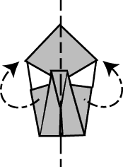
Step 7:
Fold the swan in half along the dashed line.

TIPS:
Think about what the arrows are trying to tell you....


Step 8:
Grab the swan by its little neck and pull the paper up until it looks right to you!

Then squeeze the paper at the base of its neck to crease it.

The last step is to pull up its little swan head so it looks forward... you can figure it out so I’m not going to bother to show you a picture.

Congratulations!!
You have done it!

Part II: Feedback Observations
Provide feedback using the components of the step-by-step guide. Make observations for each component in the table below.
Component | Observations
Content
- Identify the issue or performance involved.
- Provide specific of what happened.
Manner
            - Be direct when delivering your message.
            - Avoid “need to” phrases. Be sincere and avoid giving mixed messages.
            - Number of times “but,” “however,” and “although” are used.
            - In positive feedback situations, express appreciation.
            - In negative feedback situations, express concern.
            - State observations, not interpretations.

Coaching

Creating Awareness

- Self Awareness

- Self Analysis

- Self Evaluation

- Self Modification

Responsibility

- Ownership

- Commitment

- Motivation

Sample Coaching Questions∗

Assessment/Clarification
The case manager may feel the information they’ve collected as part of the assessment is ambiguous, or it may seem that they haven’t sorted through all of the information or facts. These questions can support the case manager in reaching greater clarity, as you ask them questions to further define or describe the situation.
  - What do you make of it?
  - What do you think is best?
  - How does it look to you?
  - How do you feel about it?
  - What seems to be the trouble?
  - What seems to be the main obstacle?
  - What concerns you the most about…?
  - What do you mean?
  - What does it feel like?
  - Can you say more?

Evaluation/Exploration
Sometimes it may appear that a case manager may be moving too quickly to a decision or may be arriving at a solution without enough thought. These questions can be used to slow down the pace and foster a more methodical and expanded view of the information.
  - What do you think it means?
  - What is your assessment?
  - What other angles can you think of?
  - What’s another possibility?
  - What are some other options?
  - What are other possible meanings?
  - What happens when you do…?
  - What would happen if?

Example/Elaboration
As the supervisor, you may be unclear about a case manager’s rationale for a decision or their description of a situation. The sample coaching questions for example and elaboration will prompt the case manager to provide more specific and descriptive information.
  - Will you give me an example?
  - For instance?
  - Like what?
  - Such as?
  - Will you elaborate?
  - Tell me more about it.
  - What other thoughts do you have about it?

For Instance
These questions support a case manager to engage in that own critical self-analysis to critique their own work and decisions, but in a non-threatening way. Sometimes a case manager may feel badly when the outcome is not what they intended, or just due to the urgent nature of the work that they avoid or don’t find the time to ask the “what if” retrospective questions. These examples support building self-awareness and self-evaluation.
  - If you could do it over again, what would you do differently?
  - How else could it have been handled?
  - What caused it?
  - What led up to it?
  - What have you tried so far?
  - What do you make of it?

Options/Outcomes and Planning
A case manager may have gathered a comprehensive set of information, and yet may need help in moving forward to a decision. Sometimes it’s because the case manager is not comfortable with the direction the case has taken, or the decision that the information is leading to. Other times, a case manager is uncomfortable in acting on the information that’s available because it seems that it’s not the outcome desired by the case manager.
  - What are the possibilities?
  - What are possible solutions?
  - What options can you create?
  - What do you want?
  - What is your desired outcome?
  - How will you know when you or the family has reached it?
  - What would it look like?
  - What do you want to do about…?
  - What are your next steps?
  - What support do you need to accomplish…?
  - What do you need from me?
  - What will you do?
  - When will you do it?

Probing Questions for Evaluating Child Safety

- What do we know about the parents?

- What are the risk/safety factors that affect the parents’ ability to meet the child(ren)’s basic needs and protect the child from harm?
  - Sample Probing Questions: What is the parents’ mental status? If they are psychotic or borderline personality, how does their mental illness affect their parenting? Do they use drugs or alcohol? If so, how extensive is the substance use, and how does the substance use affect parenting? Do the parents have impulse control problems? How do they manifest themselves?

- What are the strengths/protective factors in the parents?
  - Sample Probing Questions: Do they have insight into their behavior? Are they willing to work to change behavior conditions? Are there people in their lives who provide emotional support, concrete assistance, and information and advice? Do they have the intellectual capability to understand the child’s needs? Is there a parent/adult who is willing and able to protect the child in the home?

- What do we know about the child?

- What are the risk/safety factors the child presents?
  - Sample Probing Questions: How old is he/she? Does the child have any disabilities or conditions that make him/her more dependent on the care of the parents? Does the child have any behavioral, physical, mental health conditions that make him/her more difficult to care for? The vulnerability of a child can be determined by the age, physical and emotional health, development, ability to communicate needs, mobility, and size and robustness. For example, is the child dependent on others for sustenance and protection? Is the child exposed to circumstances that he/she is powerless to manage?

- What do we know about the maltreatment?
  - Sample Probing Questions: How long has it been going on? What is the frequency with which it has occurred? Has it increased in frequency and severity? If so, how? What is the nature and severity of the acts or omissions by the parent/caretaker? What are the effects on the child? How severe was the harm to the child? What is happening within the maltreatment that specifically threatens the child’s safety? Are behaviors, situations, and activities associated with the maltreatment severe in nature and likely to have a severe effect on the child? What might the effect be? Are behaviors, situations, and activities associated with the maltreatment manageable or within the control of the family or any resource available to the family? Are behaviors, situations, and activities associated with the maltreatment likely to recur in the near future?

- Tell me about the parent-child relationship. What are the strengths in the relationship?
  - Sample Probing Questions: Do the parents understand the developmental tasks, milestones, and needs for the child? Do they empathize with the child’s feelings, behavior, and condition? What types of disciplinary techniques do they use? Do the parents have realistic expectations for the child?

- What are the risk/safety factors individually or in combination that pose a risk of imminent, serious harm to the child?

- Do any of the strengths/protective factors present in the family individually or in combination mitigate against the risk factors making the child unsafe?
  - Sample Probing Questions: Which strengths/protective factors can be tapped to assure the child’s safety and how can they be used? Do the caregivers recognize threats of harm? Do the caregivers recognize the child’s needs? Are the caregivers able to develop ways to manage threats and respond to the child’s needs? Are they able to defer their own needs for those of the child? Do the parents have the skills associated with meeting the child’s needs?

- Is the child in danger right now? And, might the child be in danger within the near future?

Developing a Safety Plan
- Are there interventions/services that can be put in place to protect the child in the home? What interventions/services will effectively address each of the risk/safety factors making the child unsafe? What is the frequency and duration of interventions/services needed to control the risk/safety factors? Will the family accept and participate in these services at the recommended level?
- Do the safety interventions match the duration of the threat of harm? Do the safety interventions match the period of time when relevant protective capacities are absent? Are the safety factors accessible in time and physical proximity to the threat of harm? Will the safety interventions have an immediate effect on child safety?
- Are there relatives who are willing and able to meet the child’s needs and protect him/her from harm?
- What are the needs of the child? What are the family characteristics/
qualities/structure that can best meet the child’s needs?

Case Plan Feedback:
Coaching Techniques Observed
Observations | Coaching Technique

Comments:

Look for use of the following feedback components during the practice:

Content:  - Identify the issue or performance involved.  - Provide specifics of what happened. |  | Feedback Formula:  - Let the person see what they have done.  - Show the effect of the behavior.  - Agree on a change.

Manner:

- Be direct when delivering your message.
- Avoid “need to” phrases. Be sincere and avoid giving mixed messages.
- Number of times “but,” “however,” and “although” are used.
- In positive feedback situations, express appreciation.
- In negative feedback situations, express concern.
- State observations, not interpretations.

Comments:

Template Discussion Exercise

Select one of the following topics:

  - Physical discipline

  - Alcohol Use

  - Money

  - Education

  - Adolescent behavior

- Write down your topic for discussion:

- Briefly discuss your childhood experiences around your chosen topic. Be aware that you do not have to share more than you are comfortable sharing, and make sure that everyone in your group has a chance to share. You will have 15 minutes to discuss.

- Identify and write down one of your adult generalizations (templates) about this issue. These generalizations should only be one or two sentences and will not be posted—they are just for your own reference.

- Discuss within your group how this template might affect your own decision-making on a case brought by one of your workers.

Define Clinical Supervision

Clinical Supervision Defined

Clinical supervision focuses on the actions, responses, and decisions of the case manager in providing services to clients.

Clinical Supervision
- Always case focused
- Balances:
    - Case manager reactions and feelings/client service delivery
    - Case manager professional development/client outcome
    - Process case managers’ emotional reactions but NOT therapy
- Models commitment to the mandate of the organization (protecting children)
- Elements of support and education seek to build case manager competence
- Trust is foundational in the relationship

Source: Munson, 2002; Shames, 2006

Dimensions of Clinical Supervision

- Manage anxiety

- Focus on thinking

- Parallel process

- Context for ethical/liability concerns

- Expand empathy

- Increase Awareness

- Serve as a role model

SCENARIO – Terry, Anthony and Tia
NAME | AGE | RELATIONSHIP | ETHNICITY
Terri Ott | 30 | Mother of Children | African -American
Anthony James | 32 | Terri’s boyfriend  Father of Terri’s youngest 3 children | African -American
Tia Ott | 4 weeks | Terri and Anthony’s youngest child | African -American
Michael Carter | 35 | Father of Terri’s first 3 chidlren | African -American
Angela Carter  Jimmy Carter  Joseph Carter | 12  10  8 | Terri’s older children | African -American
Jamika Ott  Lisa Ott  Tia Ott | 7  2  1 month | Terri’s younger children | African -American
Pat James | 56 | Anthony’s mother | African -American
Gwendolyn and Wayne Franks | 48 | Tia’s foster parents (medically fragile home) | Caucasian
Monica Stokes | 26 | Case Manager | Caucasian
HISTORY:
Terri has been in residential treatment for one month, since leaving the hospital after her daughter, Tia’s birth. Tia tested positive for cocaine at birth, one month ago. Terri admits to using crack cocaine as well as drinking alcohol during her pregnancy. She admits continuing her drug usage while pregnant. She says that she was always able to stop her drug use before the birth of her other 5 children, but that this time she just could not stop. Terri was in drug treatment once before but says that it didn’t help her.
A call was made to the hotline by the hospital staff, as they were concerned that Tia’s medical condition was severe and Terri did not seem to understand the special needs of a baby who born with a heart condition and pre-natal drug exposure. Terri told the hospital social worker that she had successfully raised her 5 other children and did not think it should be a problem for her to care for Tia. Anthony, the doctor, and the Child Protective Investigator were able to convince Terri to enter a residential drug treatment program.
Terri’s older 5 children were placed with Anthony’s mother Pat James when Terri went into treatment. Pat volunteered to take the older 5 children, but was not prepared to care for a medically fragile child. Tia was placed in medical foster care home of Gwendolyn and Wayne Franks on discharge from the hospital due to her special medical needs. There were no other relatives identified at the time the children were placed. Terri was unwilling to provide information on her former paramour, Michael, or his family. The plan is for Tia and her siblings to be returned to Terri once she completes her drug treatment and can care for them. The CPI completed a risk/safety assessment for the older 5 children and found no indicators of abuse or neglect.

Drug addiction is part of Terri’s life. Her mother and grandmother were addicted and both died from their addictions. Terri was placed in foster care as a child due to her mother’s drug problem and subsequent neglect. When she was 17 years old, Terri ran away from foster care and met Michael. They never married, but were together for years, and Michael is the father of Angela, Jimmy, and Joseph. Seven years ago Terri left Michael and moved in with Anthony. She has been with him since then and Anthony is the father of Terri’s youngest 3 children.
Tia’s heart defect required surgery shortly after her birth. She continues to require extensive medical care and is considered medically fragile. The doctors could not state that Terri’s drug addiction caused Tia’s medical problems but did make it difficult to treat her due to her drug withdrawal. Tia is taken weekly to the residential treatment center for visits with Terri, Anthony, and her 5 older siblings. The visits are supervised by the case manager, Monica Stokes. Terri has always been appropriate with Tia and her other children during visits. The treatment staff report that Terri is cooperating in treatment and appears to be committed to regaining custody of all of her children, including Tia. Tia has frequent medical emergencies requiring emergency room treatment and sometimes hospitalization. Terri’s residential treatment program will allow children to move in when space is available. However the program does not have enough slots available for this large sibling group and they are on the waiting list. The program will not be able to have Tia placed in the facility due to her extensive medical needs.
Anthony has been part of Tia’s visits since she was placed in the medical foster home, and sees the other children almost daily. He has been appropriate with all of the children during the visits. Anthony works long hours and does not feel that he can handle 5 children by himself, and is in agreement with them being placed with his mother. Anthony’s mother Pat, stated that she could not handle 6 children, especially since Tia would need extensive in-home medical treatment and would need to be taken to the doctor several times a week. Her agreement to take the older 5 children was based on Anthony’s promise to assist her with them when he was not working.
A relative willing and able to care for Tia could not be found. Anthony and Terri are upset that Tia is living with strangers. They both want the family to be together as soon as possible. Anthony says that he has no problems with drug abuse, and there is no evidence to the contrary. There is no known history of Anthony ever being abusive toward any child. The 5 older children have shown no signs of abuse or neglect. Teachers of the 4 older children report that they are average students and that they appear to be connected to both Terri and Anthony. Anthony is often the parent who responds to the teachers’ notes or phone calls.

QUESTION AT ISSUE
Problem, issue
ELEMENTS OF THOUGHT
INFORMATION
Data, Facts, Observations, Experiences
INTERPRETATION and INFERENCE
Conclusion, Solutions
CONCEPTS
Theories, Definitions, Axioms, Laws, Principles, Models
ASSUMPTIONS
Presupposition, taking for granted
IMPLICATIONS and CONSEQUENCES
PURPOSE
Goal,
Objective
POINT of VIEW
Frame of reference,
Perspective,
Orientation,
Questions Which target purpose
- What is your, my, their purpose in doing________?
- What is the objective of this assignment (task, job, experiment, policy, strategy, etc.)?
- Should we question, refine, modify our purpose (goal, objective, etc.)?
- What is the purpose of this meeting (chapter, relationship, action)?
- What is your central aim in this line of thought?
- What is the purpose of education?
- Why did you say…?

Questions which target the question
- What is the question I am trying to answer?
- What important questions are embedded in the issue?
- Is there a better way to put the question?
- Is this question clear? Is it complex?
- I am not sure exactly what question you are asking. Could you explain it?
- The question in my mind is this: How do you see the question?
- What kind of question is this? Historical? Scientific? Ethical? Political? Economic? Or…?
- What would we have to do to settle this question?

Questions which target information
- What information do I need to answer this question?
- What data are relevant to this problem?
- Do we need to gather more information?
- Is this information relevant to our purpose or goal?
- On what information are you basing that comment?
- What experience convinced you of this? Could your experience be distorted?
- How do we know this information (data, testimony) is accurate?
- Have we left out any important information that we need to consider?

Questions to check your inferences
- What conclusions am I coming to?
- Is my inference logical?
- Are there other conclusions I should consider?
- Does this interpretation make sense?
- Does our solution necessarily follow from our data?
- How did you reach that conclusion?
- What are you basing your reasoning on?
- Is there an alternative plausible conclusion?
- Given all the facts what is the best possible conclusion?
- How shall we interpret these data?

Questions you can ask about concepts
- What idea am I using in my thinking? Is this idea causing problems for me or for others?
- I think this is a good theory, but could you explain it more fully?
- What is the main hypothesis you are using in your reasoning?
- Are you using this term in keeping with established usage?
- What main distinctions should we draw in reasoning through this problem?
- What idea is this author using in his or her thinking? Is there a problem with it?

Questions you can ask about assumptions
- What am I assuming or taking for granted?
- Am I assuming something I shouldn’t?
- What assumption is leading me to this conclusion?
- What is… (this policy, strategy, explanation) assuming?
- What exactly do sociologists (historians, mathematicians, etc.) take for granted?
- What is being presupposed in this theory?
- What are some important assumptions I make about my roommate, my friends, my parents, my instructors, my country?

Questions you can ask about implications
- If I decide to do “X”, what things might happen?
- If I decide not to do “X”, what things might happen?
- What are you implying when you say that?
- What is likely to happen if we do this versus that?
- Are you implying that…?
- How significant are the implications of this decision?
- What, if anything, is implied by the fact that a much higher percentage of poor people are in jail than wealthy people?

Questions to check your point of view
- How am I looking at this situation? Is there another way to look at it that I should consider?
- What exactly am I focused on? And how am I seeing it?
- Is my view the only reasonable view? What does my point of view ignore?
- Have you ever considered the way ____(Japanese, Muslims, South Americans, etc.) view this?
- Which of these possible viewpoints makes the most sense given the situation?
- Am I having difficulty looking at this situation from a viewpoint with which I disagree?
- What is the point of view of the author of this story?
- Do I study viewpoints that challenge my personal beliefs?

Foundation for Critical Thinking Online Model for learning the Elements and Standards of Critical Thinking
©2007 Foundation For Critical Thinking. - *reference material from The Thinker's Guide to Analytic Thinking

Helping Case Managers Develop Their Critical Thinking Skills
Part of your task is to support the workers in improving their critical decision making skills. Below are Characteristics of a Good Critical Thinker by Nickerson (1987).

- Uses information skillfully and impartially
- Organizes thoughts and articulates them concisely and coherently
- Suspends judgment in the absence of sufficient evidence to support a decision
- Attempts to anticipate the probable consequences of alternate actions before choosing among them
- Has a sense of the value and cost of information, knows how to seek information, and does so when it makes sense
- Applies problem-solving techniques appropriately in domains other than those in which they were learned
- Listens carefully to other people’s ideas
- Recognizes that most real-world problems have more than one possible solution and that those solutions may differ in numerous respects and may be difficult to compare in terms of a single figure of merit.
- Looks for unusual approaches to complex problems
- Can respect differing viewpoints without distortion, exaggeration, or characterization
- Is aware of the fact that one’s understanding is always limited
- Recognizes the fallibility of one’s own opinions, the probability of bias in those opinions, and the danger of differentially weighting evidence according to personal preferences
- Can strip a verbal argument of irrelevancies and phrase it in terms of its essentials
- Understands the differences among conclusions, assumptions and hypotheses
- Habitually questions one’s own view and attempts to understand both the assumptions that are critical to those views and implications of the views

Ecomap

Critical Supervision Questions to Evaluate the Quality of the Ecomap

- Is the information recorded reflecting an environmental resource which one or more family members have willingly accessed, utilized, and experienced change?

- Does the language recorded indicate that the worker engaged with the family regarding the environmental influence before recording it on the ecomap?

- Was the amount of time the family spent within the environment considered before the worker determined the environment to be considered positively or negatively influential?

- Has the worker adequately probed for information regarding the family’s expenditure of time outside the home?

- Has the worker adequately distinguished between financial and vocational environments?

- Are those environmental influences recorded in the inner circles ones that are geographically, psychologically, and financially easily accessed by family?

- Are dates and amount of time spent included in all environmental resources that have been utilized by the family in the past?

- Do all environmental resources presently being utilized by the family include amounts and duration of time?

- Does there appear to be any disagreement between the family and the worker as to the positive or negative effect of an environmental resource on the family?

Ecomap

CPS Health Extended
Care Family

Faith

Work

Family or
Household

Extended Recreation
Family

School
Friends

Genograms

Critical Supervision Questions to Evaluate the Quality of the Genogram

- Are all fathers or alleged fathers identified for all children? Has the legal status of marriage, separation, divorce been noted and dated?

- Is there a minimum of three generations recorded, including the parents of all fathers and/or alleged fathers?

- Are the birth dates or ages of children and parents included in their demographics, including siblings over 18 years of age?

- Are brothers and sisters, their spouses, and their children (of the mother and father or alleged father) included on the genogram?

- Are those living within the same household identified? Is the city and/or state of residence of all members recorded?

- Are the relationships between and among the members identified?

- Are conditions (e.g., substance abuse/alcohol, mental health, domestic violence, developmental disabilities, and physical disabilities) flagged for each individual known to have the condition?

- Are those members who have been victims of sexual abuse or those members who have sexually offended identified?

In summary, here are the four rules to build a genogram:

- The male is always at the left of the family and the female is always at the right of the family.

- In the case of ambiguity, assume a male-female relationship, rather than male-male or female-female relationship.

- A spouse must always be closer to his/her first partner, than the second partner (if any), third partner, and so on.

- The oldest child is always at the left in his family; the youngest child is always at the right in his family.
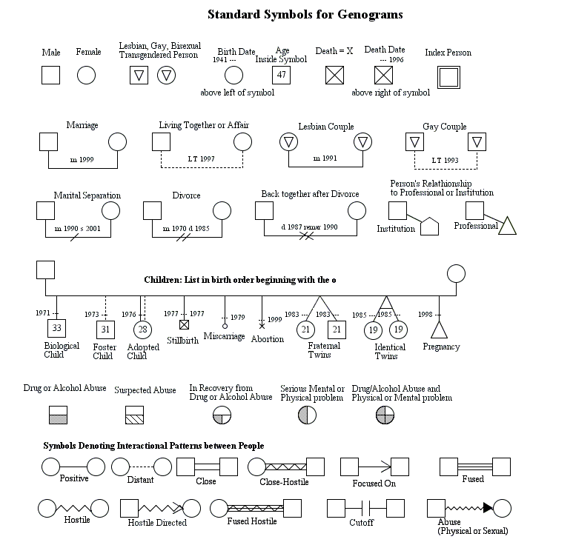
oldest

Family Mapping*

Mapping is the technique of using symbols to draw the worker’s impressions of the family relationship patterns—who is close or distant, who is aligned with whom, who has the apparent power and influence in the family, and who is in conflict with whom. It is different from a family genogram. A genogram is a multi-generational and factual picture of the family system, giving basic social information (divorces, deaths, etc.); a map is not always multi-generational, is subjective rather than factual, and gives little social history. A map includes more information than a genogram about current relationships between members.

The purposes of a map are to:

            - Organize and display our impressions of a family.

            - Help us maintain a systems focus for the counseling.

            - Indicate a broad goal for working with the family.

Here are the symbols I use and what they mean:

MAP LEGEND
Relative size of the figures indicates apparent power in the family
Female

Male

M
F
Mother

Father

14
Age (children)

or
Identified Patient
Boundary line between
parents and children
Mother has apparent power and influence (size)
Relationships are indicated by different lines between members:

Typical connection
Unacknowledged conflict
Mild conflict
Minimal connection
More connection
Enmeshed
Moderate conflict
Heavy conflict
?

Nature of relationship is unknown

What’s wrong in this picture?
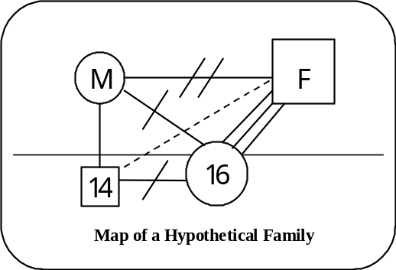
The map to the right shows conflict between the parents and a large difference in size (apparent power) between them. The older child is larger than the mother and is placed partially above the parent/child boundary, indicating too much power and influence. The father and daughter are over involved (enmeshed), and the daughter is in conflict with her mother and brother. The father-son bond is weak.

Assuming the daughter is the identified patient, the following are examples of systemic goals for counseling (while, of course, the focus is on solving the presenting problems):

            - Help the mother and father reach agreements concerning their limits on the daughter’s behavior. If mother and father are more in agreement, the father-daughter closeness will decrease. This will place the daughter in a less powerful position in the family, especially in relation to the mother.
            - Explore the father-son relationship, creating conversations (enactments) between them during the sessions. If father-son becomes more communicative, it will also decrease the father-daughter closeness.
            - Likewise, explore the mother-daughter relationship. If they become better able to communicate, the daughter-father closeness will be diminished.

A map helps us clarify what we currently believe about the family organization and what may be contributing to the presenting problem. However, it’s important to keep in mind that a map is not a fact; it is simply our subjective opinions. It’s a current working hypothesis about relationships and is subject to change as we learn more about the family.

What’s an “Ideal” Family Supposed to Look Like?

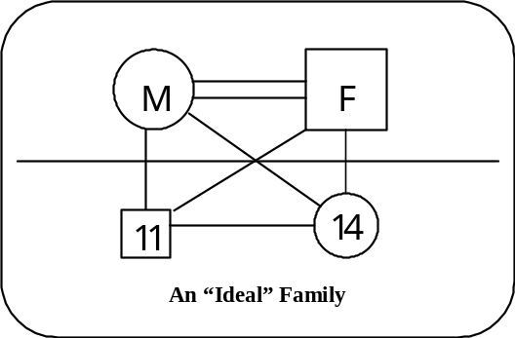
Mapping an “ideal” family reveals our assumptions about how family relationships function best. The map to the left shows the following:

            - The mother-father bond is the strongest in the family.
            - Mother and father are of equal size.
            - Children are below the parent-child boundary.
            - Children are smaller than parents.
            - The older child is slightly larger than the younger.
            - The map has no conflict lines.

Obviously, not many families look like that, certainly not all the time. It’s a model, an ideal; it gives a standard to aim for in counseling.
Family Mapping

Draw your map below.

Proactive, Structured Supervision

What is Proactive, Structured Supervision?
Proactive, structured supervision promotes an enhanced role for the child welfare supervisor to provide routine, highly structured reaction and oversight of casework practice and management. The supervisor guides workers through a systematic, frequent, clinical review of all case information with safety, permanency, and well-being as the driving forces for case activities in child welfare. Resource requirements and workload demands are considered important factors.

What are the components?
Proactive, structured supervision has four primary components:

- Structured Clinical Review includes:

- Constructing and understanding the family’s genogram, ecomap, and/or family map to provide a visual, multi-generational representation of family relationships and patterns of behavior to engage the family to visually summarize child safety, permanency, and well-being in the context of the child’s family and their environment.
- Preparing and reviewing the safety assessment/safety decision/safety plan.
- Evaluating risk assessment cluster factors such as:
- The type and degree of maltreatment of children through time.
- Child characteristics.
- Adult caregiver characteristics, including victimization of other children, psychological impairment, domestic violence, mental illness, substance abuse, assaultive behavior, abuse/neglect as a child, or delinquency as a child.
- Assessing the family’s social supports, using the family ecomap, a pictorial representation of a family’s connection to other systems or individuals in their environment that illustrates the strength, impact, and quality of the connections. The family ecomap engages the family and others to visually summarize the family’s capacity to access, use, and benefit from resources in their environment.

- Documentation of Critical Case Information includes:

- Classifying family needs. Supervisors and workers examine the capacities of families, including caregiver conditions, management of conditions through time, and their connectedness with others to categorize prognosis for change, identifies families for concurrent planning, and estimates the intensity and duration of resources they need. Families are classified as having transient needs, emergent needs, limited situational needs, or multiple needs.

- Case Direction includes:

- Case activity and time frames.
- Supervisory review dates.
- Projected permanency and closure.
- Identifying the service effort necessary to reduce risk. The supervisor and worker determine the amount of direct and indirect time that will be needed to achieve the permanency goal.

- Time and workload analysis and management is a critical responsibility of child welfare supervisors.

- Without this, children and families stay in the child welfare system too long, and caseloads are too large to allow the time to provide real, authentic family-centered casework that will achieve acceptable outcomes. Part of this supervisory process includes maintaining a balance in a frontline worker’s caseload and levels of service efforts and requires timely closure with all families.

Group Case Conferences

The group case conference is a process by which individual cases are presented by unit members, facilitated by the supervisor or an experienced unit member, with the overall goal of enhancing the professional skill level of the entire unit. Resolving individual case problems can occur—and this is a motivator for the presenter—but it is not the primary objective. Adults learn by relating new information to what they already know; in this case, the worker’s cases. The case conference allows for the deepening of the worker’s understanding of the dynamics of the specific case through comments by other unit members and the strategic injection of professional issues by the facilitator. Other unit members benefit by relating the discussion to their own cases that may have similar aspects.

Implementing Case Conferences

How to Get Started
- To be successful, the case conference should be a regularly scheduled event, just as unit meetings are. If you have staff on compressed workweeks, schedule conferences on days that everyone can be present.
- Conferences should be scheduled every two to four weeks. If possible, they should alternate with regular unit meetings at the same day and time but not be combined. Conferences should be mandatory, in the same sense that unit meetings are. Workers are extremely busy and if participation is optional, they will find other important tasks during that time. Conference times should be scheduled into worker appointment books for up to six months to minimize scheduling conflicts.
- Conferences should last between 60 and 90 minutes. These times need to be respected. Start on time. End on time.
- We recommend that the conferences be in the morning (or early in the shift) as this time is usually quieter and less stressful for workers.
- It is understood that there is wide variety in the existence of conference rooms available from office to office. Do the best that you can. Ideally, group conferences are held in a conference room that is separate from the larger (and noisier!) general workspace. If such a room is available, you should schedule it well into the future. You don’t want to be faced with an inability to hold a conference because someone else has reserved the room during your time.
- Make the conference room as comfortable as possible. Consider providing refreshments, or arrange to rotate this responsibility throughout the unit.
- To the extent possible, try to avoid interruptions. Arrange for a co-unit to provide coverage during the 90 minutes of the conference. You can return the favor for the other unit. Make sure that pagers and cell phones are turned off. Instruct the secretary/unit clerk to take messages and not interrupt the meeting.
- Schedule a meeting with your unit to discuss case conferences before you start having them. Your staff needs to know what is going on, what they stand to gain by their participation. You want all the complaints, gripes and whining to occur before you start.
- Usually only one case is presented at a conference.

Preliminary Training Issues for Workers
For the conference to be successful, workers need to know how to do certain things. Make sure that you are reasonably clear in these issues before training your staff.

- Genograms, Ecomaps, or Family Map: Workers should become familiar with basic construction for each tool.
- Case Presentation Format: Each of your staff should be given a copy of the format. You should discuss it in a unit meeting. Prior to presenting a case, you should meet with the worker to assure that they have the information needed to follow the format.
- Confidentiality: It is possible that issues may arise during a case conference that could show that a worker acted inappropriately. In discussing templates, some personal information might surface. Your unit needs to make an agreement that information shared in the group conference stays in the conference. There is no faster way to guarantee that workers will not share, take risks, or discuss problems than if the worker believes that what they say will be all over the office by the end of the day.
- “I” References: As one of the unit colleagues presents a case, other members of the unit may wish to comment on what they are hearing. There is a big difference between statements such as:

- “Why did you… ”
- “Didn’t you know… ”
- “Why didn’t you… ”

And:

- “If I had this type of case I might have… ”
- “I had good success in this type of case by… ”
- “I had a case like this and I screwed up by… ”

The point is that the first set of responses is almost accusatory and a turn off. The second set of responses offers the presenters choices on what to do where a selection can be made. The presenter is valued and unit cohesion can be built.

Preparing for the Specific Conference
- The supervisor is responsible for selecting the cases for presentation. After the conference is well established, unit members can ask permission to present cases. At first you should make the selection. We recommend that for the first conference you use your lead worker or an experienced member who is very positive in his or her outlook. Workers are often addicted to being sour about their job and lot in life. You don’t want to start the conference out on a sour note, and absolutely you don’t want to use this valuable time as a gripe session!
- After identifying the presenter and case, meet with that worker to go over the case. Share with the presenter some of the issues that you hope come out in the discussion.
- Go over the presentation format to make sure that the worker is familiar with the content for each element.
- Review the genogram with the worker and get it into a presentable form. Assure the worker that this is a learning experience and that (s)he will not be attacked or humiliated by the experience.
- It is a good idea to have a backup presentation available in the event that the worker is sick, called to court, etc.

As we all know, there are introverts and extroverts. You may find some outgoing workers more than willing to show off in the conference by presenting at each session. Conversely, you may have someone who is shy that might have the feeling that presenting a case would be the worst thing that they could think of. Use some sensitivity with both the introverts and extroverts. These conferences shouldn’t be a forum for blowhards or a horrible test for anyone. Your goal is to have a good discussion, lots of learning, and a feeling that the process is fun.

Case Conference Format

            - Discuss the players.

            - Describe the incident.

            - Review risk and protective factors.

            - Review prior interventions.

            - Discuss how to reduce future risk.

            - Discuss a focus for input from team.

Initial Assessment
Clinical Conference Questions

Case name: ___________________________________

Date:_________________________________________

CPS Assessment Staffing Between:
SSS ________________________________
Case Manager _______________________

Diversion: _____Yes _____ No

Investigation: ______ Yes _____ No

Response time met: ___ Yes ___ No

Current number of days case has been open: _________________________

Initial Allegations: _______________________________________________

History Reviewed: ______________________________________________

Impact on family and current case: _________________________________

Assessments
- Are there safety issues impacting the children? _______ Yes _____ No
    - If so, what are the safety issues?

- Are there risk factors impacting the children? _____ Yes _____ No
    - If so, what are the risk factors?

- What is the general level of violence in the family?

- What are the parental explanations – plausibility?

Relationship between type of child maltreatment, physical, sexual, emotional, etc. to:
- Child’s age? __________
- Child’s behavior?

- Child’s developmental status ____below normal ____ normal ____ above
- Frequency of abuse

- Length of time abuse has taken place _______________________________
- Nature and extent of abuse

- Child related factors:
    - Strengths

    - Vulnerabilities

Safety Responses
- Is the child safe? _____ Yes ____ No
    - What makes the child safe?

    - Where is the child safe?

      - Why can’t the child go home today?

      - Is follow up needed? ____ Yes ____ No
          - How soon? _________________________________________________

Safety Resources
            - How safe is the child?
            - How long will the child be with the resource? __________________________
                - How do we know this?
            - Is this a temporary removal? ____ Yes ____ No
            - Is there a plan to move back home? ____ Yes ____ No
            - If child can’t return home is CM discussing legal intervention?___ Yes ___ No

System of immediate protection and capability of the family to protect
- What is the parental acknowledgement/ ability of need for protections?

- Is there any evidence of denial? ____ Yes ____ No
- Are domestic violence issues present? ____ Yes ____ No
    - If yes, what are the issues?

- What is the family history of abuse, neglect or other issues?

- What is occurring differently today than when the incident occurred?

Referrals made:
Current service authorizations?

Next Steps:

Case to be completed by: __________________________________

Family Preservation
Clinical Conference Questions:

Date: _________________________________________________

Staffing between:
SSS _________________________________________________

Case Manager _________________________________________

Case has been open for ___________________ months

Household Members:

Parental Issues:

- What is their level of self-esteem?
BMo:
BFa:

- How is their relationship with significant others and caretakers?
BMo:
BFa:

- What is their knowledge of child rearing, developmental issues and how does this impact their ability to provide care?
BMo:
BFa:

- Is there an increase of decrease in parental functioning?
BMo:
BFa:

Parents current level of emotional functioning:

- Are they able to delay gratification?
BMo:
BFa:

- Are they able to nurture?
BMo:
BFa:

- Do they have impulsive or self centered behaviors?
BMo:
BFa:

- Are any significant developmental or psychological impairments present?
BMo:
BFa:

- Is there substance abuse?
BMo”
BFa:

Child Safety Risk Issues
Current Risk Level
- Based on child’s age, behavior, developmental and medical status are any safety and risk factors present?
BMo:
BFa:

- Does the child have the ability to meet parental expectations?
BMo:
BFa:

- Has abuse or neglect stopped?
BMo:
BFa:
  - If not, what are we doing?
  - If in a Safety Resource, why can’t the children go home today?

Family Issues
- Is the Family Plan/ Risk Assessment Current: ____ Yes ____ No
- Next Family Plan/Risk Assessment due date: _____________________
- Has the FTM been completed? _____ Yes _____ No Date _____________
  - If FTM not completed what is the plan to complete?
  - Target date for completion? ________________________________

  - What are the strengths we assessed and are we using them?
BMo:
BFa:

- What are the purchased services accomplishing?
    - What current services are in place?
    - Additional assessments, services and/or referrals are needed?
    - Current Service Authorization?

      - Is the family able to use extended family and community supports?
BMo:
BFa:
  - How are we promoting this to occur?

Next Steps:
      - What has the CM done to move the case forward?
      - What has occurred in the last three months?
      - What is your Supervisory Assessment of why interventions are or are not working?
      - What needs to be tried next?
      - What are specific areas CM should address in the next month?

Expected date of case completion: _____________________________

Case Review - Placement
Case name: ________________________________ Case ID#: _____________________
Review Date_________________________
Case Manager’s Name: __________________________
Supervisor’s Name: __________________________ FPS’s Name: ________________________
Date Child Entered Care: _________________________________

Does documentation indicate…………………….

Follow Up for Supervisory Directions
- Has the Case Manager followed supervisory directions and completed the assigned
tasks given from the last case review? Yes No
- If no, is this a patterned behavior for this Case Manager? Yes No

Every Child Every Month
1-30 Days
- Has the child been in foster care during the past 12 months? (Re-entry) Yes No
- Has the Case Manager reviewed the past history and documented the review? Yes No
- Did the Case Manager visit the child in the child’s current residence within 3 days of
the child’s placement? Yes No
- Did the Case Manager arrange for the child to have a medical exam within 3 days of
- entering care? Yes No
- Did the Case Manager arrange transportation, registrations, supplies, etc. for school,
if applicable. Yes No
All Reviews
- Did the Case Manager visit the child in the child’s current residence this month? Yes No
- Did the Case Manager meet with the child face to face and alone? Yes No
- Did the Case Manager assess safety of the child this month? Yes No
- Did the Case Manager assess education, medical, dental and mental health
issues with the child this month? Yes No
- Has the Case Manager made the appropriate referrals for services to the child based on
current and previous assessments? Yes No
- Did the Case Manager discuss/assess social activities with the child this month? Yes No
- Did the Case Manager discuss a connectivity activity with the child this month? Yes No

If child is 7 years old or older and developmentally appropriate this section should be completed.
- Did the Case Manager discuss the child’s case plan with the child this month? Yes No
- Has the Case Manager discussed the services with the child to determine the
effectiveness of the services this month? Yes No
- Has the Case Manager discussed permanency options with child? Yes No
- Is the child engaged in choosing a permanency option? Yes No
Youth Involvement
1-30-Days
- Is this child 14 years of age or older? Yes No
- Has a Youth Centered FTM been completed? Yes No
- Has this child been referred for ILP services and attending monthly ILP meetings? Yes No
- Does this child have a WTLP plan? Yes No
- Was the child involved in the creation of the WTLP plan? Yes No
- Has the child taken the Casey Life Skills Assessment? Yes No
Visitation
1-30 days
- Did the child visit with their parents/caregivers within 72 hours of their removal
from the home? Yes No
- Is the visitation plan entered into Shines? Yes No
All Reviews
- Has the child visited with their parents/caregivers this month? Yes No
- Has the child visited with siblings not placed with the child this month? Yes No N/A
- Has the child visited with extended family, fictive kin or friends this month? Yes No
- Has the child had visitation opportunities with the family other than the regular
visitation schedule? Yes No
- Is the family having multiple visitation opportunities in preparation for the return
of the child(ren) to the home, if applicable? Yes No

Every Parent Every Month – If TPR or VR check N/A
1-30 days
- Did the Case Manager provide the parent(s) a copy of the visitation schedule? Yes No

All Reviews
- Did the Case Manager meet with the parent(s) in their home this month? Yes No
- Did the Case Manager met with each parent face-to-face, alone this month? Yes No
- Are we working with both parents, even if both are not living in a two parent Yes No
household?
- Did the Case Manager actively searched for the absent parent(s) this month? Yes No
N/A
- Did the Case Manager discuss the family plan with the parent(s) this month? Yes No
- Do the parent(s) have an understanding of what they need to accomplish to successfully
complete their case plan and create an environment conducive to allow their child(ren) to
be safely returned to their home and care? Yes No
- Did the Case Manager discuss and explain the time line for the parent(s) completing
their case plan & the consequences of the parent(s) failure to complete the case
plan? Yes No
- Did the Case Manager discussed the effectiveness of the services provided with the
parents this month? Yes No
- Did the Case Manager discuss the foster child’s medical, dental, mental health and
educational services with the parent(s) this month? Yes No

Safety
- Is there a history of domestic violence involving either parent? Yes No
- Has the Case Manager investigated the possibility of any history of domestic
violence involving either parent in their current or past relationships? Yes No
- If identified, does documentation indicate that the extent of the domestic violence has
been assessed and appropriate services put in place within 14 working days of the
assessment, if needed? Yes No
- Has the Case Manager has assessed risk to the child if returned to parents this
month? Yes No
- Has the Case Manager visited the home and made a Safety Assessment of the
home? Yes No

Connectivity
- Does the foster child have connections with not only their family and friends, but also
with their culture, religion, or community this month? Yes No
- Has the Case Manager facilitated an exchange of photographs between child and
parents? Yes No
- Has the Case Manager invited the parents to attend the child’s medical, dental,
educational, social and mental health appointments this month? Yes No

Providers/Partners
- Has the Case Manager had contact with the Service Provider to assess the effectiveness
of the services provided to the family this month? Yes No
- Has the Case Manager received and reviewed Service Provider notes on the services
provided this month? Yes No
- Has the Case Manager had contact with Agency Partners (i.e. CASA, foster parent
- school personnel, coaches, etc.)? Yes No
- Are the services provided causing/effecting “Case Forward Movement” this month? Yes No
- Are the services provided meeting this family’s needs? Yes No

CCFA
1-30 days
- Did the Case Manager make a CCFA referral was within 3 days of the foster child
entering care? Yes No
- Date CCFA referral submitted:
- Did the Case Manager complete an informal assessment of the child and parents? Yes No
All Reviews
- Does documentation indicate receipt of the CCFA report? Yes No
- Has the Case Manager has reviewed the CCFA report and incorporated the
recommendation into the family plan? Yes No
- Has the revised family plan including the CCFA recommendation has been provided
to the court? Yes No
- Has the Case Manager has made the referral for services recommended by the
CCFA? Yes No
- Does documentation indicate an informal assessment of the child and parents was
completed by the Case Manager? Yes No
Permanency
1-30 days
- Date child was removed from the home:
- Permanency Date Deadline:
- Does documentation indicate that an appropriate permanency goal was established within in
60 days of the child’s removal?

All reviews
- Date child was removed from the home:
- Is the family engaged and actively completing their Family Plan? Yes No
- Is the Case Manager actively engaging the family? Yes No
- Is the Family Plan sufficient to facilitate permanency timely? Yes No
- Has the Case Manager carefully assessed the reasons for family’s non-engagement
and created a concurrent plan to achieve permanency timely? Yes No
- Has the Case Manager submitted a Legal Services Request to the SAAG requesting
TPR? Yes No
N/A
- Has a relative/placement resource or an adoptive resource been identified? Yes No
- Has the child been referred to the Resource Development Unit to assist in identifying
a permanent resource? Yes No
- Has the child been referred to the RAC to assist in identifying a permanent Yes No
resource?
- Was a Permanency Staffing held this month? Yes No
- Will permanency be achieved timely with the current permanency plan in place? Yes No

Family Team Meeting
1-30 days
- Was a FTM Meeting held within 9 days of the child’s removal from the home? Yes No

All Reviews
- Does documentation indicate any circumstance that would require another FTM? Yes No
- Date of the FTM Meeting:
- Was a prep interview completed and entered into Shines? Yes No
- Does documentation note the facilitator’s name, date, time and location of the Yes No
FTM?
- Were all the participants, (family and professional) invited to attend the FTM? Yes No
- Does documentation indicate who attended the FTM? Yes No
- Did the family actively participate in the FTM Case Planning process? Yes No
- Were all children 7 years old and developmentally appropriate included in the FTM
case planning process? Yes No
- Was the Family Plan submitted to the court within 30 days of the child’s removal? Yes No
- Date the Family Plan was re-submitted to the court?
- Is the Family Plan entered into Shines? Yes No
- Were referrals made to all identified Service Providers within 5 working days of the
FTM? Yes No
- Was the Family Plan submitted to the court within 30 days of the child entering
care? Yes No
- Date the Family Plan was submitted to the court?

Diligent Search
1-30 days
- Date Diligent Search is due to the Court? Date Diligent Search was submitted
to the Court?
- Was the Diligent Search submitted to the Court within 30days of the child’s removal
from the home? Yes No
- Was an Accurint Search on each identified resource attached to the Diligent Search
when submitted to the Court? Yes No
- Is the Diligent Search documented in Shines? Yes No
- Does the Diligent Search include all family members? Yes No
- Does the Diligent Search include extended family members, fictive kin, neighbors,
etc. Yes No
All Reviews
- Did the Case Manager has inquired about any additional potential placement resources
this month? Yes No
- Did the Case Manager identify any new potential placement resources this month? Yes No
- Did the Case Manager talk with the children about additional potential placement
resources this month? Yes No
- Was an Accurint Search completed on each newly identified resource and attached to the
- Was the Diligent Search attached when submitted to the Court? Yes No
- Were new additions to the Diligent Search documented in Shines? Yes No

Services to the Foster Parents
1-30 days
- Were the foster parents given form 40 at the time of the child’s placement in their
home? Yes No
- Were the foster parents given the child’s Medicaid Card? Yes No
- Did the Case Manager discuss in detail the needs, services, visits, behaviors,
medications, and other known pertinent information with the foster parents? Yes No
- Did the Case Manager ask the foster parents of any needs? Yes No
- Did the Case Manager follow up on any identified needs? Yes No

All Reviews
- Has the Case Manager made an unannounced home visit this month? Yes No
- Has the Case Manager met with both the foster mother and father this month? Yes No
- Has the Case Manager discussed in detail the needs, services, visits, behaviors,
medications, and other known pertinent information with the foster parents? Yes No
- Has the Case Manager asked the foster parents if they had any needs the Department
could assist with? Yes No
- Did the Case Manager followed up on identified needs this month? Yes No
- Has the Case Manager discussed the foster child’s medical, dental, mental health and
educational services with the foster parent(s) this month? Yes No
- Has the Case Manager discussed inviting the parent(s) to attend the foster child’s
medical, dental, mental health and educational appointments this month? Yes No
- Has the Case Manager discussed additional contacts between the foster child and the
parents, other than visitation, this month? Yes No
- Does the Case Manager have any concerns for the children in their current
placement? Yes No
- Does the Case Manager have any concerns for the children in their current
placement? Yes No

Rev Max
1-30 days
- Was the Initial Medicaid application completed and submitted to Rev Max on day 1? Yes No
- Was the IV-E application completed and submitted to Rev Max within 5 days of child’s
removal? Yes No

Next Steps:
      - What has the CM done to move the case forward?
      - What has occurred in the last three months?
      - What is your Supervisory Assessment of why interventions are or are not working?
      - What needs to be tried next?
      - What are specific areas CM should address in the next month?

Expected date of case completion: _____________________________

 Smith, D. M. & Kolb, D. A. (1986). The user's guide for the learning style inventory. Boston, MA: McBer and Company. Copyright.
 Smith, D. M. & Kolb, D. A. (1986). The user's guide for the learning style inventory. Boston, MA: McBer and Company. Copyright.
 Smith, D. M. & Kolb, D. A. (1986). The user's guide for the learning style inventory. Boston, MA: McBer and Company. Copyright.
 Kolb, David A. (2000). Experienced Based Learning Systems, Inc. Boston, MA: Hay/McBer Training Resources Group. Copyright.
 Smith, D. M. & Kolb, D. A. (1986). The user's guide for the learning style inventory. Boston, MA: McBer and Company. Copyright.
 Smith, D. M. & Kolb, D. A. (1986). The user's guide for the learning style inventory. Boston, MA: McBer and Company. Copyright.
* © Institute for Human Services, Columbus Ohio. Reproduced with permission.
 Broad, M. L. & Newstrom, J. W. (1992). Transfer of training: Action-packed strategies to ensure high payoff from training investments. MA: Perseus Books.
 Curry, D., Caplan, P. & Knuppel, J. Transfer of Training and Adult Learning (TOTAL).
 Zachary, L. (2000). The mentor’s guide. San Francisco, CA: Jossey-Bass.
 Zachary, L. (2000). The mentor’s guide. San Francisco, CA: Jossey-Bass.
 Zachary, L. (2000). The mentor’s guide. San Francisco, CA: Jossey-Bass.
 Zachary, L. (2000). The mentor’s guide. San Francisco, CA: Jossey-Bass.
 Zachary, L. (2000). The mentor’s guide. San Francisco, CA: Jossey-Bass.
 Adapted from Whitmore, L., Kimsey-House, H., & Sandahi, P. (1998). Co-Active Coaching. Palo Alto, CA: Davies-Black Publishing.
* The original source for this material was: Child Welfare Training & Research Project, University of Denver. (n.d.). New Worker Core Training. Denver, CO: Author.

