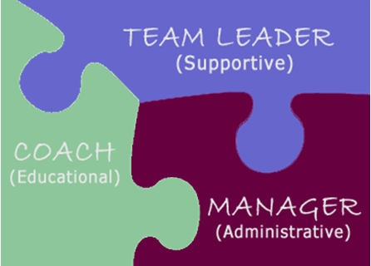
Supervisor Capacity Building: Putting the Pieces Together

The Educational Supervisor

During your classroom experience this week, you were introduced to your role as an Educational Supervisor. Educational Supervision is concerned with educating the case manager for a more skilled performance of their tasks.
Typically, three primary factors can result in non-performance:
- Organizational barriers;
- Lack of knowledge and skills; and
- Personal barriers
These reasons correlate with the Kadushin framework for supervision: Administrative, Educational, and Supportive Supervision. In this Skills Building, we will address the lack of knowledge and skills.

The “Coach” 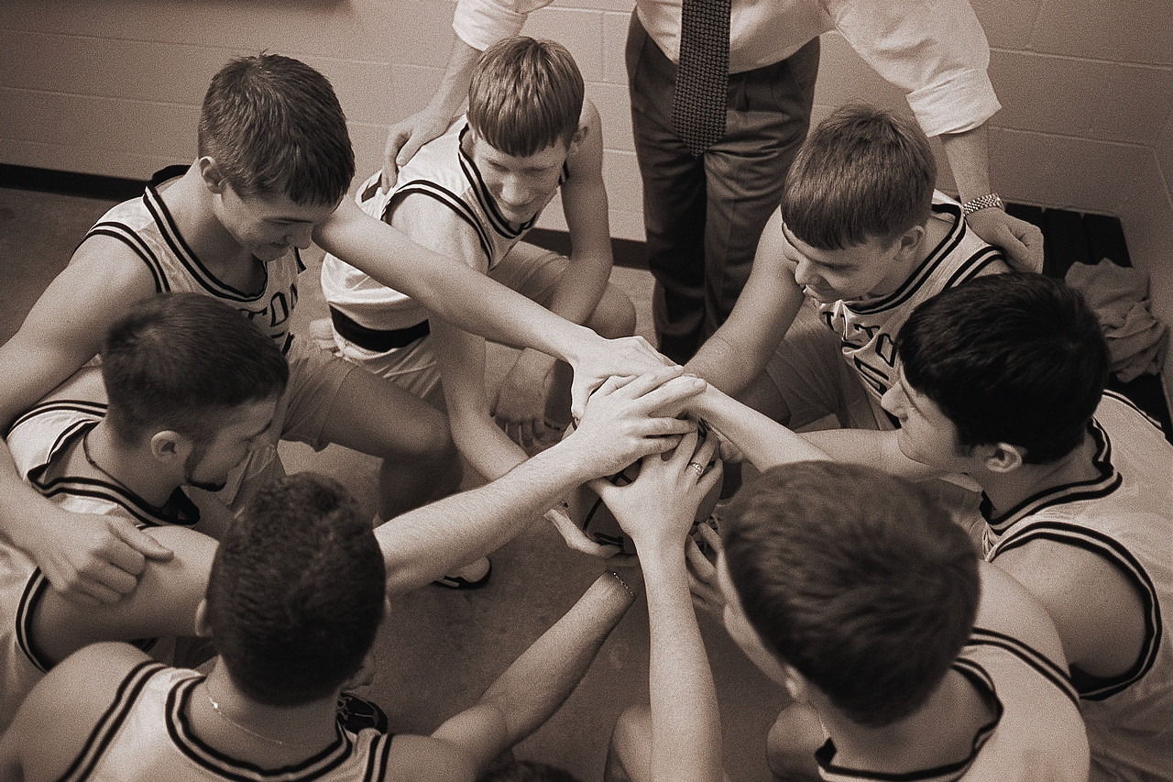

In the Administrative Skill Building activity you identified underlying culture beliefs that impacted performance outcomes. In this section, you will demonstrate how the Coach can influence the team attitude.
“A good coach will make his players see what they can be rather than what they are.”
-- Ara Parasheghian
Consider ways in which you can begin to change the culture; “ways that you can help Case Managers see what they can be rather than what they are.”

PEAS & KAROTS are trainings designed to be delivered by you with your unit during a unit meeting. As part of your role as a COACH, you will complete a PEAS & KAROTS with your unit. You may select a module from the Education and Training website.
ETS Website - http://www.dfcs.dhr.georgia.gov/training
Click on ELearning and select PEAS & KAROTS. Select a module that has not previously been covered with your unit. Contact Margaret Baklini (at mabaklini@dhr.state.ga.us) If your unit has completed all the modules posted.
Record your thoughts and experience in your Journal.
Discuss this information with your mentor.

The Mentor 

In your classroom discussion, a Mentor was defined as:
- Anyone who has an important, long-lasting beneficial life- or style enhancing effect on another person, generally as a result of personal one-on-one contact (regardless of the media used).
- One who offers knowledge, insight, perspective, or wisdom that is helpful to another person in a relationship that goes beyond doing one’s duty or fulfilling one’s obligations.

“The boss drives people; the leader coaches them. The boss depends on authority; the leader on good will. The boss inspires fear; the leader inspires enthusiasm. The boss says ''I''; The leader says ''WE''. The boss fixes the blame for the breakdown; the leader fixes the breakdown. The boss says, ''GO''; the leader says lets, ''GO!''
H. Gordon Selfridge

Review the Stages of Worker Development you completed in your classroom instruction. You were asked to assign a stage of development for each worker.
- Does your assessment of development agree with each individual?
- Do you clearly understand how well each case manager is functioning in that area?
- Do you feel that better outcomes are the result of case managers performing at the Middle and End Stages?
- What are the training needs of each of your case managers?
- What does each case manager need from you?
- Do you still agree with your mentoring strategy you identified in the classroom activity for each Case Manager?

Facilitate a minimum of one mentoring activity with a Case Manager.

Record your experience in your Journal.
Discuss the outcome of this experience with your mentor.

The Clinical Supervisor 

Clinical Supervision can be defined as an intense session of group or individual supervision.
Clinical Case Conferencing is the transfer of learning between the supervisor and Case Manager through reading, questioning, observation, mentoring, evaluation, guidance, direction and feedback of casework practice. It considers the dynamics and characteristics of individuals, families and their interaction in the social environment in which the need for Child Welfare intervention exist.
A delicate balance exists between true “mentoring” and giving directions to staff for compliance. A major pitfall for new supervisors is to play the role of “secondary” worker instead of that of “Clinical Supervisor”. Be aware of this pitfall during supervisory conferences.
Remember that your role is to ask questions that shape your case managers’ thought processes as good critical thinkers. The goal is to develop your staff to come to their own conclusions rather than always giving them the answers up front. Good mentoring skills play an important role in staff satisfaction and retention.

Ferdinand Fournies, an expert in the field of coaching implies the following:
“Information transmission equals compliance-Thought transmission equals Commitment”

Consider this comment and jot down any thoughts you have in your learning journal. Discuss with you mentor and also ways you plan to develop your clinical supervisory skills.

Ask yourself the following questions to help your Case Managers grow in his/her ability to utilize critical thinking.
  - What information do you need from case managers during supervisory conferences in order to have confidence in the assessment of that Case Manager’s performance?
  - How can asking the right question increase the Critical Thinking skills of the Case Manager?
  - Is the information gleaned during your conference evidence based?
  - Does it reflect that the right work is being done in order to achieve positive outcomes for families and children?

Develop a staffing template using the following questions that you will use during your clinical case conferencing that will challenge the Case Manager to use critical thinking. Your county office may have a conferencing form already available for you to use. Whatever staffing form you use, be sure that vital information is covered during your conference. This is your key to evidence based, results oriented outcomes for our families and children.

Use the following questions as a foundation when developing your conferenceing template:
Please note that questions 1-6 are risk based questions that help you determine risk and safety to a child. Questions 7-13 are designed to helop you determine movement in a case towards risk reduction. You can also use the questions in our current SHINES Risk assessment as a basis for oyur template.
- Maltreatment: What is the extent of the maltreatment
Explaining the nature and extent of the maltreatment should include:
  - Type of maltreatment
  - Severity of the maltreatment, results, injuries
  - Maltreatment history, similar incidents
  - Describing events, what happened, hitting, pushing
  - Describing emotional and physical symptoms
  - Identifying child and maltreating parent

- Nature: What circumstances accompany the maltreatment? Duration of maltreatment; Primary Caretaker reaction
Answering this question includes:
  - How long has the maltreatment been occurring (isolated or ongoing)
  - Use of an instrument
  - Parental intent concerning the maltreatment
  - Whether parent was impaired by substance use, or was otherwise out-of-control hen maltreatment occurred (mental health status)
  - How parent explains maltreatment and family conditions
  - Does parent acknowledge maltreatment, what is parent’s attitude?
  - Is the explanation of the incident plausible?

- What are overall parenting practices?
Find out:
  - Reasons for being a parent
  - Satisfaction in being a parent
  - Knowledge and skill in parenting and child development
  - Parent expectations and empathy for child
  - Decision-making in parenting practices
  - History of parenting behavior
  - Protectiveness
  - Cultural context for parenting approach

- How does the Primary Caretaker discipline the child?
Find out:
  - Disciplinary methods
  - Concept and purpose of discipline
  - Context in which discipline occurs, is the parent impaired by drugs or alcohol when administering discipline
  - Cultural practices

- How does the child function day-to-day?
Include the following information about the child compared to other children of their age:
  - Capacity for attachment (close emotional relationships with parents and siblings)
  - General mood and temperament
  - Intellectual functioning
  - Communication and social skills (peer relationships)
  - Behavior
  - School performance
  - Independence
  - Motor skills
  - Understanding safety threats
  - Physical and mental health (emotions/feelings)

- How does the Primary Caretaker function day-to-day?
Discover:
  - Social skills
  - Coping and stress management
  - Self control
  - Problem-solving
  - Judgment and decision-making
  - Independence
  - Employment (home and financial management)
  - Community involvement
  - Self-care and self-preservation
  - Substance use, abuse, addiction
  - Mental health (rationality)
  - Physical health and capacity
  - Functioning within cultural norms

- What is the Primary Caretaker’s capacity to change in regards to the presenting/underlying issues identified?

- How are the services being offered promoting positive outcomes?
- How does the Primary Caregiver view the progress?

- What has occurred in the last three months to facilitate Outcome Measure?

- What specific activities has the Case Manager done as a Change Agent since the last conference?

- What is your Supervisory Assessment of why interventions are or are not working?

- What interventions need to be tried next?

- What specific activities should the Case Manager address in the next month?

Conduct a minimum of one Clinical Conference with a Case Manager.
Record your experience in your Journal. Be sure to document the results of your conference.
Review your experience with your mentor. Discuss what changes if any, need to be made to your template to facilitate evidence based practice?

 The Supervisor as time manager
preparing for Unit 3: Supportive Supervsion

One of the most important supportive supervisory functions is that of time management. How can we help our staff manage their time if we have difficulty managing our own?

In Unit 3, our final week of the “Putting the Pieces Together”, we review the importance of time management and a few steps you can take as a manager to take better use of your time.

Before we discuss time management practices, we need to be aware of how we use our time and if it results in productive activity. The next Skill Building activity is designed to help you develop self awareness so that you more effectively manage your workload.

After all, we only get 24 hours a day, no more-no less.

Where did the time go?

Time log guidelines:

Complete the time log sheet set out on the next page for one ‘typical’ day. This is the minimum preparation necessary for you to gain some useful insights into how you use or spend your time during a ‘typical’ day.

The time log sheet provided should help you to see more clearly the difference between what you think is happening and what is actually happening regarding how you spend your time.

Completing your time log may slow you down or even seem like a chore. However, it is just for one day and you do not need to repeat this recording activity unless you want to.

Break your day into 30-minute chunks for recording purposes. Review after each batch of three or four chunks.
At the end of every section, summarize the time spent.

Evaluating the results

What conclusions have you drawn from analyzing your time log? Are there any surprises? What do they show or confirm?

Look for time-wasters: are these under your control or someone else’s? For example, ask yourself the following questions in the light of your time log results:
- Did I do everything I needed to do? Was I often rushed?
- When was I most/least productive? Where did most of my time go?
- How much time could I use better?
- Did I accomplish the most important things?
- Did I have enough time to do the things I wanted?

Identifying changes needed

Identify the following:
- Activities that were of little benefit or value
- Specific problems that kept you from using your time well
- Personal behavior on your part that made it difficult to use your time wisely
- Any imbalances in your life (e.g. Work vs. Leisure; time on your own vs. Time with others)
- Where you can make more time for yourself to do the things you want to do

Discuss this activity with your mentor and document your conversation in your Learning Journal.
Please bring your time log to the Unit III session.

Time Log
Name____________________________ Date__________________________
Time | Reading/ Writing | Interruptions | Chat | Phones IN | Phones OUT | Meetings | Work | Emails | Other: Specify
8:00
8:30
9:00
9:30
10:00
10:30
11:00
11:30
12:00
12:30
1:00
1:30
2:00
2:30
3:00
3:30
4:00
4:30

