Promoting Informed Decision-Making in the CPS Response
Purpose | To strengthen the ability of supervisors to use supervisory functions, SET behaviors and leadership styles, to bring about informed decisions by staff implementing the CPS response.
Rationale | In New York State’s child welfare system, the safety of children, the identification of any current abuse/ maltreatment, and the risk of future harm are necessary areas of inquiry. These areas of responsibility, under the leadership of the CPS supervisor, require the implementation of processes and procedures designed to produce good decisions. Good decisions are those that are based on an accurate understanding of the facts in each case and achieve a desired outcome, e.g., an accurate safety decision and a realistic risk assessment. Gaining such understanding necessitates the disciplined collection and analysis of specific types of information. For workers to satisfy these standards, supervisors must strategically carry out their supervisory functions, SET behaviors, and a flexible leadership style to promote their workers’ development as informed decision-makers.
Enabling Abilities | Participants will be able to:  Cognitive  - describe how to use SET behaviors to enhance the decision-making ability of the workers in their unit throughout the CPS Response  - explain informed decision-making  - identify five steps to becoming an informed decision-maker  - explain the phases of developing multiple hypotheses  Affective  - value the identification of strengths and errors related to the decision-making process  - appreciate the need to develop multiple hypotheses as part of informed decision-making  Operative  - assess strengths and errors in the decision-making process of their workers  - utilize SET behaviors with workers to strengthen their ability to make informed decisions
Materials | Handouts, Informed Decision-Making, James Gibson (and Trainer’s Key), Common Errors of Reasoning, Common Decision-Making Errors, Intake Report: Julie Brown, Sheila Fleck (and Trainer’s Key), Five Steps to Becoming an Informed Decision-Maker, Developing Multiple Hypotheses, Questioning Our Workers’ CPS Response; worksheet, Promoting Sheila’s Informed Decision-Making (and Trainer’s Key); PowerPoint slide, Abilities (PPT Slide #1).
Time | 180 minutes.

Learning Process
Integrative Statement: We’ve reviewed components of the CPS Response. We’ll now concentrate on improving the decision-making process of your workers during the CPS Response.

Introducing informed decision-making | Display and review PowerPoint slide #1, Abilities (PPT Slide #1). Elicit and respond to any questions or comments participants may have regarding the abilities.  Instruct participants:  - Read the handout, Informed Decision-Making.  - Now, read the handout, James Gibson, and decide whether he is on a path to make informed decisions with this case.  Comment: It is anticipated that participants will answer negatively.  Ancillary instruction:  - Elicit from participants the evidence they have that James Gibson both is and is not currently involved in the process of making informed decisions in this case.  - If not addressed by the group, point out the extremely inappropriate bias James has verbalized toward Native-American culture and the need for this problem to be confronted by the supervisor with James.  - Ask participants, “How would you as the supervisor address this significant negative cultural stereotype with James?”  Discuss:  - If James were making informed decisions, what would the resulting success look like?  - Do you see any errors in James’ decision-making process? If so, what are they?  Ancillary instruction:  - Record participants’ responses on the flipchart.  - Provide feedback to supervisors’ on their responses.  Reminder: A trainer’s key has been provided for support.  - Do you see other types of errors being made in child protective services that produce less-than-informed decisions and frustrate you?  Ancillary instruction: Add these responses on the flipchart associated with the errors made by James Gibson.
Identifying errors in decision-making | State:  - Based on your observation of James Gibson and your own experience in the field of child welfare, you’ve identified a host of errors. All of these errors undermine our ability to complete assessments in a timely, comprehensive, and objective manner. This, in turn, impedes our progress toward realizing the child welfare outcomes of safety, permanency, and well-being.  - You are not the only ones in our field who have identified such errors.  Ancillary instruction: Refer participants to the article, Common Errors of Reasoning, by Eileen Munro.  - In this article, Dr. Munro points out that mistakes such as these made by workers during the CPS Response can be minimized or eliminated if workers learn and practice a disciplined approach to gathering and evaluating information.  Ancillary instruction:  - Encourage participants to read this article before tomorrow to discover and address any questions they have as a result of reading it.  - Remember to check in with them after they have had an opportunity to read the article.  - In addition to the common errors identified in this study, other common errors in decision-making have been identified through case record reviews in New York State.  Instruct participants: “Read the handout, Common Decision-Making Errors, and place a check mark next to those errors you have not seen in the field.”  Comment: It is anticipated that few errors will be checked, underscoring their common nature.  Ancillary instruction:  - Elicit examples of the errors participants see in the field.  - Invite them to identify any consequences that result when workers make these types of errors.
Becoming an informed decision-maker | Explain:  - The need to make informed decisions is rooted in the values of the mission guiding our work as it relates to achieving our outcomes of safety, permanency, and well-being.  - We are legally and ethically mandated to conduct our work in a manner that will achieve these outcomes.  - In order to accomplish this, all workers and supervisors must be committed to making and able to make informed decisions.  - The safety and well-being of families and our own security, growth, and self-esteem needs all get a boost when we reduce errors and realize the positive impact of improved decision-making on CPS investigations/assessments. Think of recognizing errors as a measure of our vision, our values, and our continuous development, not our failure.  - Your role as supervisors is to implement the supervisory functions, SET behaviors, and leadership styles to bring about the preferred alternative future of informed decision-making.  Refer participants to the handout, Five Steps to Becoming an Informed Decision-Maker.  Refer to Step One: Adopt These Attributes.  Ask:  - Are your workers more likely to start out with these attributes when they join your units and then show decline in them, or vice versa? How do you account for this?  - How important are these attributes to becoming an informed decision-maker?  Instruct participants:  - Read Step Two, Recognize and Avoid Critical Mistakes and Pitfalls, and check off the ones you see in your unit.  Ancillary instruction: Elicit examples from participants of the items they checked off.  Example: The worker assumes the report narrative is accurate and therefore, constitutes abuse or maltreatment and focuses the investigation on proving this. Conversely, based on a prior history of unfounded determinations, the worker believes the current report, like the earlier reports, is not accurate.  - Some interesting factors contribute to the failure to revise existing assessments:  Ancillary instruction: Ask participants: “How might the comments you make about a family when assigning an investigation impact the first impressions of an inexperienced worker?”  Comment: Any comments a supervisor makes about a family, whether positive or negative, will likely influence the worker’s pre-engagement anticipation of the family, which may bias the worker and influence the development of the professional helping relationship and the accuracy of assessments.  - Step Three, Identify and Characterize Child Welfare Issues/Problems, reminds us of the importance of assessing underlying conditions, contributing factors, and strengths on an ongoing basis against established standards defining safety, current abuse/maltreatment, and risk.  - In addition to workers assessing these conditions and factors, supervisors must also be conscious of whether the underlying conditions and contributing factors of workers may be undermining their ability to be objective.  - One of the most helpful perspectives a supervisor can impart to a worker is to ask the worker to always consider, “Is this situation a problem for me, or is it a child welfare issue?” Does a behavior or condition impact child safety? Current well-being? Risk of future harm? Has anything changed since my last contact with the family?”  - Affirmative responses to these questions should lead to further assessment: “What underlying conditions or contributing factors are creating or sustaining the problem? What strengths are available to ameliorate the problem? What are some ways I can access the information I need or the resources the family needs?”  Ask: “Give an example of how a strength, underlying condition, or contributing factor, once understood, has influenced your or a worker’s decision.”  Refer to Step Four: Evaluate the Information Sources.  Explain:  - This step points out how making informed decisions cannot be done without important and accurate information related to any decisions that must be made.  - It contains questions that should be routinely asked in order to increase the probability of the information’s accuracy and relevance.  - For example, in training, new CPS workers often describe the process of contacting collateral resources during the investigation as simply “calling the doctor and the school.” When asked why these collaterals are contacted, a frequent response is that the worker is “required” to contact them.  - Of course, contact with school personnel and the child’s medical caregiver can often provide valuable assessment information during a CPS investigation. Of concern is the belief by many new workers that these are the ONLY collateral resources they need to contact.  - When queried about how relevant these resources would be if the investigation takes place during summer recess, and if the child, at 13, hasn’t seen the physician since a basketball physical last fall, many new workers are at a loss.  - This demonstrates the robotic approach to casework that supervisors need to help workers avoid. Instead, we need to help them to learn, think, and act in ways that will lead to informed decisions.  Ancillary instruction: Ask participants: “What are some questions pertaining to collateral contacts during the CPS response that you want your workers to consider?”  Example:  - Does the source of the information have the necessary knowledge or level of understanding of the family’s current circumstances to help me with my investigation?  - Does the information source have any motive for being inaccurate, biased or misleading?  - Are there any reasons to question the honesty or integrity of the information source or the information itself, and, if so, what are they?  - How does the information source come by his/her information (e.g., first hand involvement with the family, or other)?  - Is one information source contradicted by another? Verified by another?  - What other information resources do I need to access?  Refer to Step Five: Evaluate Decisions.  State:  - This step presents a series of questions to increase the probability of producing informed decisions.  - A central value in all of this is truth, which ought to be a value in all of our units.  Ancillary instruction: Ask: “How do you help your workers evaluate the truth, relevance, fairness, completeness, significance, and sufficiency of the evidence to support their decisions?”  - The communication of expectations is also useful in this step.  - Often, newer workers have a strong need to be given explicit instruction. Many of them want to be told, “Do A, then B, then C, in that order.”  - The temptation, often because it is easier or faster in a hectic environment, is to do just that, state, “do this and this, then this,” with no explanation of how those tasks may help the worker understand something relevant about the family, or what to do if “A” and “C” are available, but not “B.”  - Effective, efficient supervision entails helping workers to use informed decision-making skills during the CPS Response, so they can gather all the information available, consider all possible options, and not grind to a halt because they didn’t know what to do when a step in the “list of to-do’s” they were instructed to accomplish didn’t work or was unavailable; or because they don’t understand the intent behind the action, they don’t know how to use other methods.  Example:  - #1: A worker states that he has been unable to assess the home environment because the mother won’t let them into the kitchen.  - #2: One of the children named on an SCR report is not home at the time of the initial contact by CPS. The child, a 13-year-old girl, is playing in a soccer game across town. The parent states and a sibling independently verifies that the girl attended school today and is at the game. The source of the report is the school nurse who saw the child today at school. The worker is insisting that the mother divulge the location of the game and the child’s jersey #, as she is required to interview the child today to assess safety. The mother refuses to provide the information, requested that the worker return tomorrow to see the child.  - In such situations, it is important that you convey the message that you, as the supervisor, welcome their questions and concerns, and in order for you to respond effectively they have to express them.  - The following questions reflect expectations that should be made clear to workers and monitored through discussion at case conferences and case record reviews:  - With regard to child protective issues, have all plausible explanations been addressed, or dropped as implausible, based on current information?  - Go where the evidence takes you. Have all relevant collateral contacts been utilized? Refrain from making decisions until all available evidence has been gathered and evaluated.  - Is there any remaining ambiguity, key unanswered questions, or contradictory evidence needing re-examination?  - If so, how does the missing or contradictory information impact the credibility of any decisions made? How can the issue of missing or contradictory information be resolved?
Reconsidering multiple hypotheses | Explain:  - We just mentioned that the CPS Response, under your supervision, can only be a worthwhile and effective response to the circumstances of children and families warranting our involvement if it is cemented in truth.  - Informed decision-making means informed by truth, i.e., accurate and relevant information.  - One skill related to informed decision-making that is already being taught to CPS workers in the specialized training they attend following the completion of Common Core is called developing multiple hypotheses. This skill is also a task incorporated into the CPS Response.  Ancillary instruction: Refer to the handout, Developing Multiple Hypotheses.  - By systematically developing multiple hypotheses regarding the assessment decisions we are required to make, the probability of making informed decisions mightily improves.  Instruct participants:  - Let’s do a quick exercise to focus on the need for the development of multiple hypotheses.  Ancillary instruction: Refer to the handout, Intake Report: Julie Brown.  - Your task is to generate as many possible plausible explanations as you can for the information contained in the report narrative.  Ancillary instruction: Elicit participants’ possible explanations and post these responses on the flipchart.  Example: Child was, in fact, injured during an altercation between mother and child’s father; child and mother were injured in an automobile accident; mother’s injuries are unrelated to child’s condition, which could be Mongolian spots; mother may be suffering from an illness and discolorations are not black eyes; someone other than the mother could have injured the child; the “relationship problems” may not be violent.  Ask:  - What additional information do you and your worker need in order to support or refute a given hypothesis in the Brown case?  - How would you coach your worker to go about gaining this information?  State:  - There are many explanations, or hypotheses, you could develop and have your worker pursue based on the report alone.  - Your coaching on this issue should always include determining who might have access to the child, opportunity to harm the child, or opportunity to place the child at risk of harm.  - As new information is gathered, the hypotheses might need to be changed.  Ancillary instruction: Remind participants of their reading, Common Errors of Reasoning.  - Eileen Munro’s important research has shown that it is difficult for workers to change their reasoning even when there’s new evidence of a major flaw in the decision-making process.  - In other words, because workers tend to hold on to their beliefs and perceptions no matter what, informed decision-making is abandoned.  - As supervisors, we must be vigilant regarding whether workers are making informed decisions; we must also be aware of whether our own decisions are informed ones.  - For example, we need to remember that developing multiple hypotheses isn’t limited to confirming or disconfirming the report allegations.  Ancillary instruction: Ask: “What other aspects of the CPS response do you want workers to seek out and consider all related plausible information?”  Example:  - The current safety status of all children in the household.  - Whether the identified alleged subject had the access and opportunity to abuse/maltreat the child.  - Whether a different person or additional persons may have abused/maltreated the child.  - Whether other children in the home may be abused/ maltreated or at risk of abuse/maltreatment.  - Whether children in the home are being abused/maltreated in ways that are not identified in the SCR Report.  - The identification and utility of resources/services to effectively assist the family.  - Reasons for contradictory information between information sources.  - One of the major advantages to thinking in this manner is that it forces the worker to continuously evaluate information against identified hypotheses, which helps in maintaining objectivity.  - Another advantage is that it forces an examination of information that seems in conflict with other information.  - As supervisors, your expectation must be made clear that in these situations the workers are to determine the reason for any incongruence. You need to ask questions such as:  - Is it simply a matter of gathering more complete information that would resolve the discrepancy?  - Does the worker need to reconsider existing decisions and the quality of the information used to make these decisions?  - Does the worker have a bias that is undermining the need to make an informed decision?  - By exploring alternative hypotheses, and therefore other areas of inquiry and possibly other collateral contacts, during formal supervision time with a worker, the supervisor can model this thinking process, then monitor performance, and provide feedback and coaching during subsequent supervision regarding the worker’s follow-up on these issues.  - Furthermore, as supervisors, you need to be confident that workers understand the intent of the decisions they are being instructed to make and are clear about not only the decisions, but your expectations as to the most effective ways to arrive at informed decisions.  - By teaching workers the steps of informed decision-making, they become more capable of and more likely to make good, defendable decisions based on the information available to them, and are not at a standstill until they can communicate with you to obtain further direction.  - There may be a variety of reasons why a worker may not be accomplishing various aspects of the job to the degree a supervisor expects.  - When this occurs, it’s incumbent on the supervisor to determine the reasons why. In supervisory terms, monitoring the worker’s use of multiple hypotheses can help inform you about more than just the worker’s strategies. Considering alternative explanations can also be helpful in assessing the clarity and concreteness of your communication to the worker.  - If expectations have been communicated but not met, the first response should be to question the efficacy of the communication.  - The concept of multiple hypotheses can be modeled by the supervisor as an approach to understanding the problem. Ask yourself:  - Is the worker unclear about my expectations?  - Is it possible I wasn’t as specific as I thought I was?  - Does the worker want to meet expectations but doesn’t have the capability in a certain area, or is s/he capable but not willing to act as instructed?  - Is the worker reluctant to seek the information or take the action expected due to worker safety concerns?  - Considering alternatives in this way can assist you in determining the most effective way to intervene with the worker.  - The handout, Questioning Workers’ CPS Response, can help aide you in this process.  - The handout links SET behaviors with the development of multiple hypotheses, all in support of informed decision-making.  Ancillary instruction: Tell participants to read the handout and elicit any questions or comments.
Supervising the development of multiple hypotheses | Instruct participants:  - Let’s put together everything we’ve just learned about common errors in reasoning and informed decision-making, including the need for the development of multiple hypotheses.  Ancillary instruction: Have participants return to their small groups.  - Individually read the handout, Sheila Fleck.  - With your group, underline all the errors in decision-making that you see.  - Use the handout, Common Decision-Making Errors, for support.  - Then complete the worksheet, Promoting Sheila’s Informed Decision-Making.  - Use the handouts, Developing Multiple Hypotheses and Questioning Our Workers’ CPS Response, to support your efforts.  Ancillary instruction:  - Elicit Sheila’s errors and record these on the flipchart. Provide feedback as indicated.  - Elicit participants’ responses to the worksheet and provide feedback as indicated.  Reminder: A Trainer’s Key has been included to support the discussion.
Summary points | Conclude:  - Informed decision-making is a logical, rational thought process that is able to be applied by most people. Every supervisor and worker needs to be able to make informed decisions in all child protective services cases.  - Informed decision-making skills can be modeled and coached by supervisors in order to enhance workers’ competency in this area of their work.  - Infusing the cognitive process inherent in the use of multiple hypotheses into the CPS Response helps to avoid reliance on personal biases or in prejudging families, by requiring a constant re-examination of information and subsequent decisions and by providing a supportable basis for case decisions.  - This approach to decision-making can be used by a supervisor to monitor performance, provide feedback, to consider the clarity of their communication during supervision, and to coach their workers in their use of this skill to secure better outcomes for children and families.
Postlude: No where is informed decision-making more important than in relation to the outcome of safety. We will focus on that next.

Abilities (PPT Slide #1)
Participants will be able to:
Cognitive
- describe how to use SET to enhance the decision-making ability of the workers in their unit throughout the CPS Response
- explain informed decision-making
- identify five steps to becoming an informed decision-maker
- explain the phases of developing multiple hypotheses
Affective
- value the identification of strengths and errors related to the decision-making process
- appreciate the need to develop multiple hypotheses
Operative
- assess strengths and errors in the decision making process of their workers
- utilize SET behaviors with workers to strengthen their ability to make informed decisions

What is informed decision-making?
Informed Decision-Making
Informed decision-making can be described as a logical, rational thought process that most people are capable of applying. To make such decisions, you need to: identify a question, formulate an hypothesis, seek out and gather relevant information, and evaluate the information to determine if it supports the hypothesis. This process allows you to eliminate inaccurate hypotheses, identify new hypotheses, and draw reliable conclusions. Making informed decisions requires you to reason, reflect, and respond to information and situations in a focused, structured, and objective manner. Doing so allows us to make decisions about the lives and behaviors of families involved in the CPS Response, and to do so with awareness of the assumptions upon which those decisions are based.
You and your workers need to use this method in every aspect of your practice, from receipt of the intake information through every aspect of information-gathering and every decision point: face-to-face response, safety, safety planning, managing for safety, assessing current abuse/maltreatment, risk, determination, and open/close for services.
Necessary skills
Someone effective in making informed decisions is able to do the following:
- Evaluate evidence objectively and use it to draw valid conclusions.
- Organize thoughts and articulate them concisely and coherently.
- Distinguish between logically valid inferences and those that are logically invalid.
- Temporarily suspend judgment in the absence of sufficient evidence to support a decision.
- Understand the difference between reasoning and rationalizing.
- Develop multiple hypotheses, each of which brings alternative causes, actions, and/or consequences into consideration.
- Apply problem-solving techniques in domains other than those in which they were originally learned.
- Identify all the essential elements included in a particular line of reasoning.

- Habitually question his or her own assessment, consider multiple hypotheses, and attempt to consider all associated case implications.
Informed Decision-Making
- Be cognizant of and sensitive to the difference between the validity of a particular belief and the intensity with which it is held.
- Maintain an awareness of the fact that his or her personal understanding is always limited.
- Recognize the fallibility of personal opinions, the probability of bias in those opinions, and the danger of weighting case evidence in the decision-making process according to strictly personal viewpoint.

Adapted from: Steven D. Schafersman; Raymond S. Nickerson (1987).

James Gibson is an experienced child welfare worker who has just joined a new CPS unit. This is his first time working in CPS; he was previously a foster care worker for nine years. He has just been called to his supervisor’s office to be assigned a new report: a mandated reporter has alleged that a mother (age 31) and father (age 34) both have alcohol abuse problems, and that as a result they have not been meeting the minimum care needs of their three children (ages 8, 10, and 12). The report alleges that the parents do not keep food in their home, and also that they do not buy proper clothing for their children because they spend all their money on alcohol instead. The report includes an allegation that the parents engage in violent fighting while they are intoxicated. This is not the first report regarding this family, which was also the subject of a similar report two years ago. Records show that although the children’s minimal care needs were met at the time of the first report and therefore the report was unfounded, it was noted as part of the risk assessment that the parents did in fact have alcohol abuse problems and that they were referred for rehabilitative services at that time.
James Gibson
The family that is the subject of the report is Native American, and they reside on a reservation located in your county. James’ district is responsible for investigating reports about persons living on the reservation, but with the understanding that they must notify the Marshall’s office each time there is a home visit on the reservation. After reading the current report, James becomes visibly agitated. He then goes on to make a number of comments on the contents of the report: “Great, here we go again—more alcoholics on the reservation. Big surprise there…You know this is going to be indicated. I wonder if I’m going to have to take them to court. I’ve never had a case on the res alleging alcohol abuse work out…They always get so hot-headed about our going onto their territory to enforce our laws.” He goes on to express his disbelief that the parents were successful in their previous rehabilitative services, saying “the parents probably started treatment and dropped out as soon as their case was closed. Anyone can go through the motions of going for treatment once a week—They just know how to play the system and look good when we make visits.”

James Gibson is an experienced child welfare worker who has just joined a new CPS unit. This is his first time working in CPS; he was previously a foster care worker for nine years. He has just been called to his supervisor’s office to be assigned a new report: a mandated reporter has alleged that a mother (age 31) and father (age 34) both have alcohol abuse problems, and that as a result they have not been meeting the minimum care needs of their three children (ages 8, 10, and 12). The report alleges that the parents do not keep food in their home, and also that they do not buy proper clothing for their children because they spend all their money on alcohol instead. The report includes an allegation that the parents engage in violent fighting while they are intoxicated. This is not the first report regarding this family, which was also the subject of a similar report two years ago. Records show that although the children’s minimal care needs were met at the time of the first report and therefore the report was unfounded, it was noted as part of the risk assessment that the parents did in fact have alcohol abuse problems and that they were referred for rehabilitative services at that time.
James Gibson: Trainer’s Key
The family that is the subject of the report is Native American, and they reside on a reservation located in your county. James’ district is responsible for investigating reports about persons living on the reservation, but with the understanding that they must notify the Marshall’s office each time there is a home visit on the reservation. After reading the current report, James becomes visibly agitated. He then goes on to make a number of comments on the contents of the report: “Great, here we go again—more alcoholics on the reservation. Big surprise there…You know this is going to be indicated. I wonder if I’m going to have to take them to court. I’ve never had a case on the res alleging alcohol abuse work out…They always get so hot-headed about our going onto their territory to enforce our laws.” He goes on to express his disbelief that the parents were successful in their previous rehabilitative services, saying “the parents probably started treatment and dropped out as soon as their case was closed. Anyone can go through the motions of going for treatment once a week—They just know how to play the system and look good when we make visits.”
James Gibson’s Errors:
- being over-reliant on intuition based on values, beliefs experiences (i.e., this worker has prior experiences on the reservation and is making assumptions which may lead to the next decision error)
James Gibson: Trainer’s Key
- using mental shortcuts based on probabilities (i.e., he is basing probabilities on his own “track record” with such cases, in which allegations involving alcohol misuse have not resulted in his preferred outcome for these cases, therefore, he assumes that he does not need to adequately and/or objectively assess these factors).
- failing to revise existing decisions: over reliance on personal viewpoint and impressions (i.e., this worker has significant personal views/negative racial stereotypes related to working with Native Americans and working on the reservation, which leads to the next error)
- fixing on a single hypothesis and only looking for information that confirms it (i.e., the worker is making character judgments based on his personal viewpoint)

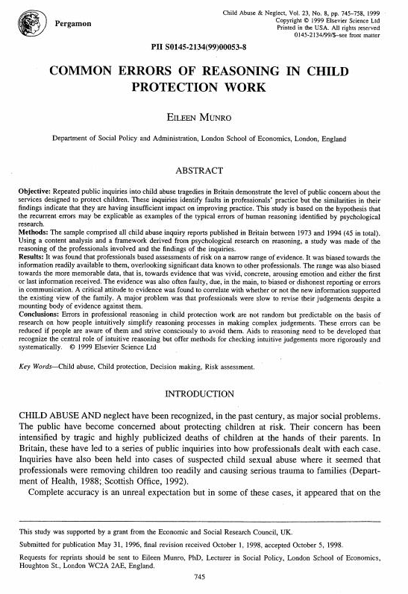Common Errors of Reasoning

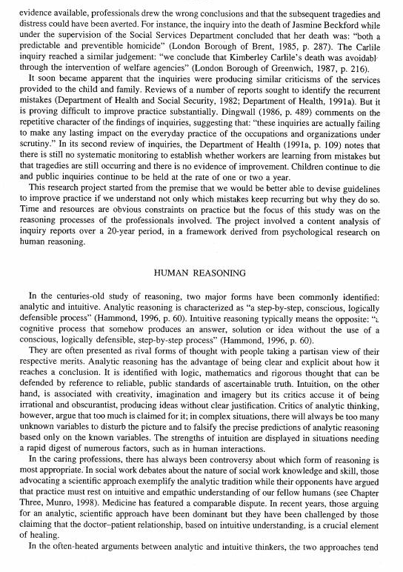
Common Errors of Reasoning

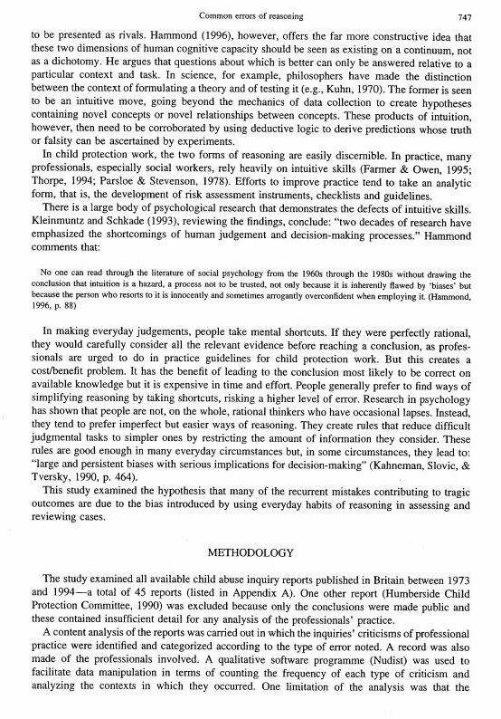Common Errors of Reasoning

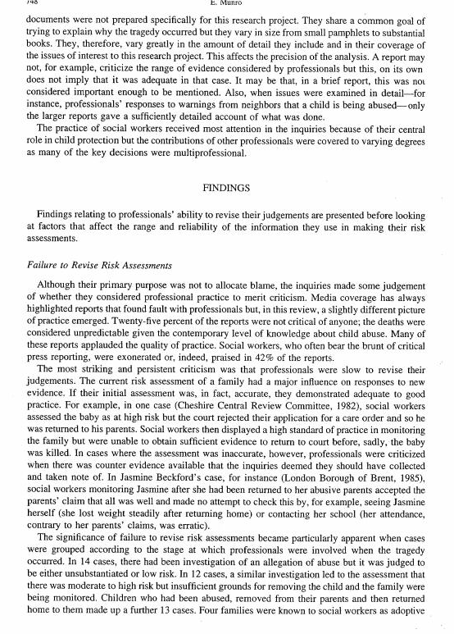Common Errors of Reasoning

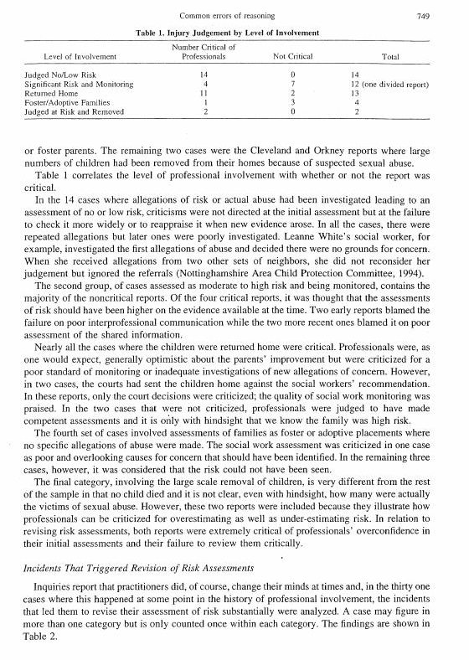Common Errors of Reasoning

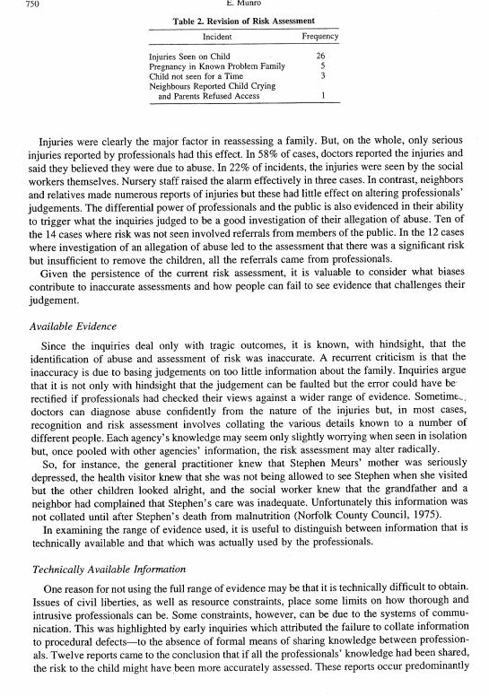Common Errors of Reasoning

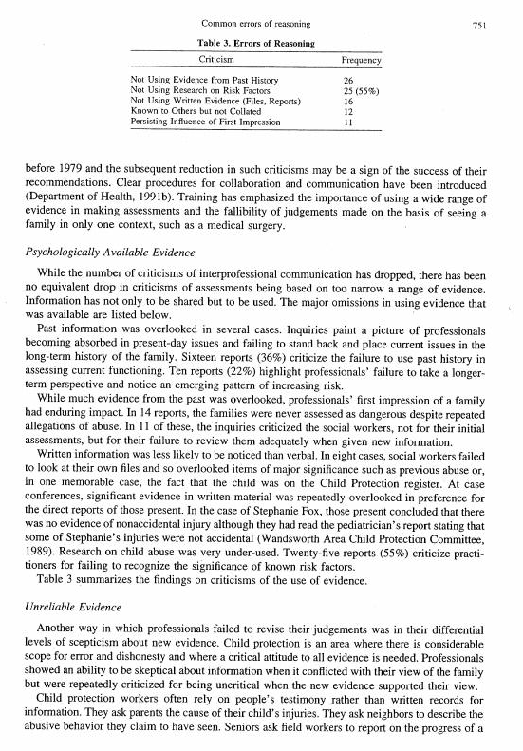Common Errors of Reasoning

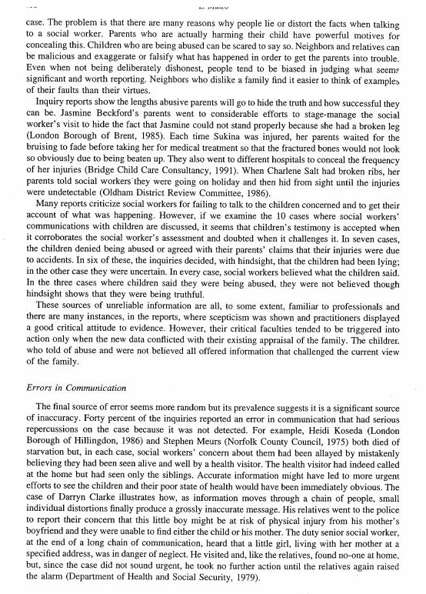Common Errors of Reasoning

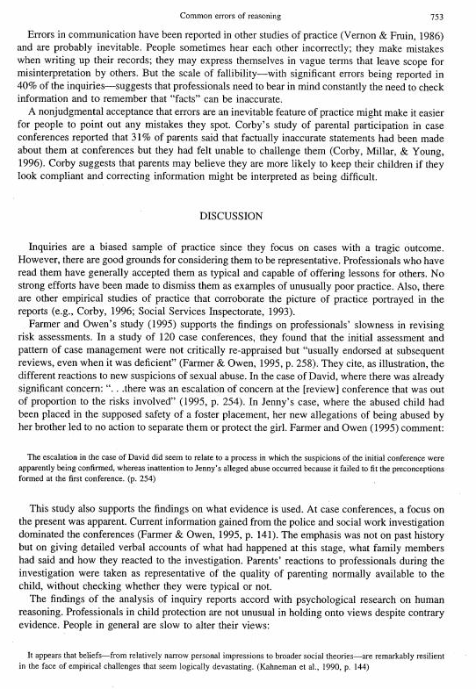Common Errors of Reasoning

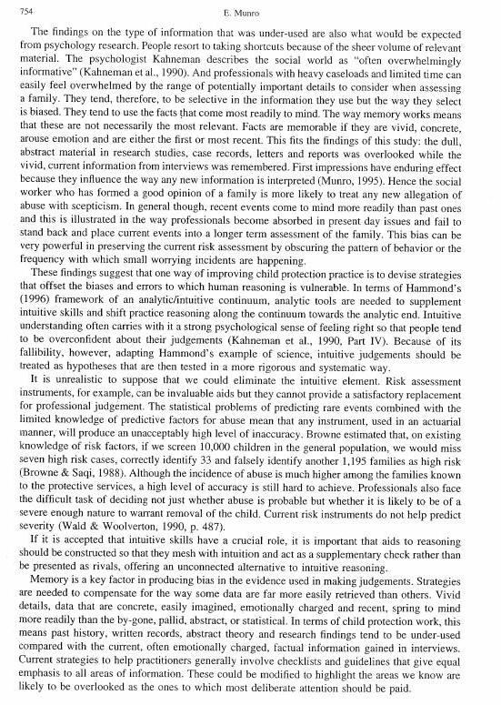Common Errors of Reasoning

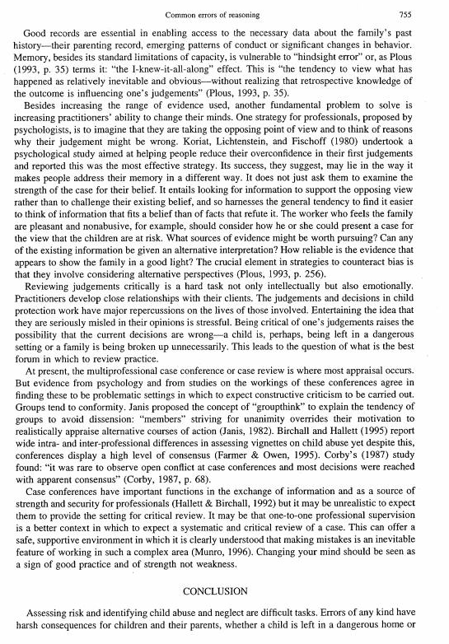Common Errors of Reasoning

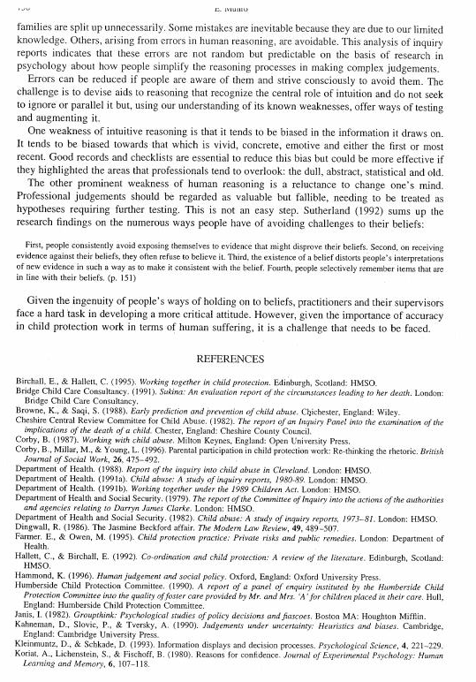Common Errors of Reasoning

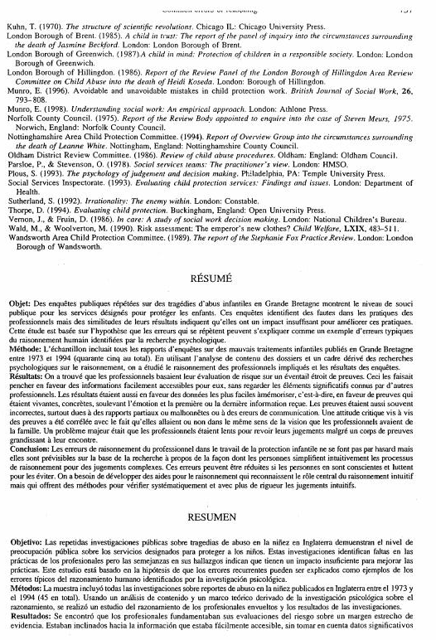Common Errors of Reasoning

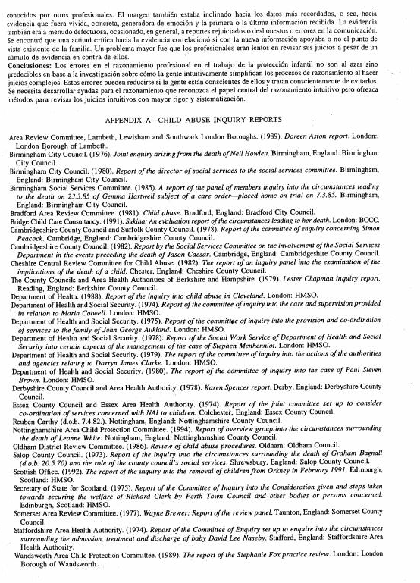Common Errors of Reasoning

- Over-reliance on intuition. Many people in the helping professions often rely on intuition to help them make decisions. However, there is a large body of research that supports the conclusion that such decision-making can lead to faulty conclusions because the thinking of most people is subtlety biased in some way, being based on their own beliefs, values, experiences, etc., and they are often overconfident about what they know (as opposed to what they believe).
Common Decision-Making Errors
- Using mental shortcuts. To save time and effort, most people take mental shortcuts when making everyday judgments, making assumptions based on probabilities. However, when variables are added (or not identified), a higher probability of errors in judgment results.
- Not applying guidelines. Practice guidelines exist in child protection work to support workers in reaching sound, supportable decisions. Such decisions are based on the process of gathering as much information as possible, and then carefully evaluating all the relevant information available. Problems may sometimes arise because the practice guidelines only tell the worker where to look, but not what to see. It’s the worker’s ability to apply the guidelines to the child and family’s environment that ultimately results in informed decisions in the CPS Response.
- Failing to revise existing decisions. Research has demonstrated that some workers rely too heavily on initial assessments when evaluating new information, rather than being open-minded and using new information to re-evaluate previous decisions. Even in the face of contradictory information, these workers will often stick with a previously made decision.
- Failing to look at current circumstances in the context of prior history. Research has shown that case conferences tend to be dominated by what is presently occurring in the family (for valid reasons, of course). However, the most current information is often not examined in relation to family history, which might support different decisions. Failing to recognize a pattern of chronic neglect, of repeated allegations, and/or a situation that seems to be deteriorating can lead to inaccurate assessments and ongoing harm to children.
- Weighting professional sources of information over the knowledge/input of family and community resources. Child welfare professionals often place greater significance on information obtained from other professionals than that gleaned from informal sources who may actually have much greater intimate knowledge of the day-to-day functioning of the family. Many cultural groups have a rich foundation and history of extended family, along with neighborhood and community support to promote the safety and well-being of children and families. However, these resources may have infrequent contact with (or little interest in) initiating contact with formal institutions or the state or local government as a result of their own cultural perspectives.
Common Decision-Making Errors
- Making communication errors. Deletions, distortions, and generalizations all lead to lack of specificity, which in turn leads to a gradual erosion of the accuracy of the information that people are relying on to form impressions and make decisions. Therefore it is important to record all facts while also avoiding the inherent dangers of skewed descriptions and vague general statements.
- Over-reliance on memory. Research demonstrates that facts are the most memorable if they are vivid, concrete, arouse emotion, and are either the first or most recent observations. However, the most vivid or memorable piece of information doesn’t automatically make it the most relevant.
- Making a decision with insufficient information. Deciding that a child is safe, based on information obtained from the source and from the child and without having contacted the parents/persons legally responsible for the child as part of the assessment, is not considering all the relevant information that may be available.
- Failing to recognize the possibility of changing circumstances. This possibility would come into play when, for instance, a child initially assessed as safe (due in part to the ability to monitor the child through the child’s regular attendance at school and daily interaction with school personnel) is assumed to be safe on a continuing basis without considering the possibility of other developments (such as the child not being seen at school since the initial contact with the family).
- Being swayed by emotional or vivid information. Deciding that a mother should also be held responsible for abuse after a sobbing, emotionally distraught female teenager who has alleged being sexually abused by her stepfather and who went on to say that her mother “didn’t care, because she didn’t do anything to stop the abuse” would constitute being swayed by emotion. A situation such as this would demand further fact-finding and corroboration.
Common Decision-Making Errors
- Fixing on a single hypothesis and only looking for information that confirms it. Immediately reaching the conclusion that a 4-year-old child has been sexually abused by her father (based on the child’s mother reporting that the child returned home from visitation with the father with redness in her vaginal area and stated, “My pee-pee hurts”) would fail to consider any other possible origin for the child’s problem. The correct alternative would be seeking out or evaluating any other information.

Step 1: Adopt these attributes.
Five Steps to Becoming an Informed Decision-Maker
- Open-mindedness
- Healthy skepticism
- Intellectual humility
- High motivation
Step 2: Recognize these mistakes and pitfalls.
The following are some common decision-making errors, along with associated pitfalls, made in child welfare/child protective services work:
- Over-reliance on intuition
Those in the helping professions often rely on their intuition to help them make decisions. However, there is a large body of research that demonstrates the problems with this can be hazardous because the thinking of most persons is inherently biased and they are often overconfident in applying it to solve problems. Intuition must be balanced by the disciplined gathering of relevant evidence, and then analyzing the evidence before reaching a conclusion.
- Using mental shortcuts in reasoning
In an effort to save time and reduce effort, most people usually take mental shortcuts when making everyday judgments. However, this practice generally results in higher levels of error. In child welfare work, this can have tragic consequences. Practice guidelines exist to support workers in reaching sound decisions after gathering and considering all relevant information/evidence. Thorough assessments are time-consuming, but very necessary.
- Failure to revise safety/risk decisions
The most striking error in the reasoning of child welfare staff is not revising initial safety and risk assessments, where appropriate. Some research has demonstrated that workers rely on their initial assessments to evaluate new evidence rather than being open-minded and using new evidence to continuously assess safety and risk.
These are some key factors that contribute to failure to revise assessments:
Five Steps to Becoming an Informed Decision-Maker
Personal viewpoint and first impressions – Workers have shown the ability to be skeptical about information when it does not conflict with their view of a family; however, they have also been shown to be resistant to considering new evidence if that evidence conflicts with their own view/experience of the family.
Failure to look at current behavior in the context of past family history – Research has shown that case conferences tend to be dominated by what is presently occurring in a family, including police or child protective services investigations. However, the emphasis on this information is generally not examined in relation to past family history, which may support a different assessment decision. Repeat allegations and chronic neglect can easily be overlooked if past family history is not sufficiently used as part of the assessment.
- Weighting professional resource expertise over knowledge/input of family and community resources
All information sources may have their own bias or problems with the facts they present to child welfare professionals, who tend to weigh facts or evidence from other professional resources (e.g., doctors, police, other workers) more than facts or evidence gathered from other familial resources, neighbors, etc. However, those with intimate knowledge of the family have the most experience with the family and the importance of their experience should not be discounted.
- Communication errors
Such errors and problems may include the following:
Deletions and distortions – The individuals involved may hear each other incorrectly, make mistakes in writing, leave pertinent information out from their notes because they have not held it in their memory, or fail to share relevant information with each other.
Generalizations – Generalization, or drawing of inferences from a limited range of experience or observation, may lead to the inability to consider new information. For example, if you describe a visit with a generalized comment such as “negative parent-child interaction” without commenting on the specifics of the interaction (such as a parent who was short-tempered
with the child during the visit but then recognized and corrected that behavior) it is possible to fail to document important information (such as the strength in the parent recognizing and self-correcting the interaction with the child).
Five Steps to Becoming an Informed Decision-Maker
- Lack of understanding of memory function
Child welfare professionals with heavy caseloads and limited time tend to be selective in the way that they use their memory, often focusing on whatever memories most readily come to mind even if those memories are not the most pertinent to the case. Research demonstrates that “facts are memorable if they are vivid, concrete, arouse emotion, and are either the first or most recent.” Therefore, “dull, abstract material in research studies, case records, letters, and reports was overlooked while the vivid, current information from interviews was remembered.”
- Mistaking compliance for long-term change
The impact of memory function and the bias in remembering recent events can lead child welfare professionals to focus on present-day issues and mistake compliance for long-term change.
Step 3: Identify and characterize child welfare issues/problems.
At the heart of making informed decisions is the ability to recognize and evaluate problems. Workers’ assessment skills will be particularly useful in identifying the problems within the family that led to child welfare intervention, including any underlying conditions and contributing factors that are affecting the family’s ability to meet the children’s needs for safety, permanency, and well-being. Assessment of strengths that the family can utilize to successfully resolve their problems/issues and achieve the child welfare outcomes is equally important. It is essential to conduct ongoing assessments. Safety and risk assessment must occur at every case contact, and not just at prescribed time frames such as when safety or risk protocols (e.g., Safety Assessment, Initial RAP) must be documented in CONNECTIONS.

Step 4: Evaluate the information sources.
Five Steps to Becoming an Informed Decision-Maker
Facts are usually acquired from information sources and their observations. What is seen, told, or heard from other persons who are operating as experts (e.g., doctors, attorneys, police, educators, social workers) and/or those or who have intimate or relevant knowledge about the family (e.g., extended family members, neighbors, clergy) would be included. Remember that it is necessary to gather facts from all information sources, being careful not to overlook the importance of information provided by those who are not “experts” but who do in fact have experience with the family.
Information must be sought from sources that are credible, unbiased, and accurate. These conditions will depend on the integrity of the person who is the source of information. In order to assess these conditions, seek answers to the following questions about the information source:
- Does the information source have the necessary knowledge or level of understanding required to help me with my decision?
- Does the information source have any motive for being inaccurate or biased?
- What are the source’s underlying conditions, contributing factors, and/or factors of difference that may be contributing to his/her motive?
- Are there any reasons for questioning the honesty or integrity of the information source and, if so, what are they?
Step 5: Evaluate decisions.
These are some questions that you should ask yourself when evaluating any decisions reached during the decision-making process in a child welfare case:
- What is my decision based upon?
- Is there any ambiguity, vagueness, or obscurity that hinders my understanding of key issues that will help me make a decision?
- Is my written documentation clearly based upon facts gathered during the assessment process, or is it influenced by my own personal viewpoint, including my beliefs, values, experience, and contributing factors?
- Have I evaluated the truth, relevance, fairness, completeness, significance, and sufficiency of the reasons (i.e., evidence) to support the decision against current laws, regulations, and/or policies?
Five Steps to Becoming an Informed Decision-Maker
- Do I need to gather further information to reach an accurate decision on this family because of omissions, distortions, overgeneralizations, or other reasons?

Material in this handout has been compiled and adapted from the following sources:
Munro, Eileen. “Common Errors of Reasoning in Child Protection Work.” Child Abuse and Neglect. Vol. 23, No. 8, pp.745-758, 1999.
Haskins, Greg. “A Practical Guide to Critical Thinking.”
Available online at: www.skepdic.com/essays/haskins.pdf

Phase One – Organize your basic perceptions in relationship to the case.
Developing Multiple Hypotheses
Before you begin the process of generating alternative—or multiple—hypotheses, you need to gather and understand some basic information about the case and about yourself:
- The information currently available, e.g., the SCR report or prior history information.
- Your awareness of your own feelings, values, beliefs, and experiences as they relate to the current case situation.
Mentally or with another person, acknowledge your basic thoughts and feelings related to the information currently existing and the issue to which it is connected.
Phase Two – Develop initial hypotheses.
Generate explanations (hypotheses) related to the case, based on the information currently available to you. How does this information lead logically to the hypothesis? Identify gaps in the logic.
Phase Three – Gather data to evaluate current hypotheses and/or to create new ones.
Connect hypotheses to the evidence that currently exists, including:
- Statements, reports, photos; physical, psychological, and environmental evidence of safety issues, abuse/maltreatment, risk of future harm; and any other evidence.
- Any facts or circumstances that materially affect the weight of each item (e.g., the credibility of key information sources, evidence).
- Interpretations of verbal and nonverbal behaviors.
Determine any additional actions you could take to retain, modify, or reject a particular hypothesis (e.g., re-interviewing a family member based on all the evidence, or re-interviewing collateral contacts such as medical professionals for clarity).
Develop and implement the strategy for clarifying or obtaining additional information for whatever is missing or confusing. From whom do you need to obtain information? What is the most effective way of obtaining the information?
Developing Multiple Hypotheses
Phase Four – Identify the most plausible explanation.
Determine the most plausible explanation based on credible information gathered regarding the multiple hypotheses that have been considered.
Phase Five – Test the hypothesis.
Discuss the case with your supervisor to receive feedback and input on the recommended decision, course of action, or on your work during the previous phases. Is any significant information still missing or contradictory? Have all plausible explanations for concerns been confirmed or disconfirmed? Has the CPS Response been conducted objectively, based on a supervisory review?
Phase Six – Reevaluate.
Reevaluate with the worker the action taken based on the decisions made in Phases Four and Five. Continually ask yourself and the worker, “What did we miss?”

DATE REPORTED | : |  | 05/04/XXXX |  |  | PRIMARY WORKER |  |  | :
TIME REPORTED | : |  | 02:08 pm |  |  | COUNTY/ZONE |  |  | :
CLASSIFICATION | : |  | CPS - Familial |  |  | SECONDARY WORKER |  |  | :
INTAKE TYPE | : |  | Initial |  |  | COUNTY/ZONE |  |  | :
DUP. OF STAGE ID | : |  |  |  |  | WORKER TAKING INTAKE |  |  | : | 15109
 |  |  |  |  |  | COUNTY/ZONE |  |  | :
Worker Safety |  | : |  | N | Sensitive Issues |  | : | N |  |  | Special Handling | : | N

LIST OF PRINCIPALS
Line | ADDR # | NAME: |  | AKA | RELATIONSHIP | ROLE | SEX | DOB (AGE) | TYPE | DOD | PERSON ID | REL | LANG | Line
01 | p01 | Julie Brown |  |  | Mother | No Role | F | (30) |  |  | 12700644 | N | EN | 01
 |  | ETHNICITY / RACE: | African American
Line | ADDR # | NAME: |  | AKA | RELATIONSHIP | ROLE | SEX | DOB (AGE) | TYPE | DOD | PERSON ID | REL | LANG | Line
02 | p01 | Sissy Brown |  |  | Child | Mal Child | F | (3 mo.) |  |  | 12700645 | N | EN | 02
 |  | ETHNICITY / RACE: | African American

REPORTED ADDRESS INFORMATION
 |  |  |  |  |  |  | ADDR |  |  | PHONE
ADDR # | STREET | CITY | ST | ZIP | CNTY | CD | TYPE | PHONE | EXT | TYPE | ADDR #
01 | 1 Anytown Lane | Anytown | NY |  |  |  | RS |  |  | RS | 01

ALLEGATION DETAIL
Line | MALTREATED/ABUSED CHILDREN | ALLEGATIONS | Line | ALLEGED SUBJECT(S)
04 | Sissy Brown | Lacerations, Bruises, Welts  Inadequate Guardianship | 02 | Julie Brown

REPORTER INFORMATION
NAME | : | anonymous |  | RELATIONSHIP : |  | AGENCY : |  | SUMMARY OF FINDINGS : | N
ADDR | : |  |  |  |  | NY
 |  |  | PHONE: |  | Ext.

SAFETY FACTORS
Report Narrative on the Next Page

Call Narrative
Narrative:
Child was observed with bruises on the right leg. When mother was asked what happened to the child she covered the child’s legs and stated “it’s none of your business”. Mother was also observed to have two black eyes. Source suspects mother and child were injured during an incident of domestic violence since the mother previously reported having relationship problems with the child’s father.
Miscellaneous Information:
Mother ended all contact with source of report after this confrontation.
Locating Information:

- Acknowledge your current perceptions of the case, including your workers’ thoughts, feelings, concerns, and related actions.
Questioning Our Workers’ CPS Response
- Based on your monitoring of currently available information concerning the case or issue at hand, provide feedback, set new expectations, and coach the worker in what to do in order to advance the CPS Response, particularly in relation to developing multiple hypotheses.
- Monitor the outcome of step two and examine the hypotheses the worker formulated against the information collected.
Evaluate/determine the validity of the worker’s assumptions and any pitfalls in the worker’s thinking.
- If necessary, coach the worker in making informed decisions, including the identification of the most plausible explanation and the communication of any expectations that will improve the worker’s performance.
- If necessary, coach the worker in testing the hypothesis. Provide feedback and input on the decision you reached together in step four, the course of action, or on the worker’s performance during the previous steps.
- Reevaluate the action taken based on the decisions made in steps four and five, asking: “What did we miss?”

Sheila Fleck, a new worker, is following up on the CPS report on the Brown Family.
Sheila Fleck
The worker located the single mother, Julie Brown, along with the child in question, Sissy, at their residence. She explained the nature of the report to the mother and went on to say that it would be necessary “to examine the child’s leg to observe the bruises and take photographs.” Ms. Brown denied that the child had any such bruises and proceeded to undress the child. At that point, the worker observed two blackish-blue discolorations on Sissy’s right leg: one just below the knee and another just at the ankle. When the worker commented upon the marks, Ms. Brown said that her mother had identified them as “Mongolian spots.” Sheila then confronted Ms. Brown regarding the allegations of her having black eyes due to domestic violence. Ms. Brown told the worker that she’s “not a beaten woman…I have a three-month-old, colicky infant, and I just have not had a decent night’s sleep in the past three months…those are bags under my eyes, not bruises.” Sheila returned the focus to the child and stated that she still wanted to take photographs of the bruises and seek medical attention for the child that very day. At this point, Ms. Brown became very upset, refused to allow any photographs to be taken, and told the worker that she would not “…just drop my entire schedule for the day to take Sissy to the doctor just because some nosy person made some kind of report.” Ms. Brown went on to say, “I know that my child is not hurt,” and then she asked the worker to leave immediately.
Sheila has just returned to the office and is discussing the case with her supervisor. She relayed the mother’s denial of having black eyes. She also made reference to the mother’s explanation of the discolorations on the child’s legs being Mongolian Spots. Upon further questioning by her supervisor, Sheila reluctantly admitted that there were no other concerns regarding the care of the child (the home was appropriate, the baby was appropriately clean and dressed, the interaction between the parent and child appeared to be nurturing, the child appeared to be developmentally on target, and the mother had adequate supplies and formula for the baby, etc.). However, the worker still wants to obtain a court order to get medical attention for Sissy. She is also vehement in expressing the opinion that the mother is being “uncooperative” and is merely attempting to “explain away” some injuries that were inflicted on the child. Visibly upset about the child’s observed condition, Sheila vehemently states, “This is a small, fragile infant with injuries all over her legs…she is a tiny infant who can’t speak for herself, and she needs us to protect her.”

Sheila Fleck, a new worker, is following up on the CPS report on the Brown Family.
Sheila Fleck: Trainer’s Key
The worker located the single mother, Julie Brown, along with the child in question, Sissy, at their residence. She explained the nature of the report to the mother and went on to say that it would be necessary “to examine the child’s leg to observe the bruises and take photographs.” Ms. Brown denied that the child had any such bruises and proceeded to undress the child. At that point, the worker observed two blackish-blue discolorations on Sissy’s right leg: one just below the knee and another just at the ankle. When the worker commented upon the marks, Ms. Brown said that her mother had identified them as “Mongolian spots.” Sheila then confronted Ms. Brown regarding the allegations of her having black eyes due to domestic violence. Ms. Brown told the worker that she’s “not a beaten woman…I have a three-month-old, colicky infant, and I just have not had a decent night’s sleep in the past three months…those are bags under my eyes, not bruises.” Sheila returned the focus to the child and stated that she still wanted to take photographs of the bruises and seek medical attention for the child that very day. At this point, Ms. Brown became very upset, refused to allow any photographs to be taken, and told the worker that she would not “…just drop my entire schedule for the day to take Sissy to the doctor just because some nosy person made some kind of report.” Ms. Brown went on to say, “I know that my child is not hurt,” and then she asked the worker to leave immediately.
Sheila has just returned to the office and is discussing the case with her supervisor. She relayed the mother’s denial of having black eyes. She also made reference to the mother’s explanation of the discolorations on the child’s legs being Mongolian Spots. Upon further questioning by her supervisor, Sheila reluctantly admitted that there were no other concerns regarding the care of the child (the home was appropriate, the baby was appropriately clean and dressed, the interaction between the parent and child appeared to be nurturing, the child appeared to be developmentally on target, and the mother had adequate supplies and formula for the baby, etc.). However, the worker still wants to obtain a court order to get medical attention for Sissy. She is also vehement in expressing the opinion that the mother is being “uncooperative” and is merely attempting to “explain away” some injuries that were inflicted on the child. Visibly upset about the child’s observed condition, Sheila vehemently states, “This is a small, fragile infant with injuries all over her legs…she is a tiny infant who can’t speak for herself, and she needs us to protect her.”

Sheila’s Errors:
Sheila Fleck: Trainer’s Key
- being over-reliant on intuition based on personal values, beliefs, experiences
- using mental short-cuts based on probabilities
- failing to apply structured practice guidelines (i.e., making decisions, such as seeking a court order, with insufficient information)
- failing to revise existing decisions by not seeking information from collaterals that could support her original (i.e., that marks are bruises) or an alternative hypothesis
- sticking with personal viewpoint/first impressions, failing to look at current circumstances in the context of prior history (i.e., lack of cultural competence may be influencing worker’s impressions of the child’s marks)
- weighting professional sources of information over knowledge/input of family and community resources (i.e., worker assumes that what she is seeing on the child is bruises and this is more credible than the grandmother’s knowledge of Mongolian spots)
- failing to contact collateral contacts and resources (i.e., worker fails to contact pediatrician for additional information before seeking court order)
- making communication errors (such as deletions, distortions, and generalizations)
- being over-reliant on memory (remembering vivid, concrete, emotional images)
- fixing on a single hypothesis (i.e., that the child’s marks were caused by abuse/maltreatment) and seeking only information that confirms it
- under-attending to core conditions, interpersonal helping skills, and the professional helping relationship (i.e., worker becoming confrontational with mother leads to the end of the interview)

Complete the following task for your assigned worker scenario as if you were the worker’s supervisor. Use the handouts, Developing Multiple Hypotheses and Questioning Our Workers’ CPS Response, for support.
Promoting Sheila’s Informed Decision-Making
- Develop evaluative and/or developmental feedback for the worker at this point in the case.

- Develop your expectations of the worker in relation to reviewing the case history, having a plan for the next interview, and/or gathering more relevant information.

- If necessary, how would you coach the worker to advance his/her performance?

- Describe your plan for monitoring how well the worker meets the expectations.

The following are some potential examples:
Promoting Sheila’s Informed Decision-Making (Key)
- Develop evaluative and/or developmental feedback for the worker at this point in the case:
Evaluative
- The worker shows strength (positive feedback) in her vigilance about the safety of the baby.
- It seems that her feelings about the baby are impeding an objective investigation/assessment (negative feedback).
- The worker seems to have already decided that the child has inflicted injuries and she has discounted other hypotheses, such as the mother’s explanation of the child’s injuries (negative feedback).
Developmental
- Having such a bias will negatively impact her relationship with the family, which will impact her ability to get accurate assessment information.
- The approach she is taking could lead to an inaccurate assessment of safety and risk as well as any service needs.
- Develop your expectations of the worker in relation to reviewing the case history, having a plan for the next interview, and/or gathering more relevant information.
- The worker should check for prior history and check with the mother and/or collaterals as to any history of domestic violence.
- Before attempting to file for a court order, the worker is to revisit the family and gather more objective information.
- The worker is to find out the last time the child saw a medical professional. Contact this professional to confirm or disconfirm the presence of Mongolian spots.
- The worker is to demonstrate respect for mother’s time and her concern about CPS involvement.
- The worker is to assess the presence and quality of the mother’s support network.
Promoting Sheila’s Informed Decision-Making (Key)
- If necessary, how would you coach the worker to advance his/her performance?
I would model the following:
- How to generate multiple hypotheses.
- How to approach the mother to re-engage her in the investigative/assessment process while acknowledging her strengths.
- An informed decision-making approach, which would include identifying appropriate collaterals that could confirm or disconfirm the mother’s explanation of the marks observed on the child’s leg.
- Describe your plan for monitoring how well the worker meets the expectations:
Develop time frames with the worker for when the above expectations will be accomplished and when they will meet again to review her success/or lack thereof in fulfilling the expectations.

