PRIMER HANDS ON -

CHILD WELFARE

TRAINING FOR CHILD WELFARE STAKEHOLDERS

IN BUILDING SYSTEMS OF CARE

TRAINING GUIDE

MODULE 2
Definitions, History and Values

A Skill Building Curriculum

By Sheila A. Pires

In Partnership with Katherine J. Lazear, University of South Florida, and Lisa Conlan, Federation of Families for Children’s Mental Health

Based on
Building Systems of Care: A Primer
By Sheila A. Pires

Human Service Collaborative
Washington, D.C.

Sponsored by the National Child Welfare Resource Center for Organizational Improvement, University of Southern Maine, in partnership with the National Technical Assistance Center for Children’s Mental Health, Georgetown University, and the National System of Care Technical Assistance and Evaluation Center, Caliber/ICF, with funding from the Administration for Children and Families, U.S. Department of Health and Human Services.

Table of Contents

Table of Contents 2.2
Module 2 - Context: System Building Definitions, History, Values, Principles
and Characteristics
System of Care (SOC) Definition 2.3
Administration for Children and Families (ACF) System of Care Sites 2.4
SOC History 2.5
Child Welfare SOC Activities 2.6
Avoiding “Categorical Systems of Care” 2.6
Alamance County, NC 2.7
Organizing Framework Supported by Core Values 2.7
Full Range of SOC Values and Principles 2.8
Synergy with Values of Family Support and 2.10
Youth Development Movements 2.10
Wraparound Milwaukee 2.11
Handout 2.1 – Alabama’s R.C. Goals and Principles 2.11
Nevada, Kansas, North Carolina, Oregon 2.12
and North Dakota
SOC Operational Characteristics 2.12
Consistency with CFSR Systemic Factors 2.13
Resonance between SOC and CFSR Outcomes 2.14
SOC as a “Differential Response System” for Child Welfare 2.15
Oregon 2.17
System Problems 2.18
Fractured Accountability 2.19
SOC Connected to Larger System Reform 2.20
Need for Frontline Practice Change 2.21
How Families Become Involved with SOC 2.21
Family-Centered Practice Approach 2.22
Shifts in Roles & Expectations of Families & Youth 2.23
Shifts in Child Welfare Decision Making Practice 2.24
Change at Multiple Levels 2.25
Policy, Management, Frontline & Community
Non-Categorical Vs. Categorical System Reform 2.26
Population Focus 2.27
Prevalence and Utilization 2.28
A Population-Driven Systems Approach 2.29
State Commitment and Local Ownership 2.30
Definition of Evidence-Based and Promising Practices 2.31
Examples of Evidence-Based and Promising Practices 2.32
California’s Evidence-Based 2.33
Clearinghouse for Child Welfare 2.33
Shared Characteristics of Evidence-Based & Promising Practices 2.34
Returning to Values, Exercise Sheet 2.1 – Assumptions and Values 2.34
MODULE 2  Context: System Building Definitions, History, Values, Principles, and Characteristics  Definition  SLIDE 2 (10)  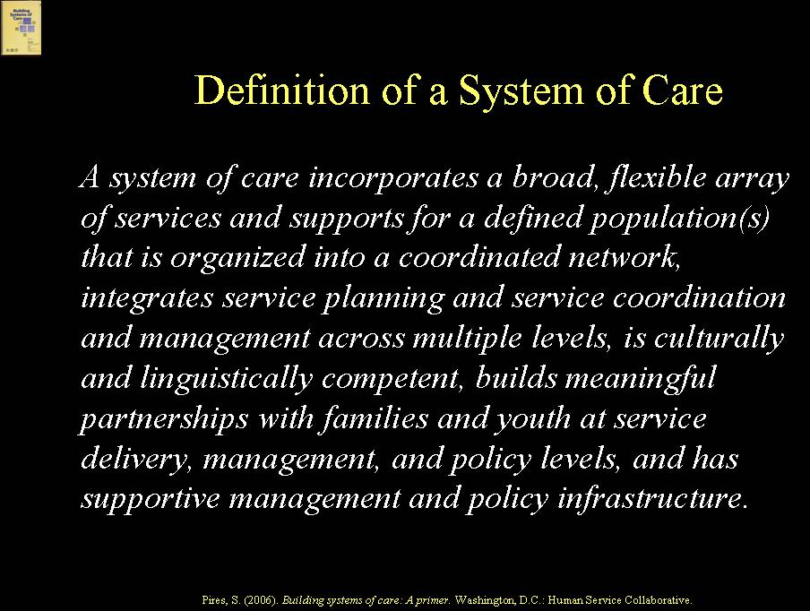  This material is adapted primarily from the Introduction to Building Systems of Care: A Primer (pages 3-12). Stakeholders involved in building systems of care for children, youth and families involved, or at risk for involvement, in the child welfare system are not operating in a vacuum. There is a considerable and rich history to systems of care. The concept of systems of care originated over 20 years ago and was applied initially to children and youth with serious emotional disorders (SED) and their families, including children with SED involved in the child welfare system. It has evolved over time as a concept that can be applied to any designated population of children, youth and families that requires an array of services and supports from multiple entities, including any or all populations of children, youth and families involved, or at risk for involvement, in the child welfare system.  This training defines a system of care as: “a broad, flexible array of services and supports for a defined population(s) that is organized into a coordinated network, integrates services and supports planning, and service coordination and management across multiple levels, is culturally and linguistically competent, builds meaningful partnerships with families and youth at service delivery, management and policy levels, and has supportive management and policy infrastructure.”  Administration for Children and Families (ACF) System of Care Sites  SLIDE 3 (11)  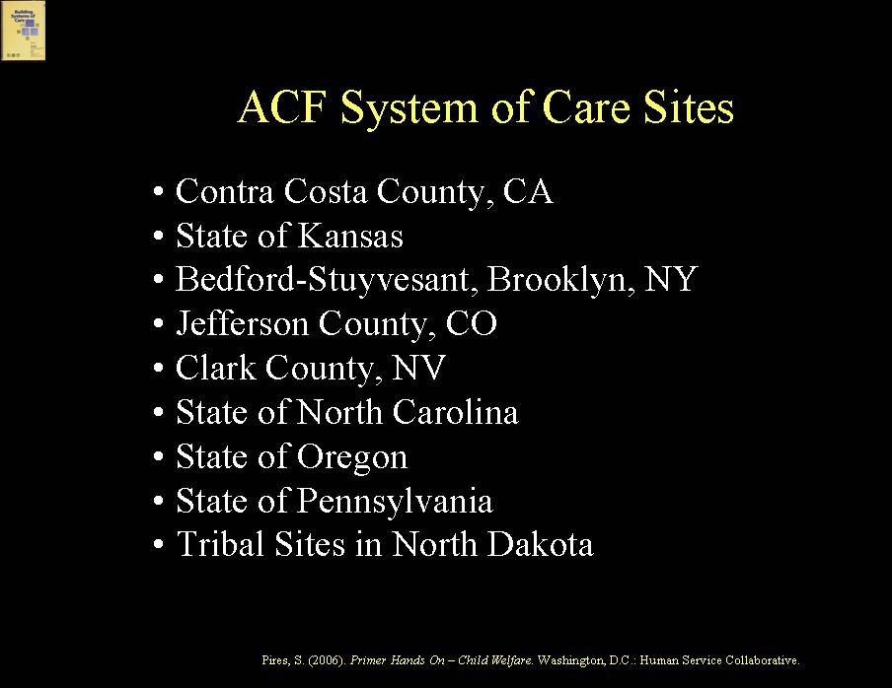  In recent years, most of the major federal agencies serving children and adolescents have funded system of care demonstrations for designated populations, including the Administration for Children and Families (ACF), which currently is funding nine system of care demonstrations. The ACF system of care grant sites include: Contra Costa County, CA; State of Kansas; Bedford-Stuyvesant, Brooklyn, NY; Jefferson County, CO; Clark County, NV; State of North Carolina; State of Oregon; State of Pennsylvania; and Tribal Sites in North Dakota.  System of Care History  SLIDE 4 (12)  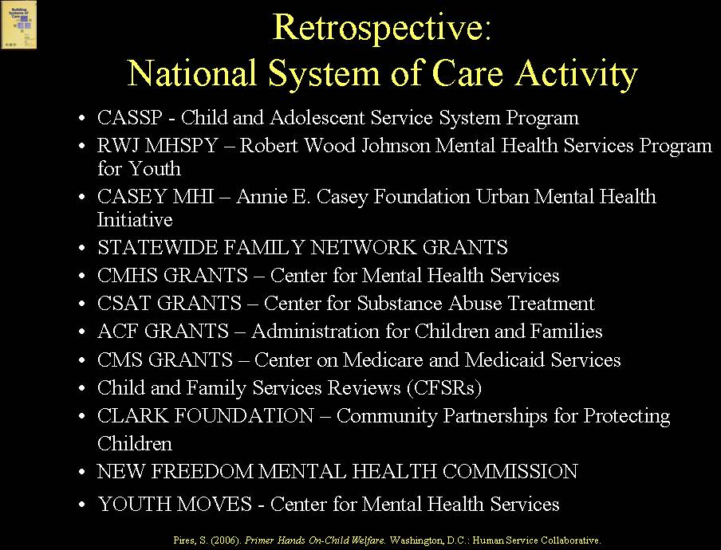  A retrospective review of national system of care (SOC) activity begins with the original Child and Adolescent Service System Program (CASSP), which launched the SOC concept, as well as early national foundation-sponsored system of care demonstrations. These included the Robert Wood Johnson Foundation’s Mental Health Services Program for Youth (MHSPY), which introduced the use of managed care technologies to systems of care and the concept of one accountable care management entity, and the Annie E. Casey Foundation’s Urban Mental Health Initiative, which took the SOC concept to a neighborhood level.  Current national SOC grant initiatives include over 100 SOC grant communities funded by the federal Center for Mental Health Services, virtually all of which include populations of children involved, or at risk for involvement, in child welfare and several of which focus predominantly on the child welfare population, such as Los Angeles County, the State of Maine, and Multnomah County, OR. Current SOC activities also include those sponsored by the Center for Substance Abuse Treatment and those sponsored by ACF already mentioned. System of care principles and goals also are evident in grant activities of the federal Centers on Medicare and Medicaid Services (CMS) – for example, the CMS demonstration grants that allow use of 1915(c) Home and Community-Based waivers to create home and community-based alternatives to residential treatment. System of care principles are embedded in the President’s New Freedom Mental Health Commission report and in the federal Substance Abuse and Mental Health Services Administration’s “transformation” grants to states. Most importantly for child welfare, the SOC concept also resonates with the principles and goals underlying the CFSR process and with recent foundation-sponsored child welfare initiatives, such as the Edna McConnell Clark Foundation’s Community Partnerships for Protecting Children Initiative.  Child Welfare System of Care Activities  SLIDE 5 (13)  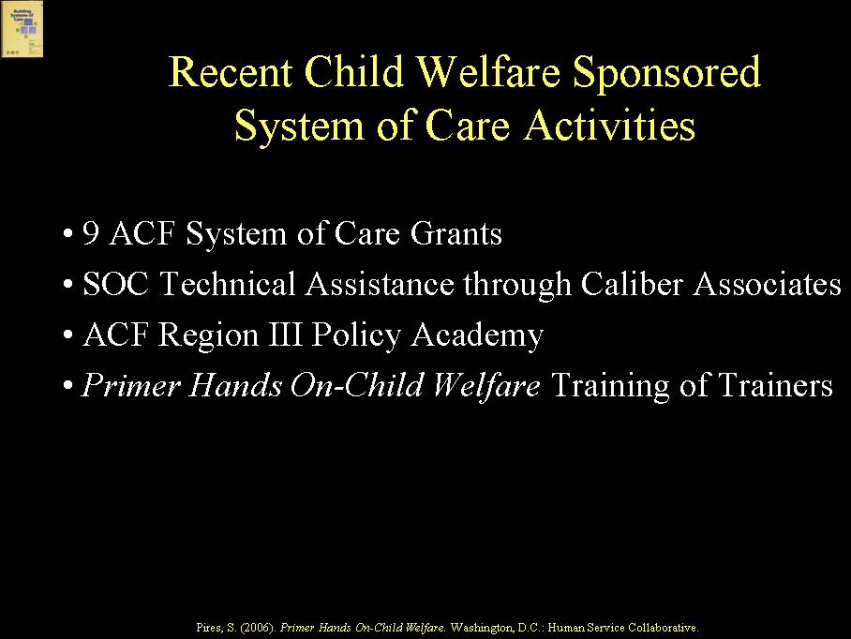  System of care activities recently sponsored by national leadership in child welfare include: the nine ACF grant sites; technical assistance for systems of care in child welfare provided through the National Systems of Care Technical Assistance and Evaluation Center at Caliber/ICF; the ACF Region III Policy Academy sponsored by ACF and the federal Substance Abuse and Mental Health Services Administration (SAMHSA) in partnership with the National Technical Assistance Center for Children’s Mental Health at Georgetown University and the National Child Welfare Resource Center for Organizational Improvement at the University of Southern Maine; and the Primer Hands On-Child Welfare Training and Training of Trainers.  Avoiding “Categorical Systems of Care”  The commonality of a system of care focus across major federal programs is encouraging, but there is a danger now in States and localities building “categorical systems of care”, depending on which federal or foundation initiative may be leading the way. One of the major opportunities that a SOC approach provides is to bring together related reform efforts and reduce a “siloed” approach to serving children, youth, and families.  EXAMPLE  Alamance County, North Carolina, is an example of a county that has multiple children’s reforms underway supported by multiple planning and governance bodies. It has formed an overarching Children’s Executive Oversight Committee, comprised of the leaders of these multiple initiatives, to ensure synergy and coordination across the reforms.  Organizing Framework Supported by Core Values  SLIDE 6 (14)  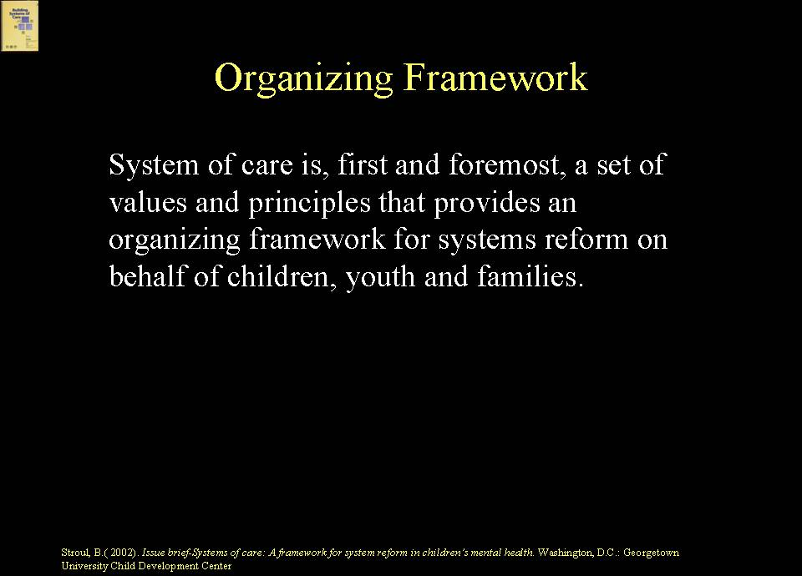  The system of care concept provides an organizing framework, a philosophy and a values base, which can be applied to any population that requires services and supports across multiple providers or systems.  SLIDE 7 (15)  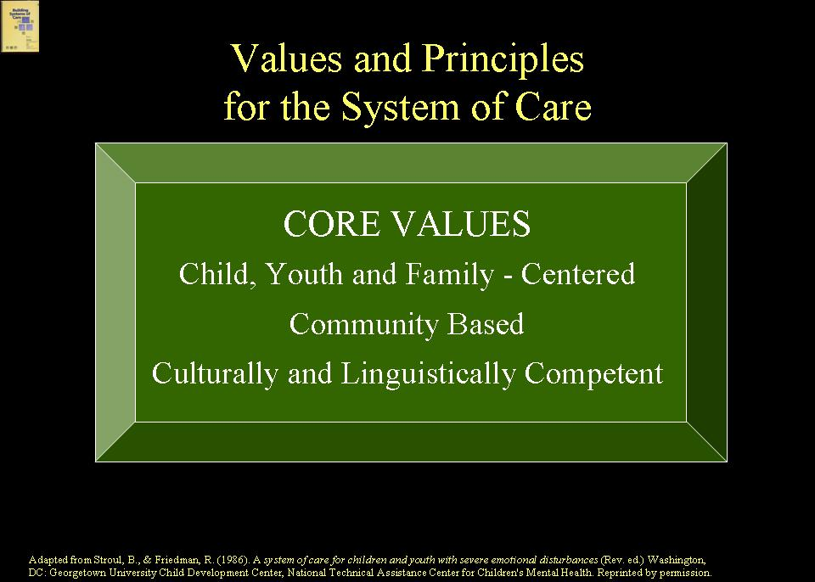  System of care core values developed over 20 years ago. They include: child/youth-centered and family-focused; community-based; and culturally and linguistically competent. They developed, initially, out of a children’s mental health movement at a time when many mental health systems were adult-focused and hospital-based. Hence, values of “child and youth centered and family focused” were in direct response to concerns that children were being treated as “little adults” and not within the context of their families. The value of “community-based” was in direct response to the lack of home and community services for children and families and the bias at the time to hospitalize children with serious disorders. The value of “cultural and linguistic competence” was in response to concerns over the disparity in access to services experienced by racially and ethnically diverse children and families and their disproportional representation in restrictive services. These core values have evolved in meaning over time as multiple systems serving children, youth and families have embraced a system of care approach.  Full Range of SOC Values and Principles  SLIDE 8 (16)  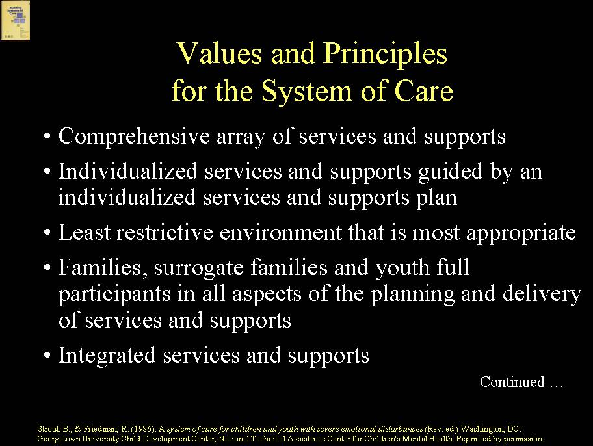  SLIDE 9 (17)  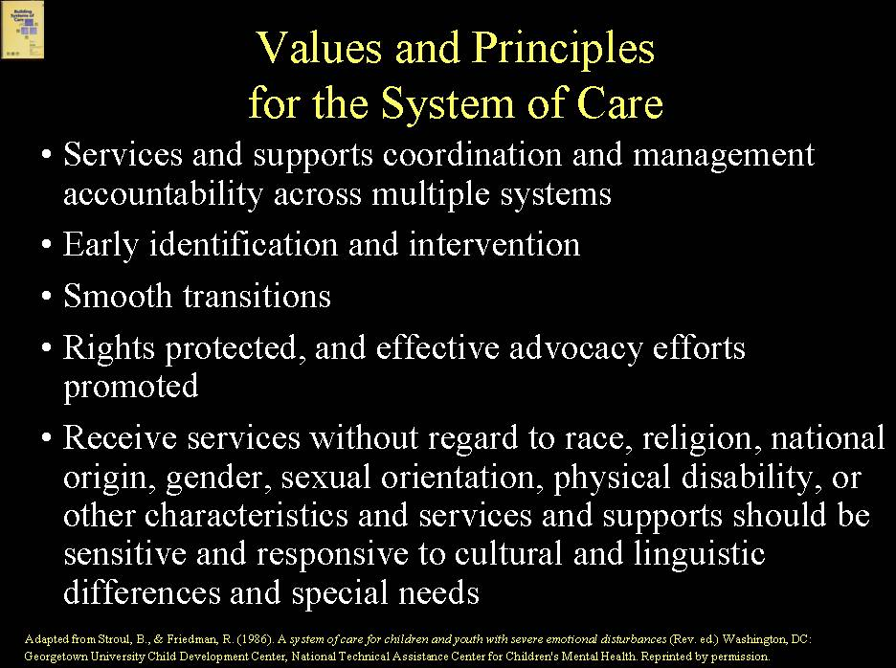  The full range of system of care values and principles includes:  - comprehensive array of services and supports;  - individualized services and supports guided by an individualized service/support plan;  - least restrictive, most appropriate environment;  - families, surrogate families and youth as full participants in all aspects of the planning and delivery of services and supports;  - integrated services and supports across systems and providers;  - services/supports coordination and management accountability across multiple systems;  - early identification and intervention;  - smooth transitions;  - rights protected and effective advocacy efforts promoted;  - non-discrimination; and  - provision of services that are responsive to cultural and linguistic differences and special needs.  Synergy with Values of Family Support and Youth Development Movements  SLIDE 10 (18)  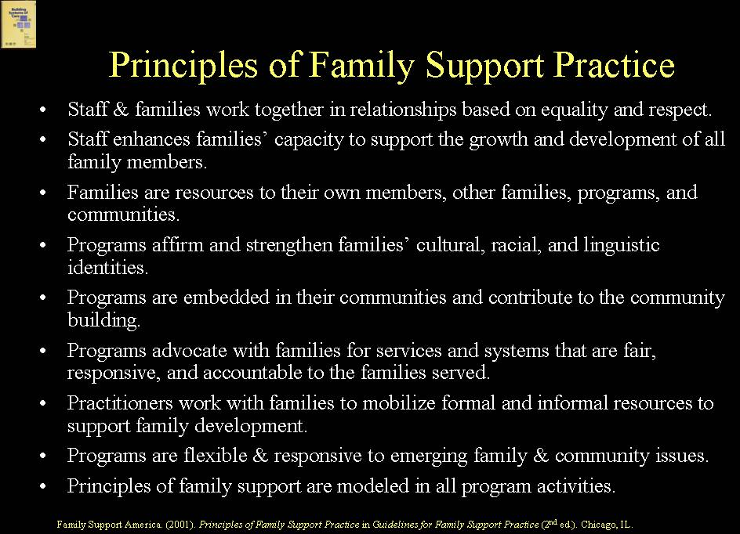  SLIDE 11 (19)  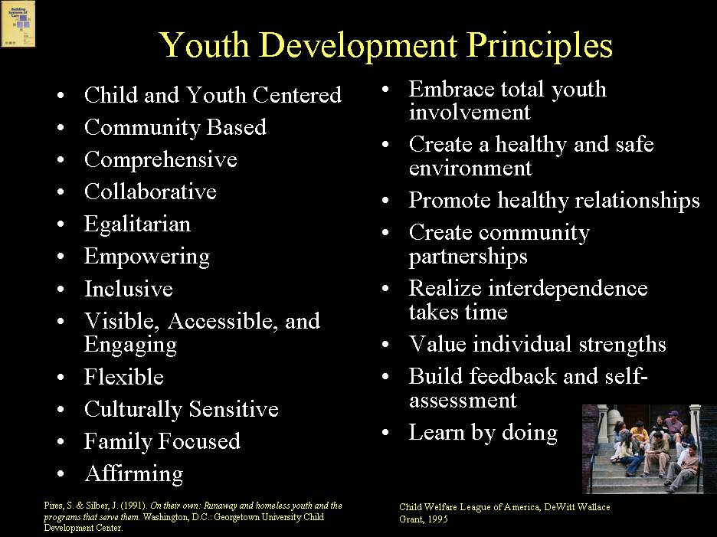  System of care values and principles are very similar to the principles and values that grew out of the family support movement in child welfare, as well as youth development principles that emerged initially in youth employment and youth work. System of care is now being used as an organizing framework for many different populations of children, youth and families.  EXAMPLE  Milwaukee, Wisconsin, Wraparound Milwaukee, which began to use a system of care approach for children involved in child welfare who were in, or at risk for, residential treatment, is now applying a system of care approach to divert youth from detention and for adult family members with substance abuse challenges who are involved in child welfare.  Synergy with Child Welfare CFSR Principles  SLIDE 12 (20)  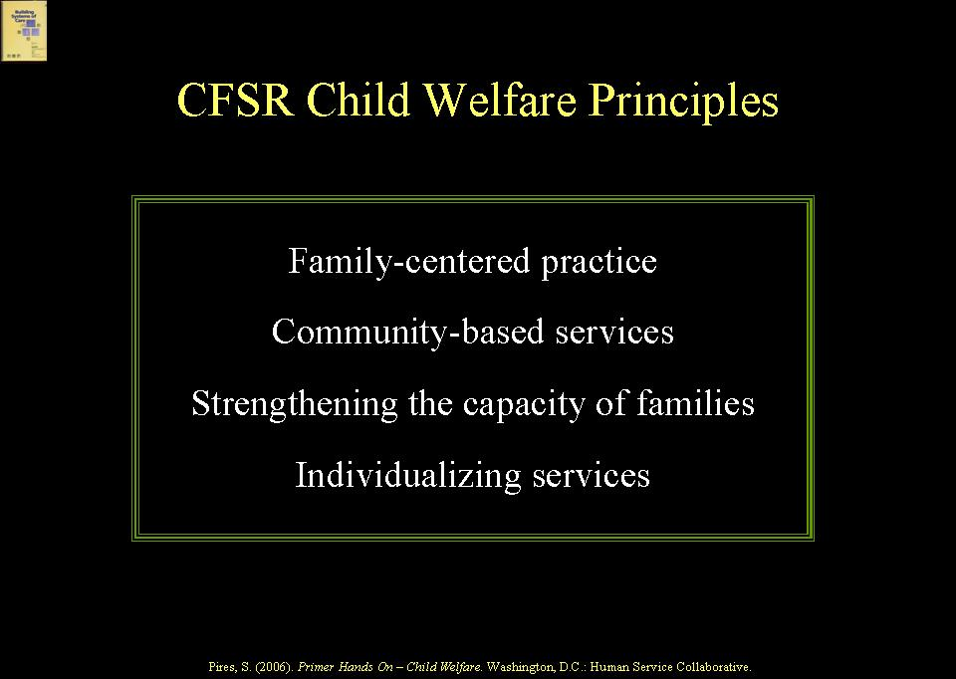  System of care values also resonate closely with the child welfare principles that underpin the CFSR process, including: family-centered practice; community-based services; strengthening the capacity of families; and individualizing services.  EXAMPLE  Alabama is an example of one of the first States to undertake reform of its child welfare system utilizing system of care principles and values, adding to them and adapting them for the child welfare system, and anticipating by several years CFSR principles in the process.  HANDOUT 2.1  Handout 2.1 describes the Alabama goals and principles.  SLIDE 13 (21)  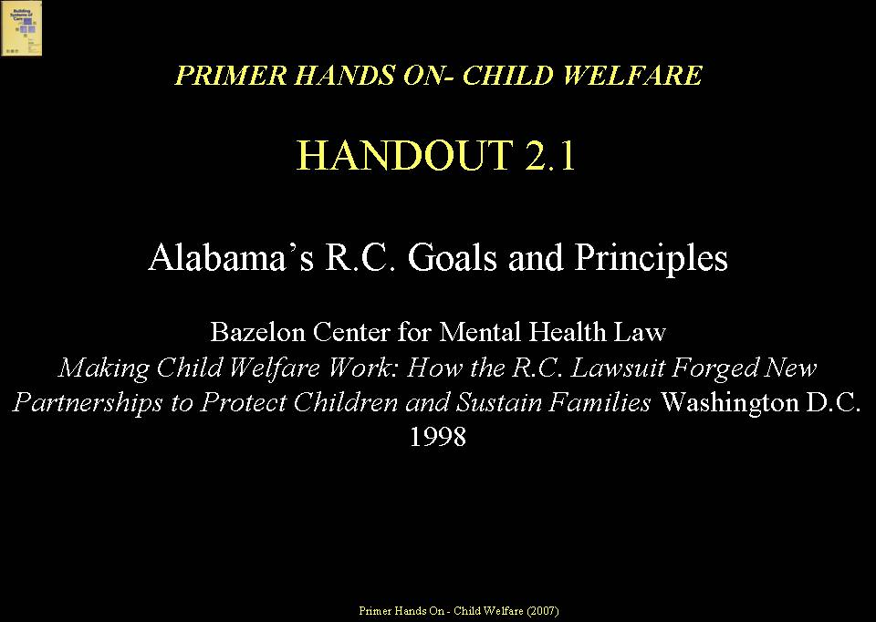  EXAMPLE  Nevada, Kansas, North Carolina, Oregon, and North Dakota are examples of state child welfare systems that more recently adopted system of care values and principles to guide their Program Improvement Plan (PIP) activities.  SOC Operational Characteristics  SLIDE 14 (22)  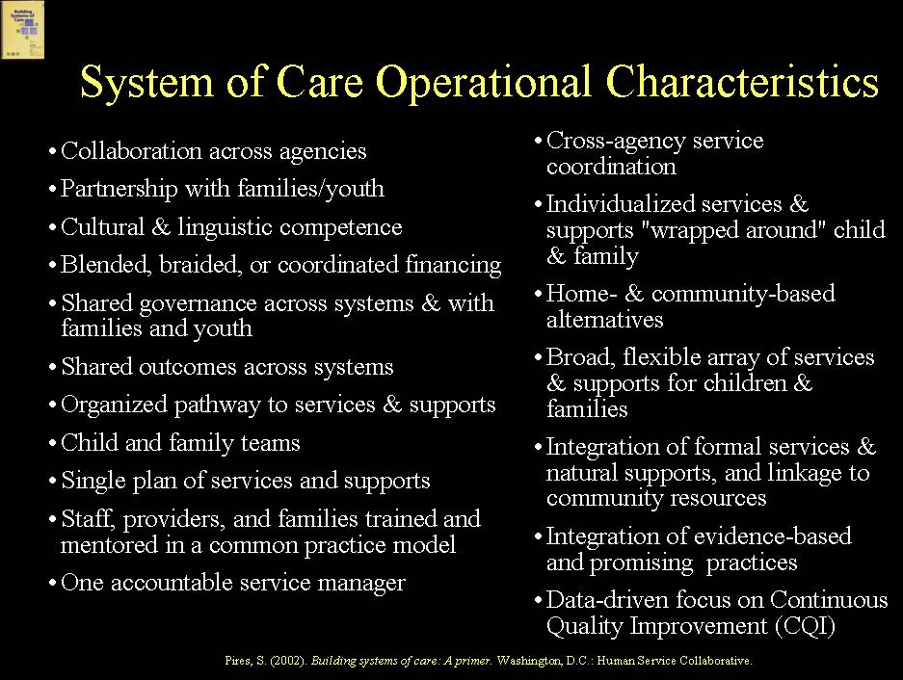  From a philosophy/values standpoint, there is far more synergy today among all of the systems that serve children, youth and families than there was twenty years ago when the system of care movement began. There is greater understanding and more examples of how to apply a system of care approach to different populations of children, youth and families (and not just for children with serious emotional challenges as was the case 20 years ago when the movement began). There also is more shared understanding today across systems about the operational characteristics of systems of care. The operational characteristics of systems of care include: collaboration across agencies; partnerships with families and youth; cultural and linguistic competence; blended, braided or coordinated funding; shared governance (and liability) across systems and with families; shared outcomes across systems; organized pathway to services and supports; staff, supervisors, providers, and families trained and mentored in a common practice model; interagency child and family service planning and monitoring teams; single plan of services and supports; one accountable service manager; cross-agency service coordination; individualized services and supports “wrapped” around children, youth and families; home and community-based alternatives; broad, flexible array of services and supports; integration of formal services and natural supports and linkage to community resources; integration of evidence-based and promising practices; and data-driven systems supported by cross-system management information systems and focused on continuous quality improvement.  Consistency with CFSR Systemic Factors  SLIDE 15 (23)  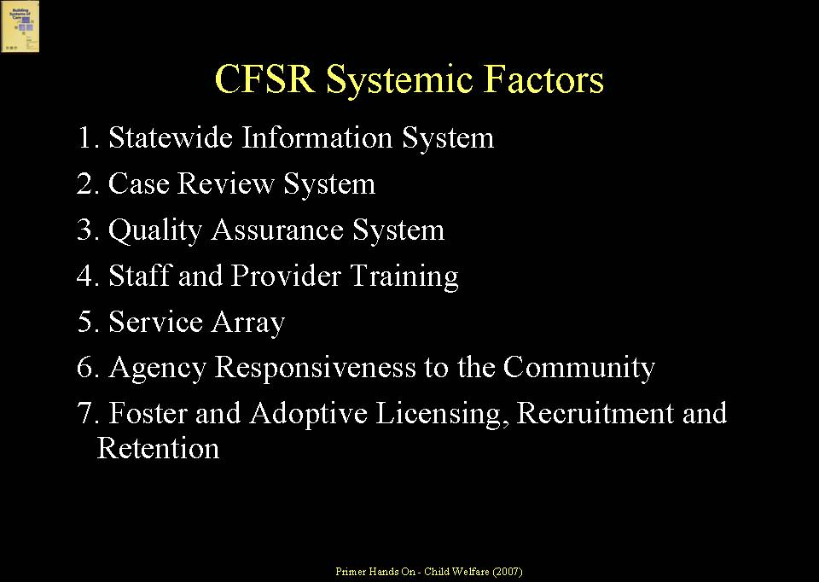  A number of SOC operational characteristics are reflected in the systemic factors that are reviewed as part of CFSR, which are related to a State’s capacity to achieve CFSR outcomes. CFSR systemic factors include:  - Statewide information system (having access to “real time” information to inform decision making at policy and service levels);  - case review system (having a process in place to ensure development, in partnership with families, of timely and appropriate plans for services and supports and review of plans as needed to ensure appropriateness and effectiveness of supports;  - quality assurance system (using information to improve quality on a systematic basis);  - staff and provider training (capacity building in new practice models and system goals);  - service array and resource development (having access to a broad and diverse array of services and supports through partnerships and collaborative financing);  - agency responsiveness to the community (ensuring involvement of the community, drawing in community resources, and being responsive to unique community needs); and  - foster and adoptive licensing, recruitment, and retention (with appropriate supports for foster and adoptive families to enhance recruitment and retention efforts).  Resonance Between SOC and CFSR Outcomes  SLIDE 16 (24)  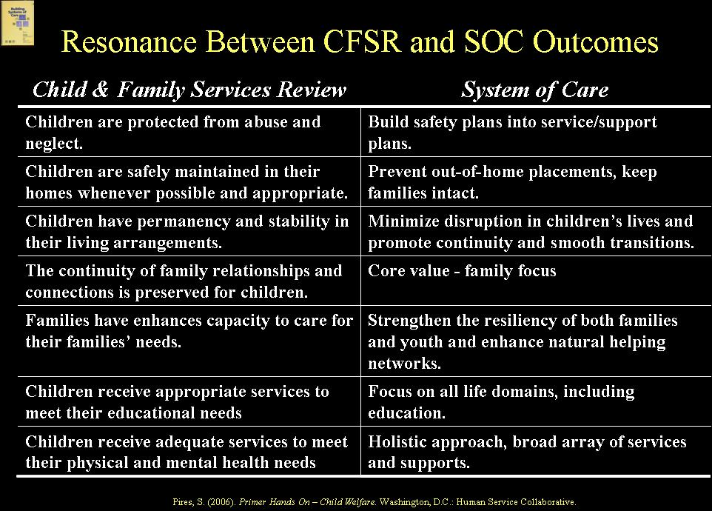  Over time, the system of care movement has become very outcomes-oriented. Systems of care focus on outcomes both at the child/family level, such as clinical and functional outcomes and family/youth satisfaction and their experience with the system, and outcomes at a systems level, such as reduced use of out-of-home placements and family stability. Because systems of care include children and families involved in child welfare systems, they pay attention to safety outcomes, quality of living arrangements, and overall well-being. Outcomes that are important to child welfare systems, such as reduction in the incidence of repeat maltreatment or foster care re-entries, permanency and stability are also important to systems of care.  Similarly, the CFSR process is inherently outcomes-focused. It is concerned ultimately with whether safety, permanency and well-being outcomes are achieved on behalf of a defined population of children and families – i.e., those in, or at risk for involvement in, the child welfare system. The CFSR Child and Family Outcomes resonate with a system of care approach and include:  - Children are, first and foremost, protected from abuse and neglect. (Systems of care are fundamentally concerned about safety and address safety issues through child and family team processes, building safety plans into services and supports plans.)  - Children are safely maintained in their homes whenever possible and appropriate. (Systems of care seek to prevent out-of-home placements and strengthen the capacity of families to keep families together.)  - Children have permanency and stability in their living situations. (Systems of care seek to minimize disruptions in children’s lives and promote continuity of services and supports and smooth transitions.)  - The continuity of family relationships and connections is preserved for children. (This is a core value of systems of care.)  - Families have enhanced capacity to care for their children’s needs. (Systems of care seek to strengthen the resiliency of both families and youth and enhance natural helping networks to strengthen families’ capacities.)  - Children receive appropriate services to meet their educational needs. (Systems of care focus on the strengths and needs of children and families across life domains, including education.)  - Children receive adequate services to meet their physical and mental health needs. (Systems of care take a holistic approach and have as a core tenet the importance of a broad, flexible array of services and supports to meet the needs of children, youth and families.)  Systems of Care as a “Differential Response System” for Child Welfare  SLIDE 17 (25)  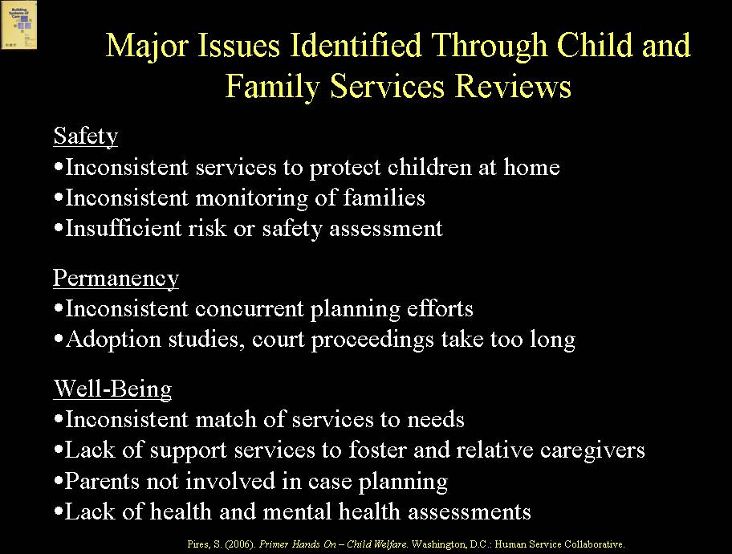  As one considers many of the issues that have been identified through the CFSR process, one can begin to conceptualize use of a SOC approach as a “differential response system”, in effect, for child welfare’s work with families. Major issues identified through the CFSR include:  Safety  - Inconsistent services to protect children at home  - Inconsistent monitoring of families  - Insufficient risk or safety assessment  Permanency  - Inconsistent concurrent planning efforts  - Adoption studies, court proceedings take too long  Well-Being  - Inconsistent match of services to needs  - Lack of support services to foster and relative caregivers  - Parents not involved in case planning  - Lack of health and mental health assessments  Systems of care provide a framework for a differential response to addressing these issues, including a framework for:  - Engagement of families and youth  - Cross-training around a common family-centered practice model  - Collaboration with other systems and programs, such as substance abuse and mental health, domestic violence, housing, etc.  - Expansion in the availability of services and supports through partnerships and collaborative financing approaches  - Comprehensive child and family assessments, including risk and safety and strengths and needs  - Data-driven policy and service delivery  - Quality improvement informed by data.  SLIDE 18 (26)  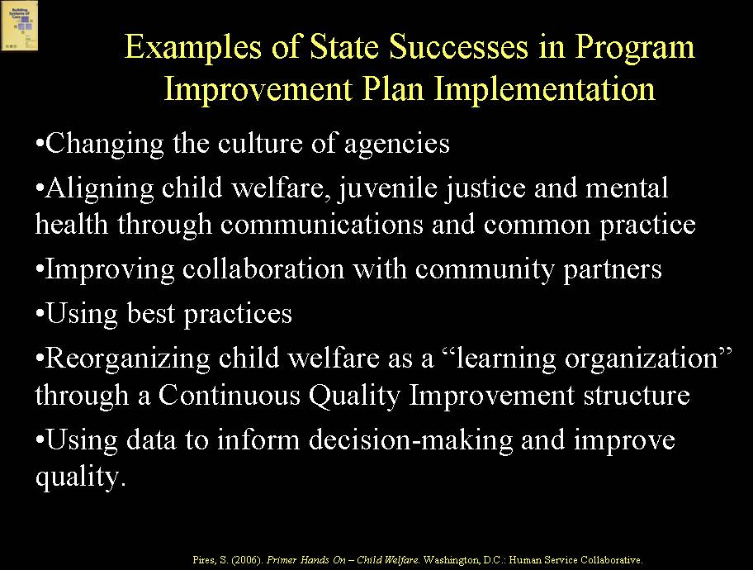  The CFSR process has led to identification of “State successes” in implementing Program Improvement Plans (PIP). These successes include: changing the culture of agencies; aligning child welfare, juvenile justice and mental health through communications, shared values, and common practice; improving collaboration with community partners; using best practices; reorganizing child welfare as a “learning organization” through a Continuous Quality Improvement structure; and, using data to inform decision-making and improve quality. As discussed throughout Primer Hands On-Child Welfare, these are the same strategies and desired outcomes seen in systems of care. Indeed, many of the States that have successfully implemented their PIP have adopted a system of care approach to do so.  EXAMPLE  Oregon is an example of a State that utilized a system of care approach in response to a child welfare-related law suit. Oregon connected its system of care strategies to the CFSR and its PIP, in particular incorporating the SOC and CFSR principle of family-centered, comprehensive assessment throughout the entire period of a child and family’s involvement in child welfare to prevent repeat maltreatment, promote permanency, and ensure well-being through the provision of needed services and supports.  Systems Problems  SLIDE 19 (27)  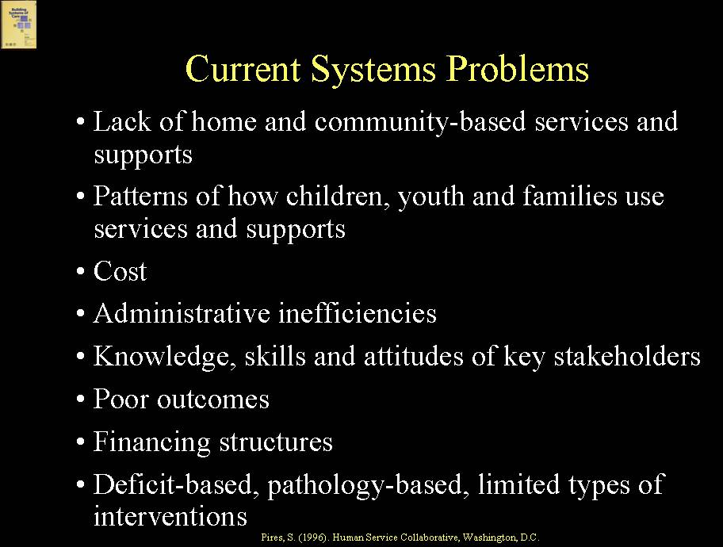  The concept of systems of care developed and has taken root over time as an approach to address long-standing problems with traditional systems, many of which persist today. Entrenched systems problems include:  - lack of home and community-based services and supports both for children and youth and for families;  - patterns of utilization – that is, the ways in which children and families use services and supports - in which relatively small percentages of children and families with the most serious and complex issues use a very large percentage of the service dollars because, for example, children are placed for too long or repeatedly in restrictive levels of care and because financing streams may create incentives to place children;  - high costs associated with these patterns of utilization;  - administrative inefficiencies when multiple systems serving children and families create parallel delivery systems serving many of the same children and families;  - knowledge, attitudes and skills of key stakeholders (e.g., staff, supervisors, providers, clinicians, families) that do not embrace or know how to implement family-driven, youth-guided, culturally and linguistically competent, strengths-based and individualized services and supports;  - a history of poor outcomes;  - rigid financing structures; or  - deficit models with limited types of interventions that do not lend themselves to a strengths-based, individualized approach.  These types of systems problems translate, in child welfare, to a range of issues that have led to increasing interest in a system of care approach. These include such issues as:  - lack of services and supports for parents, particularly for those with challenges such as mental health or substance abuse problems;  - lack of services and supports for youth transitioning from foster care;  - lack of prevention and outreach to high-risk populations because the bulk of resources are tied up in out-of-home placement costs; and  - a recognition that the farther a child is removed from family, the poorer the outcomes and the higher the costs.  A system of care approach recognizes that the child welfare system alone cannot be expected to address successfully these and other cross-system issues; they are the responsibility of multiple systems and of the larger community.  Fractured Accountability  SLIDE 20 (28)  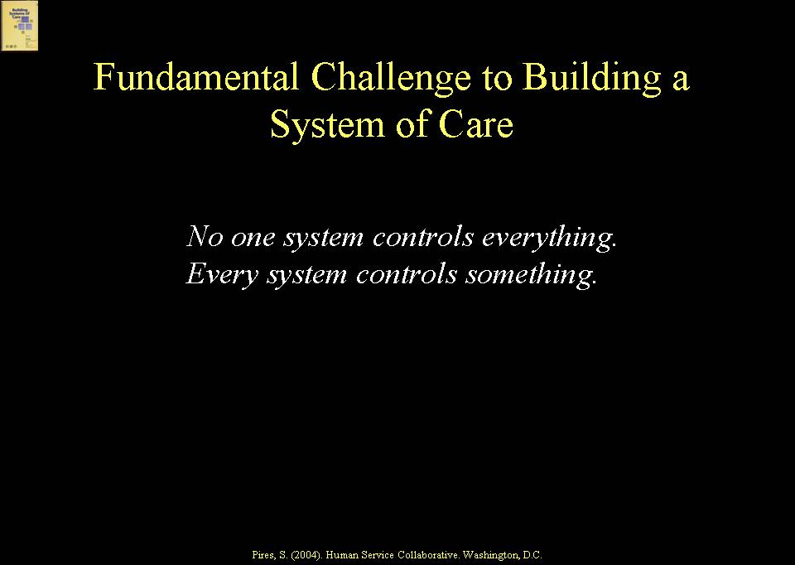  Systems of care represent a way to address the basic challenge of multiple system involvement in the lives of families – particularly true for children and families involved in child welfare – and fractured accountability.  SOC Connected to Larger System Reform Movement  Slide 21 (29)  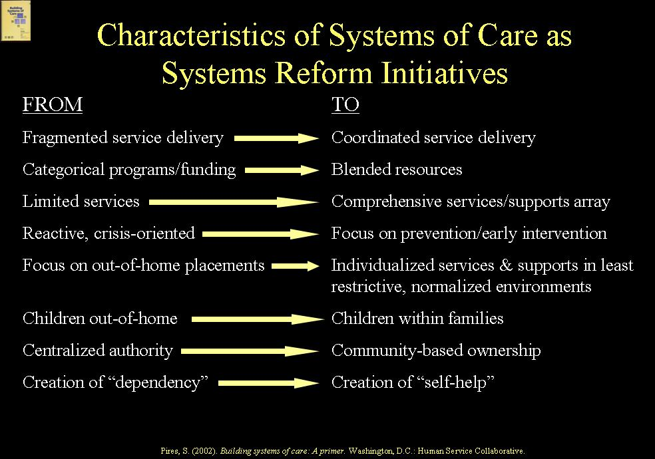  The system of care movement is part of a larger systems reform agenda in child, youth and family services, which has multiple characteristics, including movement from:  - fragmented service delivery to coordinated service delivery;  - categorical funding and programs to blended resources;  - limited services to a comprehensive services and supports array;  - reactive, crisis-oriented systems to a focus on prevention and early intervention;  - a focus on out-of-home placements to individualized services and supports in least restrictive, normalized environments;  - children out-of-home to children within families;  - centralized authority to community-based, local ownership;  - creation of system dependency to self help.  Need for Frontline Practice Change  SLIDE 22 (30)  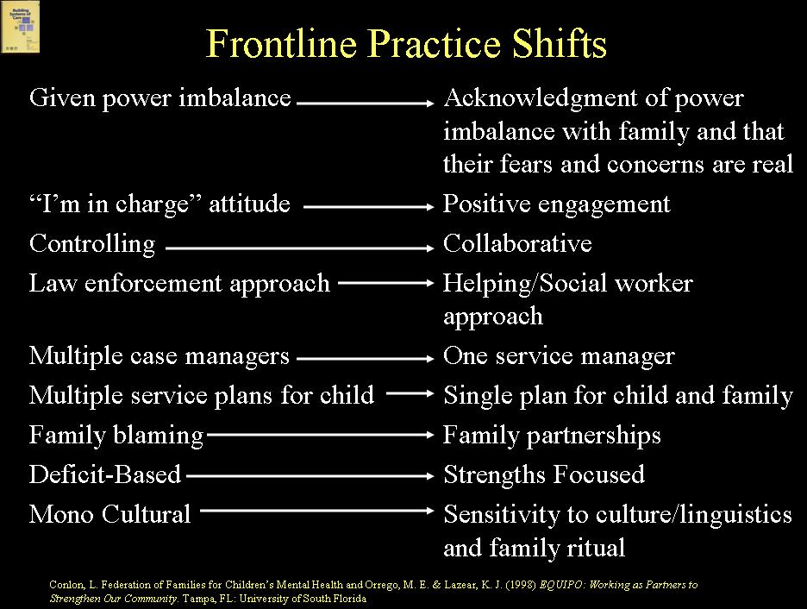  Systems reform involves both systems-level and frontline practice change. Shifts required at a practice level include movement from: 1) control by professionals to partnerships with families and youth; 2) only professional services to a partnership between professional services and natural helpers and supports; 3) multiple case managers to one accountable service manager; 4) multiple service plans to a single plan for a child and family; 4) family blaming to family partnerships; 5) a deficits to a strengths-based approach; and 5) a mono cultural to a culturally and linguistically competent approach.  How Families Become Involved with Systems of Care  SLIDE 23 (31)  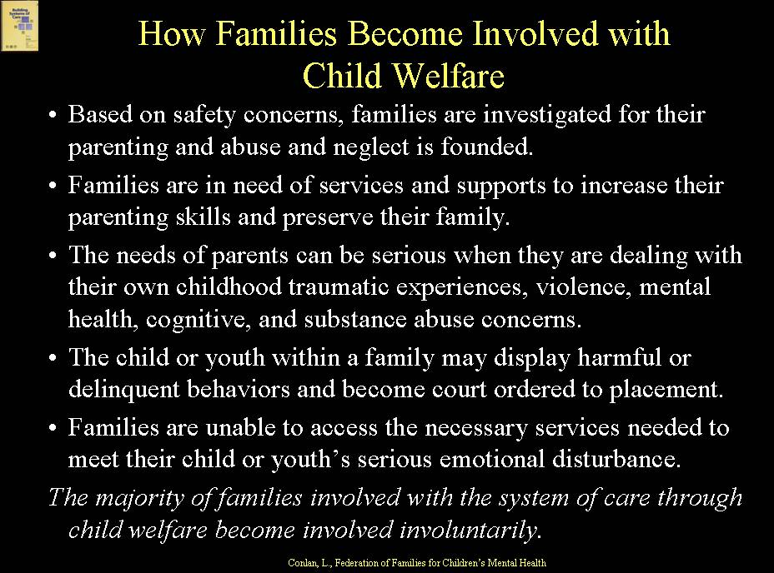  It is important for all system partners to understand how families representing the child welfare population may become involved with the system of care. The majority of families who become involved with the system of care based on their involvement with child welfare may be involuntarily involved due to any number of experiences. Based on safety concerns, families may have been investigated, and abuse and neglect may have been founded. Families may be seeking additional services and supports for themselves to prevent their children from going into placement and may be trying to strengthen their parenting skills and preserve their family. Parents’ needs be serious as parents may be dealing with their own childhood traumatic experiences, cognitive impairments, mental health and/or substance abuse issues, lack of access to housing and other basic needs, and family violence issues. Sometimes, the child or youth within a family may display harmful or delinquent behaviors, and families become involved with child welfare in an attempt to access services needed to meet their child or youth’s serious behavioral health challenges. From a frontline practice standpoint, understanding a particular family’s reasons for being involved with child welfare and the system of care, and understanding the strengths and challenges within the family, is a critical first step in partnering with families and moving toward a family-centered approach. A better understanding of and partnership with families also can help in the development of prevention strategies to keep families from becoming involved, or from deeper involvement, or repeat involvement with child welfare.  Family-Centered Practice Approach  SLIDE 24 (32)  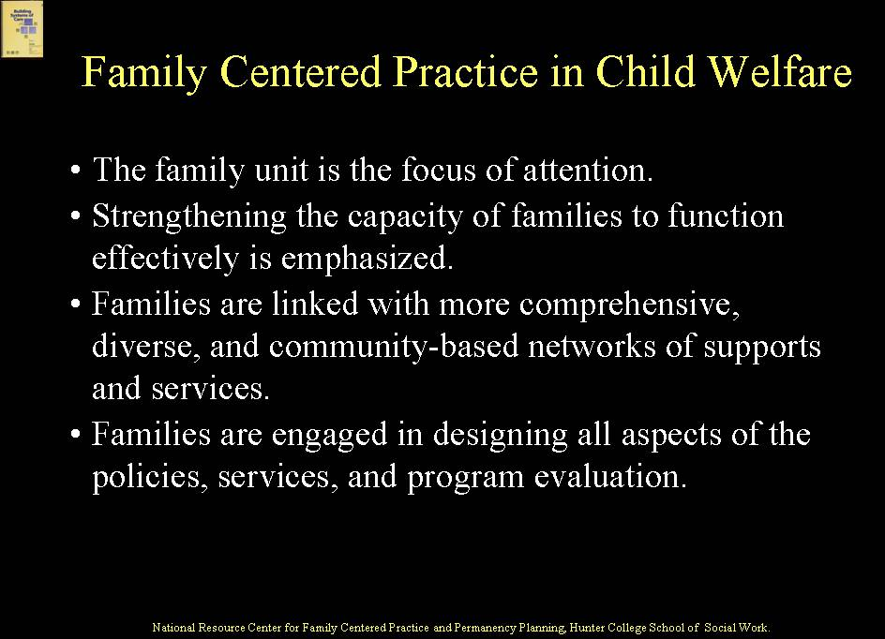  The implementation of family-centered practice is an expectation in child welfare practice, just as it is in systems of care. The National Resource Center for Family Centered Practice and Permanency Planning reports four essential components of family-centered practice, which include: 1) The family unit is the focus of attention. This helps to ensure the safety and well-being of all the family members. 2) Strengthening the capacity of families to function effectively is emphasized. The primary purpose of family-centered practice is to strengthen the family’s potential for carrying out their responsibilities. 3) Families are linked with more comprehensive, diverse, and community-based networks of supports and services. Family-centered interventions assist in mobilizing resources to maximize communication, shared planning, and collaboration among the several community and/or neighborhood providers that are directly involved with the family. 4) Families are engaged in designing all aspects of the policies, services, and program evaluation. To successfully implement family-centered practices, learning new approaches for engagement is critical.  Shift in Roles and Expectations of Families and Youth  SLIDE 25 (33)  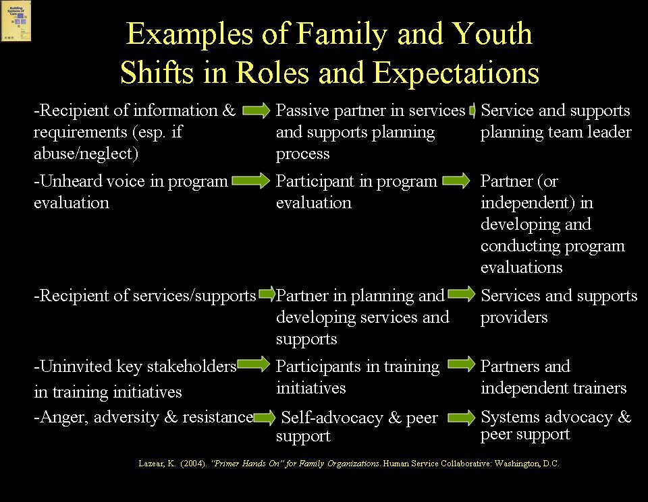  Systems change not only involves changes in the way that staff and providers interact with families and youth but changes as well in the roles and expectations of families and youth themselves. Some of these shifts in roles and expectations include moving from: 1) being a recipient of service plan information and service requirements to participating in service planning to being a service planning team leader; 2) being an unheard voice in program evaluation to participating in evaluation to being a partner in developing and conducting program evaluations; 3) being a recipient of services and supports to partnering in planning and developing services/supports to being a service/supports provider; 4) being uninvited to training activities to participating in training to partnering in developing training and being trainers; and 5) being angry and resistant to what may feel like coercion to self advocacy and peer support to systems-level advocacy and expanded capacity to provide peer support. Just as staff and providers need training and support to make the shifts called for in a system of care practice model, so, too, do family and youth partners.  Shift in Child Welfare Decision Making Practice  SLIDE 26 (34)  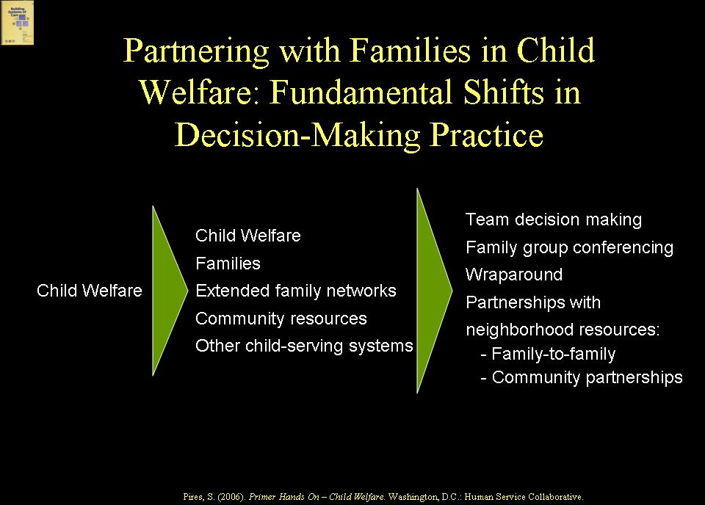  Partnering with families involved in child welfare, many of whom are involved involuntarily, entails a fundamental shift both in the perspective of families and of child welfare systems. Judgments about children’s safety within families still fundamentally have to be made. However, a systems of care approach moves child welfare from unilateral decision-making about children and families to one of partnering with youth and families, extended family networks, community resources and other systems that serve children, youth and families to ensure the safety and well-being of children and support for families. At a practice level, this is reflected in such approaches as Team Decision Making, Family Group Conferencing, and Wraparound, as well as by partnerships with neighborhood collaboratives through “Family-to-Family” and “Community Partnership” initiatives, which we will talk about in more detail later.  Change at Multiple Levels  SLIDE 27 (35)  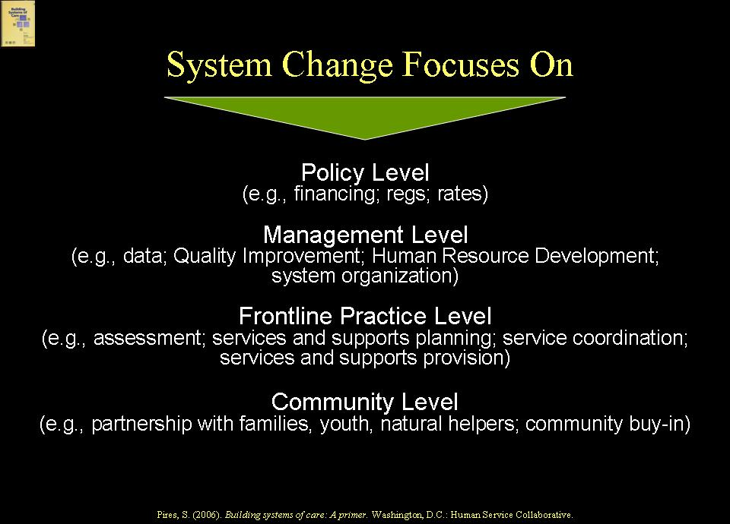  As noted earlier, systems reform entails changes at multiple levels and with multiple stakeholders. These levels include: the policy level, where changes need to be made in such areas as financing, regulatory policy, rate-setting, etc.; the management level, where changes are needed in such areas as information management, quality improvement, training, and system organization; the frontline practice level, where changes are needed in assessment, services and supports planning, service coordination, etc.; and the community level, where changes are required to partner with families, youth, and natural helping networks and to achieve community support.  Non-Categorical vs. Categorical System Reform  SLIDE 28 (36)  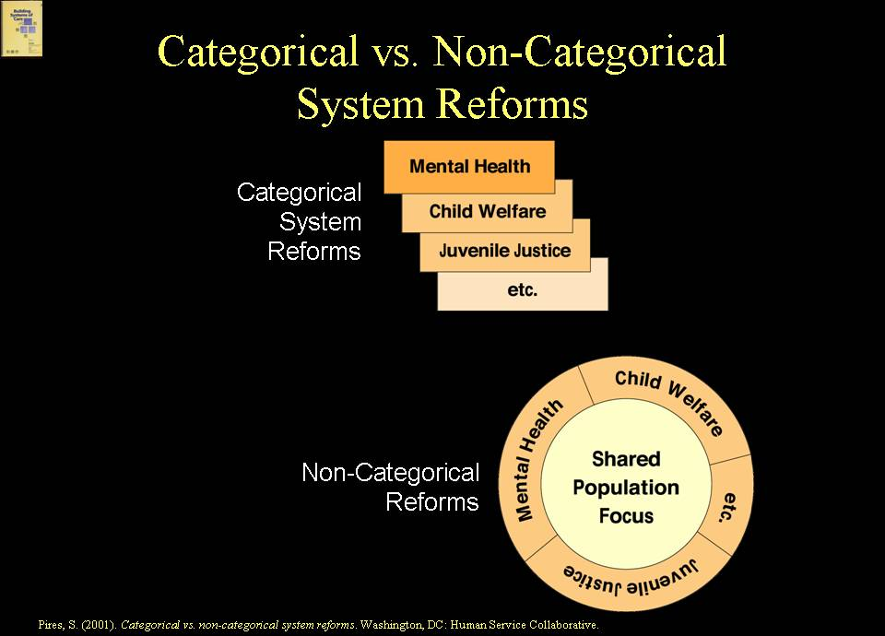  Systems of care are fundamentally non-categorical reform initiatives, unlike categorical reforms in child and family services where individual systems engage in efforts to reform their own systems, such as de-institutionalization in mental health, child welfare reforms that seek to prevent or reduce lengths of stay in foster care, school-based inclusion reforms in special education, and alternatives to incarceration in juvenile justice. As a non-categorical reform, a system of care reform takes a population focus; that is, it focuses on a population or populations of children and families who cross, or at risk of crossing, all or many of these systems and engages all systems in a reform agenda.  A Population Focus  SLIDE 29 (37)  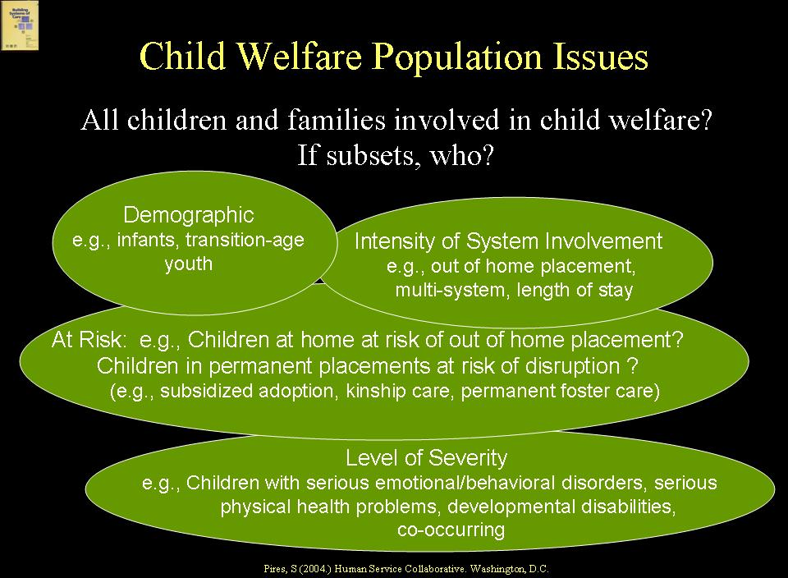  An essential early focus of system builders needs to be on understanding the populations of children, youth and families that are involved, or are at risk for involvement, in the child welfare system and determining target populations for the developing system of care, which may be the total population or subsets of the total. Population issues for the child welfare system include whether the focus is on the total population or subsets. Several ways of thinking about subsets is by:  - Demographics, e.g., Infants and toddlers? Transition-age youth? Racially and ethnically diverse children over-represented in child welfare?  - Intensity of system involvement; e.g., out-of-home placement; length of stay in foster care; multi-system involvement; number of placements; repeat maltreatment  - At risk characteristics, e.g., children with birth families at risk of child welfare involvement; children in permanent placements at risk for disruption; families in which methamphetamine abuse is occurring; teen mothers under severe stress, etc.  - Level of clinical/functional impairment, e.g., children with serious emotional disorders; children with serious physical health conditions; children with developmental disabilities; children with co-occurring disorders, such as mental health and developmental challenges.  Prevalence and Utilization  Understanding prevalence of problems and current utilization – that is, the way that children and families use services and supports - also is essential. Visually, think of a triangle representing prevalence and utilization among all children and families in a given State, Tribe, or community for problems that may lead to involvement with public systems.  SLIDE 30 (38)  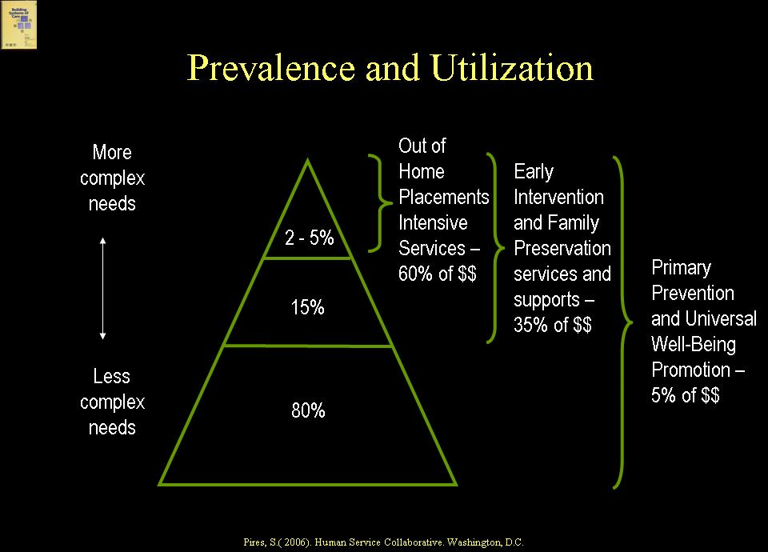  At the top of the triangle is the relatively small percentage of children and families with serious and complex problems that may be using a large percentage of the dollars, including many of the children and families involved in child welfare. These include, for example, children in out-of-home placements. In the middle of the triangle are various at risk populations of children and families who need services and supports but where there may be few resources available (because a large percentage of the dollars are going to the top of the triangle). This includes many families at risk for child welfare involvement. At the bottom of the triangle are most children and families, who do not need specialized services and supports but where primary prevention is imperative; in most States, however, very few resources are available for prevention (because the dollars are being spent on the rest of the triangle).  A Population-Driven Systems Approach  SLIDE 31 (39)  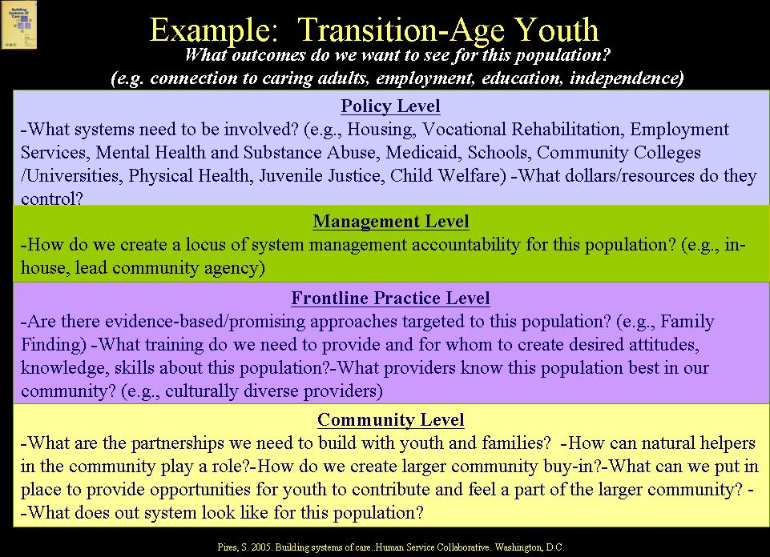  The strengths and needs of the populations must drive the types of services, supports and strategies that will be required in the system of care, the financing streams that need to be accessed, the stakeholders that need to be involved, etc. For example, if the system is focusing initially on infants and young children and their families, it must partner with early intervention programs, Head Start and day care, and primary care practices become even more critical. If it is focusing on transition-age youth, another set of players, funding streams, services, supports and community resources come into play. For example, in a system of care approach to a population subset of transition-age youth (i.e., youth aging out of the child welfare system), it is important to recognize that this population is not only involved in child welfare but also may be involved with juvenile justice, mental health and substance abuse, special education, etc. and will require supports from many systems, such as vocational rehabilitation, public assistance, housing, employment services, etc.  State Commitment and Local Ownership  SLIDE 32 (40)  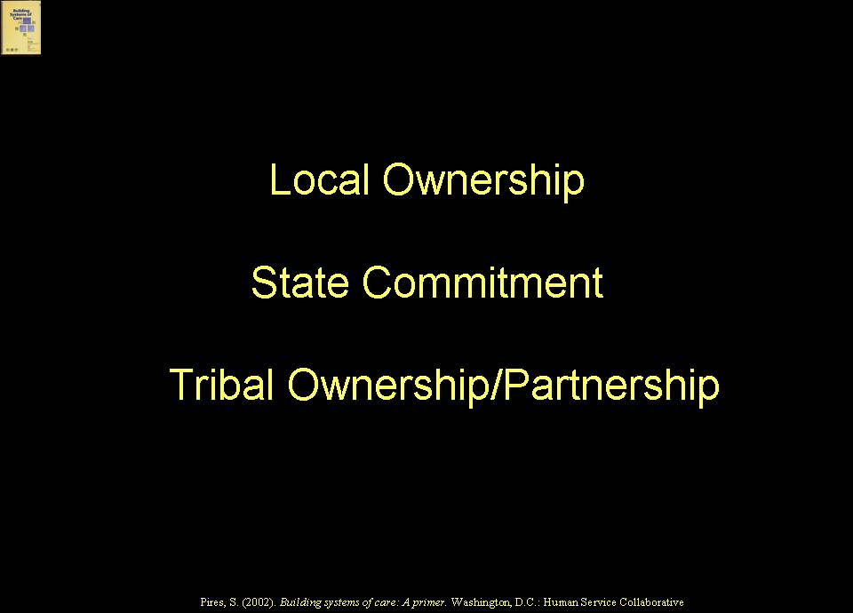  System of care reforms entail State, Tribal and local partnerships. States must be committed to reform because so much of the needed financing is controlled at State levels, along with critical policy and regulatory responsibilities. Local ownership is essential to reflect community strengths, needs, values, and day-to-day realities in order to make the system of care relevant to the community. In some States, child welfare is a State-supervised system, in which State-level stakeholders must figure out how to generate community-level involvement and buy-in. In other states, child welfare is a locally-run system in which local stakeholders must figure out how to create State-level buy-in. In still other States, child welfare is a hybrid with both the State and localities playing major policy and funding roles. In States where child welfare has been privatized, private providers are playing key roles that, historically, were played by state or local agencies. Tribal authorities also play key roles, with a right to intervene in situations involving children enrolled as Tribal members.  Definition of Evidence-Based and Promising Practices  SLIDE 33 (41)  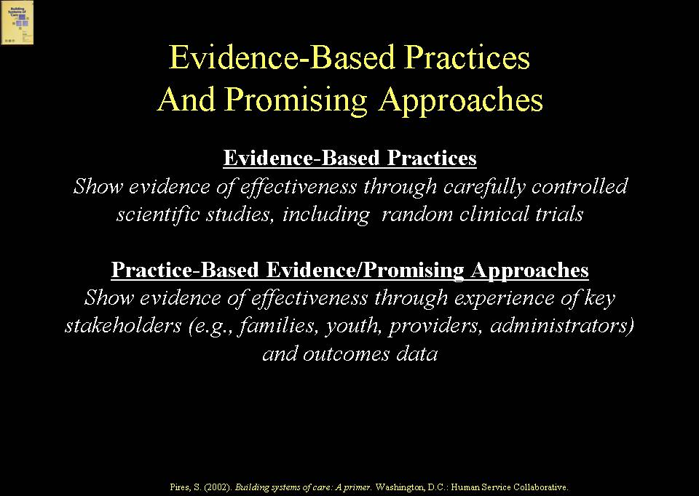  Systems of care have been influenced over the past decade by the movement toward evidence-based and effective practices in child and family services – and vice versa. Evidence-based practices “show evidence of effectiveness through carefully controlled scientific studies, including random clinical trials”; these are practices that have had the benefit of research dollars. Promising approaches (also referred to as “practice-based evidence”) “show evidence of effectiveness through the experience of key stakeholders – e.g., families and youth, providers and administrators – and outcome data”. Both evidence-based and promising approaches are needed in systems of care.  Examples of Evidence-Based and Promising Practices  SLIDE 34 (42)  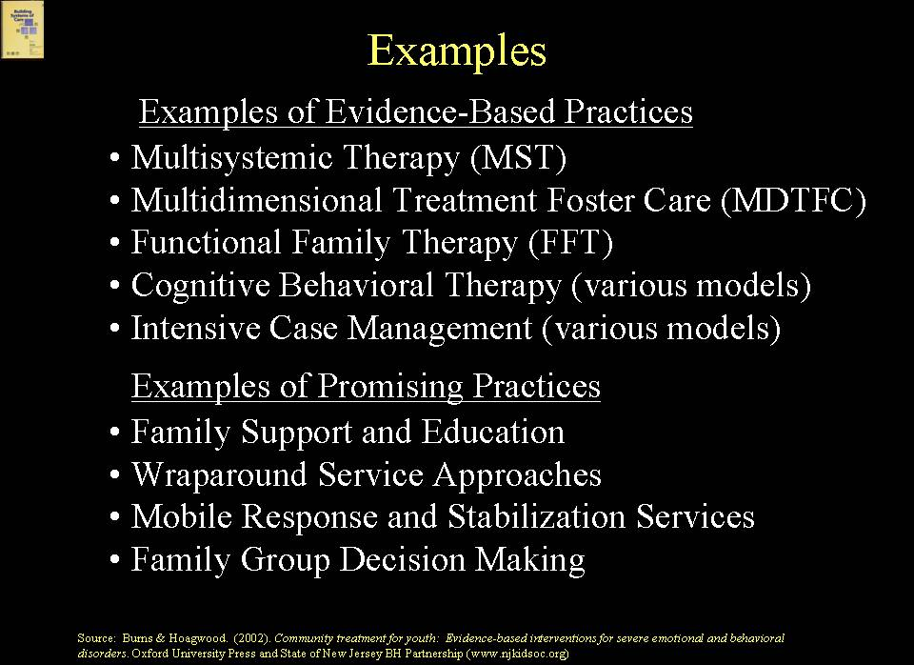  SLIDE 35 (43)  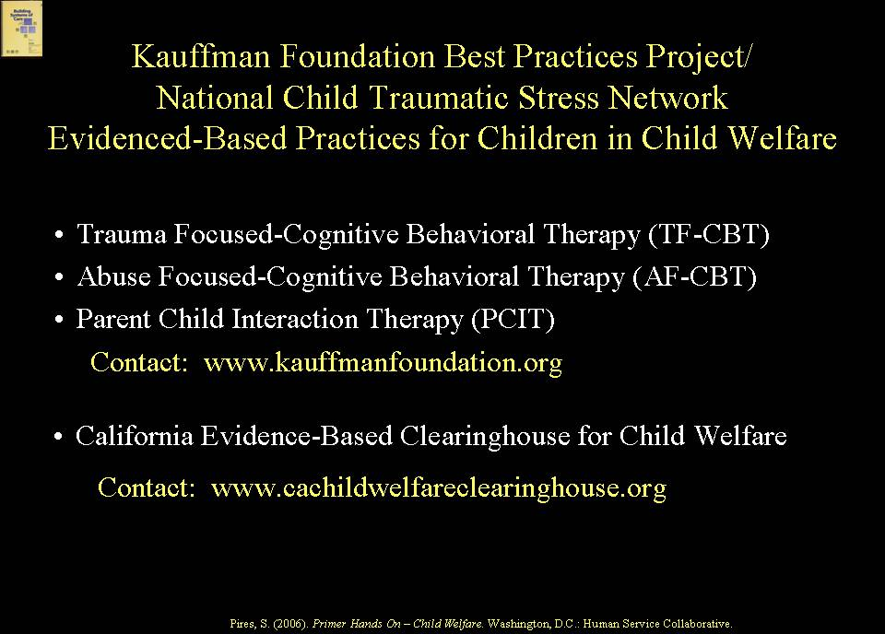  Examples of evidence-based practices include Multi-Dimensional Treatment Foster Care (MDFT) and Multisystemic Therapy (MST,) and promising approaches, such as Family Group Decision Making, Wraparound, and Mobile Response and Stabilization Services. The Kaufman Foundation, in collaboration with the National Child Traumatic Stress Network, recently published a report on evidence-based practices for children involved in child welfare who have been exposed to trauma. These include a number of cognitive behavioral therapy approaches, as well as Parent-Child Interaction Therapy.  EXAMPLE  Several States also are systematically trying to identify and implement effective practices for children involved in child welfare, such as California’s Evidence-Based Clearinghouse for Child Welfare. (www.cachildwelfareclearinghouse.org)  Comparative Evidence  SLIDE 36 (44)  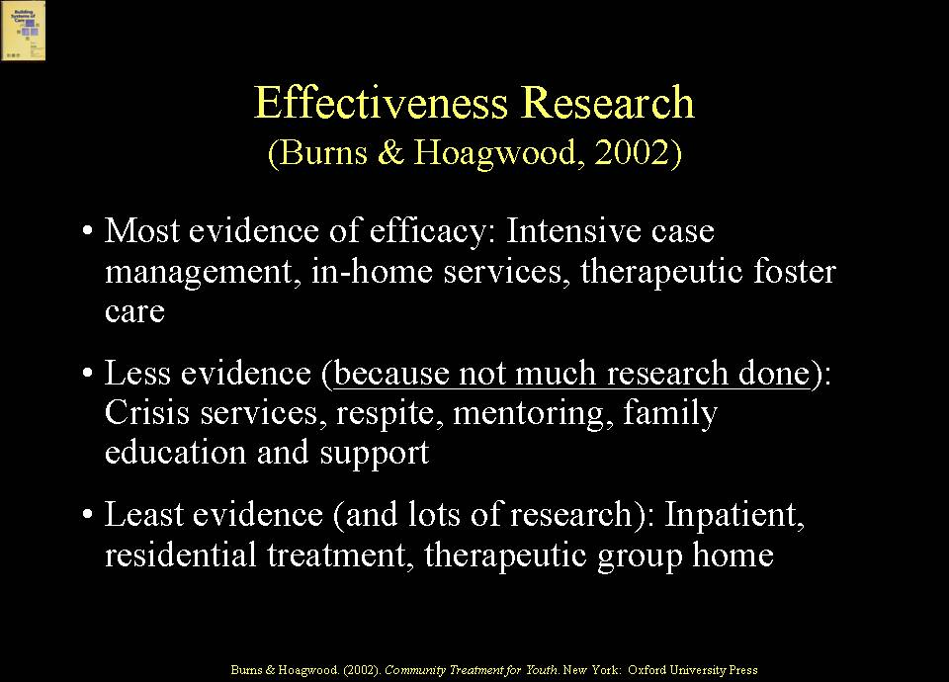  Research conducted by Barbara Burns and Kimberly Hoagwood examined evidence-based practices for children with serious behavioral health disorders, including children and youth involved in child welfare, whose prevalence for behavioral health problems is very high. They concluded that there was most evidence for the following services: intensive case management, in-home services, and treatment foster care. They found less evidence, because so little research has been done, for crisis services, respite, mentoring and family education and support; to reiterate, there was little evidence because so little research has been done – this is an important caveat because families often identify these services as the most “missing” and most needed within the service array. Burns and Hoagwood found the least evidence (and lots of research) for the services we tend to use the most for children with serious problems, namely, inpatient hospitalization, residential treatment and group homes.  Shared Characteristics of Evidence-Based and Promising Practices  SLIDE 37 (45)  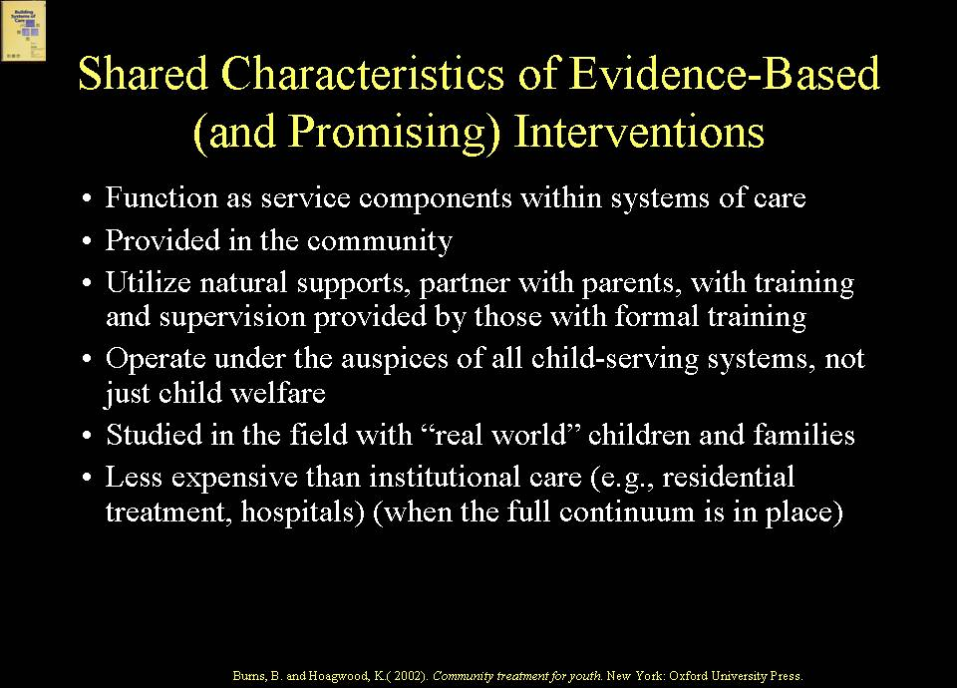  Burns and Hoagwood identified shared characteristics of evidence based and promising practices. These characteristics include that they: function as service components within systems of care; are provided in the community; utilize natural supports and partner with families, with training and supervision provided by those with formal training; operate under the auspices of all systems serving children and families; are studied in the field with “real world” children and families; and are less expensive than institutional care, such as residential treatment and hospitals, when a continuum is in place.  Returning to Values  This Module began with a discussion of values because that is where system of care work begins. Shared system of care values are what guide a system building process. Achieving consensus on values across diverse stakeholder groups is a first step in system building.  EXERCISE 2.1  Assumptions and Values  A system of care approach begins with shared values and principles. The various stakeholders involved come with their own established values that are not necessarily shared at first. Exercise 2.1 provides you an opportunity to fill out a sheet that expresses the degree to which you hold certain values related to building systems of care and to spend a few minutes, in large group discussion, exploring similarities and differences in perceptions. Later, in your team meetings, you will have an opportunity to compare similarities and differences in greater depth among your team members.  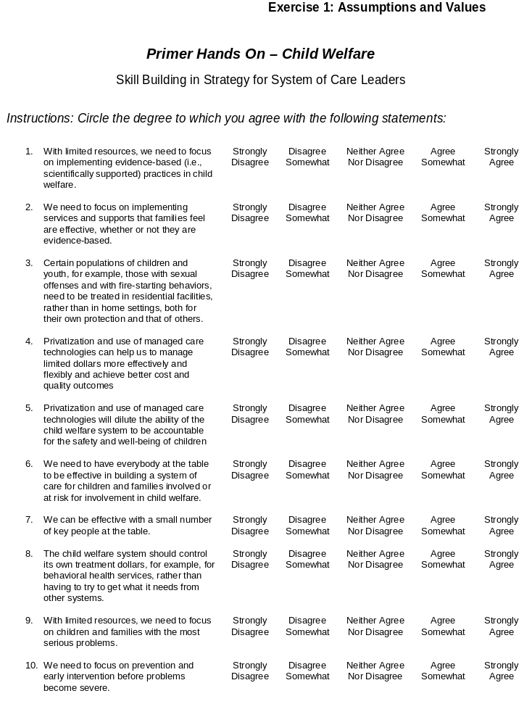  SLIDE 38 (46)  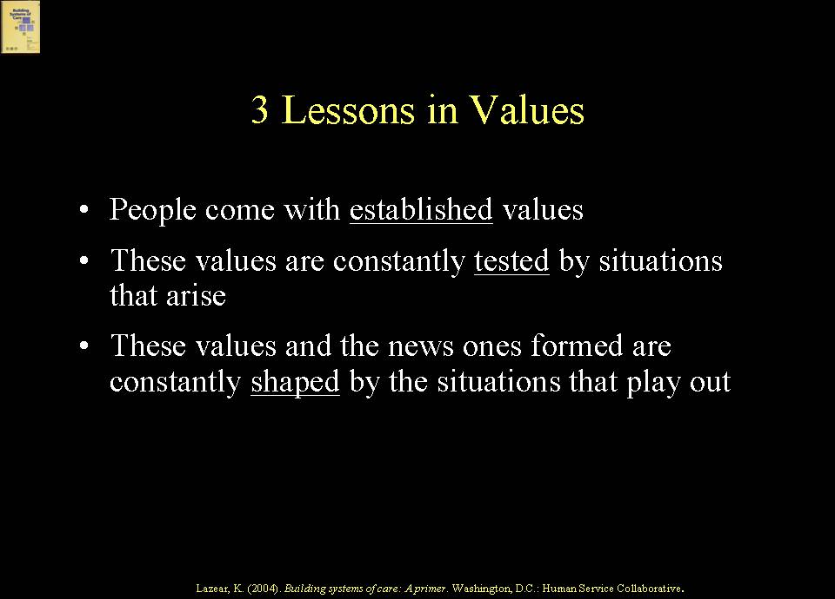  We all come to this work with values that we have integrated into our lives from our culture, family, our work environment, sub-groups, etc. These values are tested over time and shaped as system building proceeds. System builders need to create an environment in which it is safe for stakeholders to express their values, and system builders need to provide leadership in developing sufficient common ground for system building to advance. The most successful and sustaining system building efforts have been those that establish their values early, use them to guide their decisions, and revisit them often. | Trainer’s Notes  Goals  This is a didactic presentation of material from Primer Hands On-Child Welfare: A Skill Building Curriculum. The goals of Module 2 are to familiarize participants with definitions, history, values, principles and characteristics of systems of care for children, youth and families involved, or at risk for involvement, in the child welfare system. The synergy between the Child and Family Services Review (CFSR) process in child welfare and system of care values and principles is emphasized.  Method  PowerPoint Presentation; didactic; large group discussion  Training Aids  Microphone if necessary; projector, laptop computer, screen; slides #1-38 (slides #10-46 if utilizing the complete curriculum version with no module cover slide). Exercise 2.1  Approximate Time  30 min.  Expected Outcomes  At the end of Module 2, participants should be familiar with:  - Definition of system of care  - Administration for Children and Families System of Care Sites  - Brief history of system of care  - Child welfare system of care activities  - System of care as an organizing framework for reform supported by core values  - Similarity between values in family support and youth development movements and system of care values and goals  - Consistency between Child and Family Services Review (CFSR) factors, process, and outcomes and system of care principles  - System of care operational characteristics  - Systems problems addressed, including fractured accountability  - System of care connected to a larger system reform movement  - Focus on multiple system levels: policy, management, frontline practice, and community  - Shifts in roles of families and youth  - Difference between non-categorical versus categorical reform efforts  - Importance of a population focus and a population-driven systems approach  - Need for state commitment, tribal and local ownership  - Definitions, comparisons, shared characteristics and examples of evidence-based and promising practices.  Please note that in the full two-day Primer Hands On-Child Welfare training, Module 2 provides an overview and basic context-setting that is designed to be presented in no more than 30 minutes. It assumes a basic level of familiarity with systems of care by participants. Module 2 can also be presented by itself, or in combination with Modules 3 and 4, as a more in-depth orientation to systems of care for a participant group that is not generally familiar with systems of care.  Trainer’s Notes  Emphasize the common system of care framework from which the federal agencies and national technical assistance centers today are working. This has evolved over time  Trainer’s Notes  Slide 5 (13) provides examples of how child welfare nationally has been increasingly involved in system of care activities. Feel free to add to these examples from your own knowledge base.  Trainer’s Notes  In addition to Alamance County, NC, you may want to provide other examples that you are familiar with that illustrate how States, Tribes, or communities have pulled together related system of care reform efforts initiated by separate federal or foundation grants to avoid perpetuating “categorical” systems of care.  The next several slides address the importance of values in systems of care.  Trainer’s Notes  Let participants know that throughout this training, the goal is to illustrate how these values and principles can be operationalized, providing “real world” examples that allow for strategic consideration of the pros and cons of various approaches.  Trainer’s Notes  Many participants may be familiar with system of care values and principles. You do not need to go into depth on each of these, nor do you have time in the two-day training. Rather, touch upon a few key ones, and acknowledge that participants may already be familiar with them. This is a context-setting Module to ensure that all participants have the same basic understanding of systems of care.  .  Trainer’s Notes  Use the next two slides to emphasize the synergy between the values of the family support movement that grew out of child welfare and the youth development movement that developed, initially, in youth employment and youth work, and system of care values and principles. You do not need to go through all of these in detail. Point out a few to illustrate the synergy with system of care values.  Trainer’s Notes  Emphasize the synergy between system of care values and principles and the child welfare principles that inform the CFSR process.  More information about the principles embedded within CFSR can be found at: www.acf.hhs.gov/programs/cb/cwmonitoring/results/index.htm  Alabama’s R.C. Goals and Principles (Handout 2.1) are the result of the first statewide-bottom-up reform of a child welfare system in the United States based on system of care principles. Alabama’s child welfare system “reflected all the problems seen nationally: huge backlogs of uninvestigated child abuse and neglect reports, children languishing for years in foster care and children with serious emotional problems on long waiting lists for treatment, often ultimately provided in institutional settings far from their homes,” * and a rigid bureaucratic structure which had drifted from its purpose. This was the impetus for the class action lawsuit, R.C. v. Hornsby, which was settled in 1991.  For more information read: *Making Child Welfare Work: How the R.C. Lawsuit Forged New Partnerships To Protect Children And Sustain Families, Judge David L. Bazelon Center for Mental Health Law, Washington DC, May 1998. www.bazelon.org.  In addition to the examples provided, include other examples with which you are familiar to illustrate use of a system of care approach in child welfare.  Emphasize to participants that there is also more shared understanding today both within and across systems about the operational characteristics of systems of care.  Trainer’s Notes  Note that system of care operational characteristics are reflected in the systemic factors that are part of the CFSR process.  Trainer’s Notes  Slide #16 (24), which illustrates the resonance between system of care and CFSR outcomes, will help provide an important framework from which the rest of the curriculum builds. It is critical therefore, to spend some time emphasizing the similarities and asking participants if they have any questions or comments at this time. Many of the questions that will be asked will be answered in later Modules. However, do provide brief responses to help alleviate any concerns that some participants may have about these operational characteristics.  Trainer’s Notes  Trainer’s Notes  The next two slides create an opportunity to address how systems of care can be utilized by child welfare as a “differential response” to issues raised in CFSR reviews related to safety, permanency, and well-being.  Trainer’s Notes  You may wish to share other examples from your own experience of how States used a system of care framework to implement Program Improvement Plans (PIP).  Trainer’s Notes  Note that the systems problems that systems of care are intended to address cut across and have been prevalent, historically, in all systems that serve children, youth and families. One could use the same list of systems problems to categorize historic issues in child welfare, mental health, juvenile justice, etc. You might use this segment to describe particular systems problems in child welfare that create interest in a systems of care approach – for example, lack of services for adult family members with substance abuse and mental health challenges; or, lack of a coordinated child and family services/supports plan; or, lack of services for youth transitioning from foster care; or, lack of resources for prevention if most of the resources are going to children in out of home care.  Trainer’s Notes  Use the simple reality on this slide to reinforce the concept that better outcomes for children and families in child welfare are more likely to be achieved through effective collaboration.  Trainer’s Notes  Note that these system reform characteristics are applicable to all systems that serve children, youth and families.  Trainer’s Notes  Systems reform requires changes at both a systems and a frontline practice level. The following slides focus on the types of changes needed at a frontline practice level.  One of the most critical shifts in a system of care approach is partnering with families and youth. This can be especially challenging in child welfare with families who are not voluntarily involved in the system.  The following four slides, which address a family-centered approach with child welfare-involved families, are most effectively presented by the parent co-trainer, who can emphasize the shifts from a more personal basis ( just as the “professional” co-trainer(s) speaks from her or his personal/professional experiences).  Trainer’s Notes  These are elements of a family-centered practice approach as described by the National Resource Center for Family Centered Practice and Permanency Planning (www.hunter.cuny.edu/socwork/nrcfcpp)  Trainer’s Notes  Point out to participants that a family-centered approach not only requires changes on the part of staff and providers but changes in the roles and expectations of families and youth as well.  Trainer’s Notes  You may want to provide an example from your own experience about how a child welfare system has moved from unilateral decision making to one that includes families and youth, using a supportive approach, such as Family Group Decision Making.  At this point in the training, participants may want to delve deeper into concerns about and the “hows” of partnering with families involved in child welfare. While it is important to be responsive to questions, be brief and assure participants that you will be covering this aspect in more detail throughout the training as this particular module is a broader context-setting piece.  Trainer’s Notes  This slide returns to a point made earlier that a system of care approach requires change on multiple levels. This is what makes system building challenging but also transformative.  Trainer’s Notes  This slide introduces a key concept of systems of care – that it takes a population focus and requires involvement of all systems involved with the population(s) of focus. It is not a unilateral system change.  Trainer’s Notes  Make the point that children and families involved, or at risk for involvement, in child welfare are not a homogenous population. A first step in systems of care for child welfare populations is determining whether the population focus is on all children and families involved in the system, all children and families at risk for involvement, or subsets.  Trainer’s Notes  Understanding prevalence and utilization can help system builders prioritize their population(s) of focus. For example, system builders may decide to focus on children, youth and families at the top of the triangle (“high utilizers”) because outcomes are poor or expenditures are high. Or, they may want to focus on children and families in the middle (those “at risk”) to reduce the numbers of children and families reaching the top of the triangle.  Trainer’s Notes  Slide #31 (39) provides an example of a population-driven systems approach focusing on transition-age youth, a population for whom multiple players, funding streams, services, supports and community resources come into play. It is important to recognize that this population is not only involved in child welfare but also may be involved with juvenile justice, mental health and substance abuse, special education, etc. and will require supports from many systems, such as vocational rehabilitation, public assistance, housing, employment services, etc.  Feel free to add examples of effective practices for transition-age youth – for example, use of Family Finding to create connection to extended family networks and provide youth with a sense of belonging.  Trainer’s Notes  Part of the strategic assessment that system builders need to undertake is to ascertain how child and family systems, including the child welfare system, are structured in their particular States and localities, including the role that counties play versus the State, and the role played by private providers, especially when the child welfare system has been privatized. This also includes understanding Tribal structures if Native American children are included in the population(s) of focus.  Trainer’s Notes  The next five slides provide an opportunity to discuss how systems of care, increasingly, are benefiting from development of evidence-based and effective practices, including practices developed specifically for children and families involved in child welfare, such as trauma-informed practice. The slides also allow trainers to point out the differences between, and need for, both evidence-based and promising practices.  Let participants know that further discussion of evidence-based and promising practices will occur in the Module on Service Array/Financing. The purpose of introducing the topic here is, again, as part of a broader context-setting overview.  Trainer’s Notes  You may wish to use additional examples of evidence-based and promising approaches.  The Kauffman Foundation Best Practices Project report can be found at: www. kauffmanfoundation.org.  Trainer’s Notes  From your own experience, add to the growing list of States and localities that are developing evidence-based and promising practices for child welfare populations.  In addition to the resources cited on the slides, another resource is a toolkit on evidence-based practices that can be downloaded from the federal Substance Abuse and Mental Health Services Administration (SAMHSA) web site: http://www.mentalhealth.samhsa.gov/cmhs/communitysupport/toolkits  For further reading, the Burns and Hoagwood research is found in the publication, Community Treatment for Youth, eds. Burns, B. and Hoagwood, K., 2002, Oxford University Press.  Trainer’s Notes  Remind participants that this Module has presented a context-setting overview. Many of the points touched upon here will be dealt with in greater depth in subsequent Modules.  Trainer’s Notes  This exercise has participants fill out a sheet that expresses the degree to which they hold certain values related to building systems of care. Give participants 5-8 minutes to complete the written portion of the exercise. You or your co-trainer will then facilitate a large group discussion inviting participants to share their responses and their reasons for those responses.  The goal of this discussion is to have participants understand that there is no right or wrong answer, but that the items in the exercise – and similar ones that crop up in system building -- need to be discussed openly, with agreed-upon definitions. Often, by exploring why someone takes a particular stance, common ground can be found with those who seem to take an opposite view.  Encourage different participants to share their thoughts and feelings. Later, participants will have an opportunity to compare similarities and differences among their team members in their small group work.  Trainer’s Notes  Following the discussion, end this Module by emphasizing to participants the importance of the values work a community engages in throughout the system building process.  ,

