PRIMER HANDS ON -

CHILD WELFARE

TRAINING FOR CHILD WELFARE STAKEHOLDERS

IN BUILDING SYSTEMS OF CARE

TRAINING GUIDE

MODULE 3
Process and Structures

A Skill Building Curriculum

By Sheila A. Pires

In Partnership with Katherine J. Lazear, University of South Florida, and Lisa Conlan, Federation of Families for Children’s Mental Health

Based on
Building Systems of Care: A Primer
By Sheila A. Pires

Human Service Collaborative
Washington, D.C.

Sponsored by the National Child Welfare Resource Center for Organizational Improvement, University of Southern Maine, in partnership with the National Technical Assistance Center for Children’s Mental Health, Georgetown University, and the National System of Care Technical Assistance and Evaluation Center, Caliber/ICF, with funding from the Administration for Children and Families, U.S. Department of Health and Human Services.

Table of Contents

Table of Contents 3.2

Module 3 - Process and Structure in System Building 3.3
Definition of Structure 3.3
Example of Structure’s Impact 3.4
Wraparound Milwaukee 3.5
Important Points about Structure 3.6
Targeted Case Management System 3.6
Functions Requiring Structure in Systems of Care 3.7
Core Elements of System Building Process 3.8
Components of Effective Leadership 3.10
Leadership Styles 3.11
Elements of Partnership 3.11
Challenges to and Strategies for Collaboration 3.13
Catalysts for Reform 3.14
Managing Complex Change 3.15
Cuyahoga County, Ohio (Cleveland) 3.15
Family-to-Family

MODULE 3  Process and Structure in System Building  This material is drawn primarily from Section I of Building Systems of Care: A Primer (pages 17-21) and Section II (pages 143-191). System building involves both process, i.e., how system builders conduct themselves, and structure, i.e., what gets built and how.  SLIDE 2 (47)  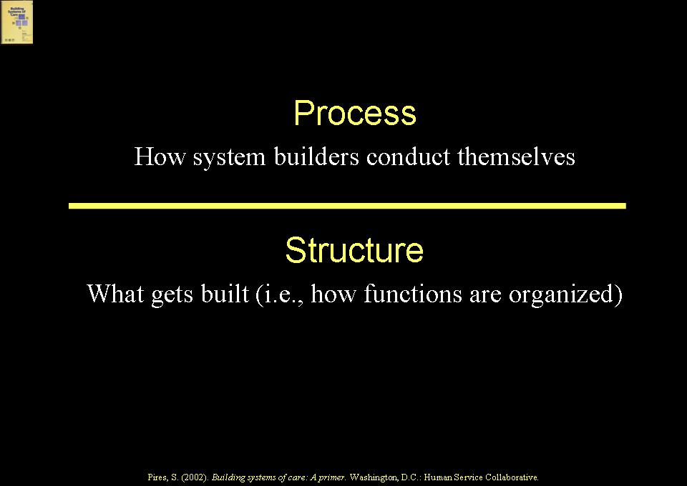  Definition of Structure  SLIDE 3 (48)  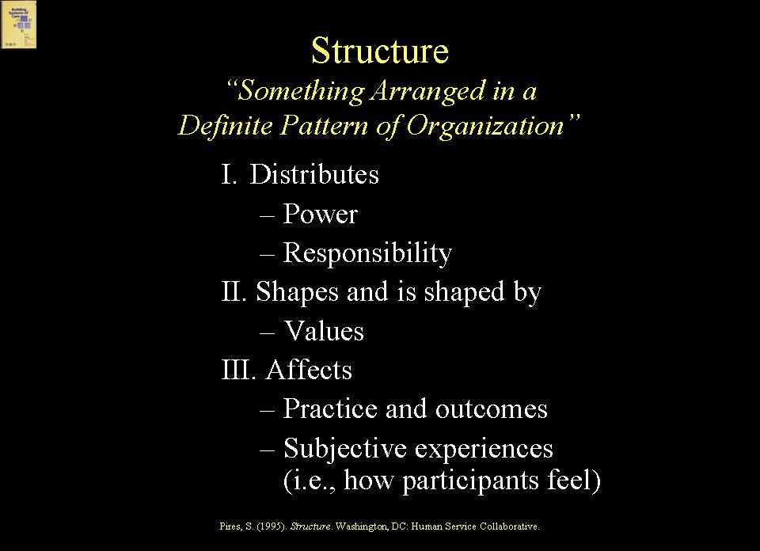  Structure can be defined as “something arranged in a definite pattern of organization”. The types of structures that are created (or left standing) reflect and influence values, have very much to do with how power and responsibility are distributed, will affect how stakeholders experience the system of care, and will affect outcomes.  Example of Structure’s Impact  SLIDE 4 (49)  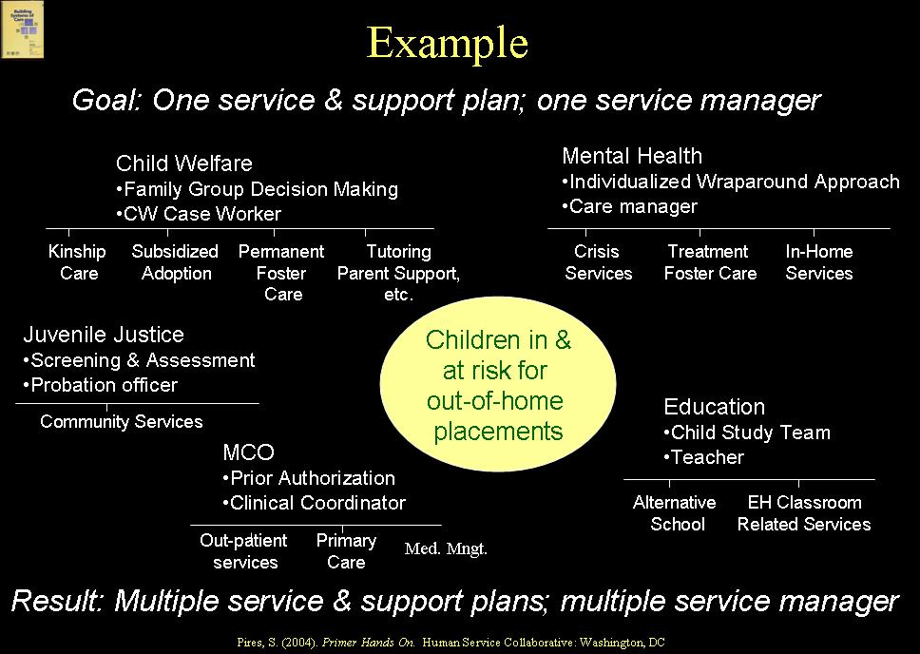  For example, let us say that an important goal of the system of care is one plan of services and supports for children and families involved in child welfare who are also involved with other systems, such as mental health, education, juvenile justice and Medicaid. Typically, each system has structured its own services/supports planning process – e.g., child welfare uses family group decision making, mental health uses a wraparound approach, education uses its child study team, juvenile justice uses an assessment center, and Medicaid uses a managed care plan. Even if most stakeholders agree to the principle of one plan of services and supports, the multiple structures for the same function (i.e., services/supports planning) will make it frustrating to achieve that goal, and stakeholders, such as families, will likely feel overwhelmed. Restructuring is needed.  EXAMPLE  Milwaukee, Wisconsin’s Wraparound Milwaukee illustrates how restructuring can help to support achievement of the goal of one plan of services and supports. In this case, one entity – Wraparound Milwaukee – serves as the locus of accountability for the development of one plan of services and supports covering all needed services and placements for populations of children, youth and families involved in multiple systems. Child welfare, juvenile justice, education and mental health partner as needed on child and family teams with families and youth to develop one services/supports plan for a given family, and the child and family team recommendations count as “medical necessity” for purposes of accessing Medicaid.  SLIDE 5 (50)  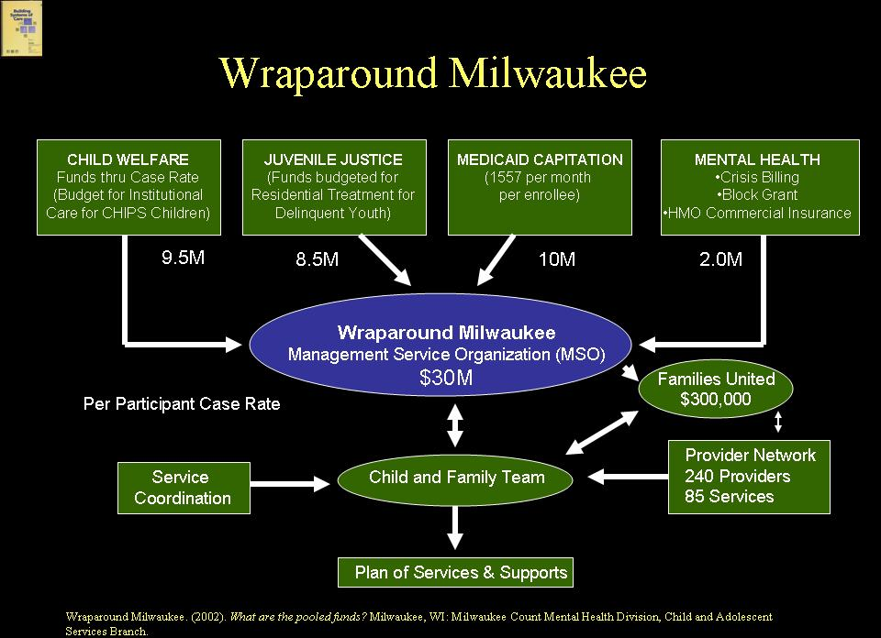  Important Points about Structure  SLIDE 6 (51)  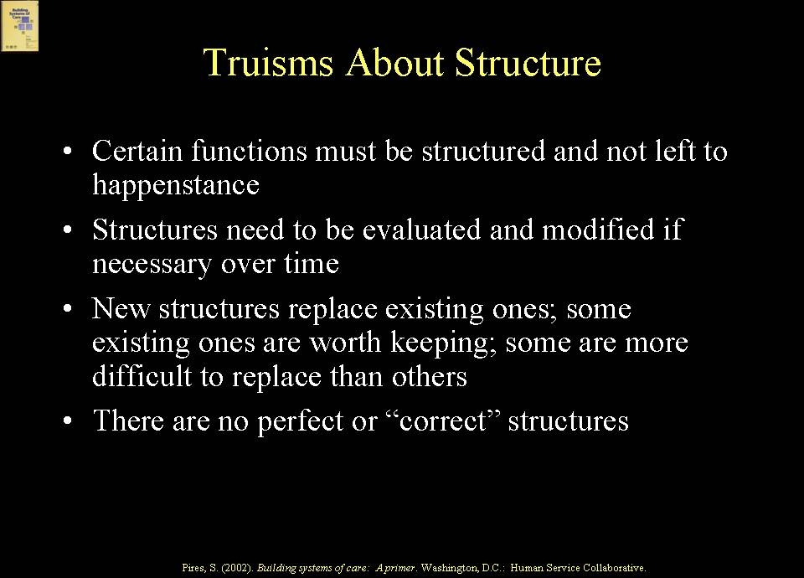  Several points about structure in systems of care must be made. Specifically, certain functions must be structured and not left to happenstance. For example, if quality improvement is not structured, it is unlikely to occur. Structures need to be evaluated and modified, if necessary, over time. System builders may have to create new structures and demolish old ones, or keep or modify existing ones. The analysis of what structures to keep, modify or destroy is a strategic one. It needs to take into account what system builders are trying to achieve, as well as the difficulty involved in creating a new structure or getting rid of an existing one. Considering structural change is a strategic process in which all system builders need to have voice. There are no perfect or “correct” structures, but there are pros and cons to structures that make one more desirable than another. The relative pros and cons will vary in communities, as well as the capacity to undertake structural changes.  EXAMPLE  For example, a rural community decided to structure a Targeted Case Management system incorporating Master’s level care managers, based on the belief that Medicaid would require this type of structure. It was impossible for the community to recruit a sufficient number of Master’s level care managers, and this critical element of the system of care floundered as a result. The community had to re-structure Targeted Case Management to allow for paraprofessionals (including family members) to be care managers and to have them work under the supervision of licensed staff, which satisfied Medicaid requirements.  Functions Requiring Structure in Systems of Care  SLIDE 7 (52)  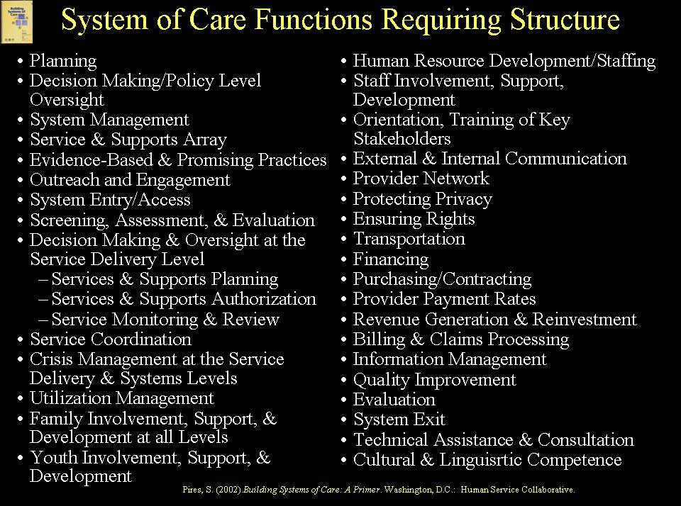  There are many functions that require structure in systems of care: planning; policy level oversight (governance); system management; service and supports array; outreach and engagement; system entry and access; screening, assessment, including risk assessment, and evaluation; services and supports planning; service authorization; service monitoring; service coordination and management; crisis management; utilization management; family and youth partnership; human resource development; external and internal communication; provider network; protection of privacy; protection of rights; transportation; financing; purchasing/contracting; rate-setting; revenue generation and reinvestment; billing and claims processing; information management; quality improvement; evaluation; cultural and linguistic competence; and technical assistance and consultation. Though daunting, this list is also no doubt incomplete. The reality is that most of these functions already are structured, but they may not be structured in ways that will support attainment of system of care goals. Determining which to tackle over what time period, and how to approach structuring various functions, is part of the strategic decision making process involved in system building.  Core Elements of System Building Process  The core elements of an effective system building process can be clustered under two broad headings: leadership and constituency building and a strategic orientation. The first of these is leadership and constituency building.  SLIDE 8 (53)  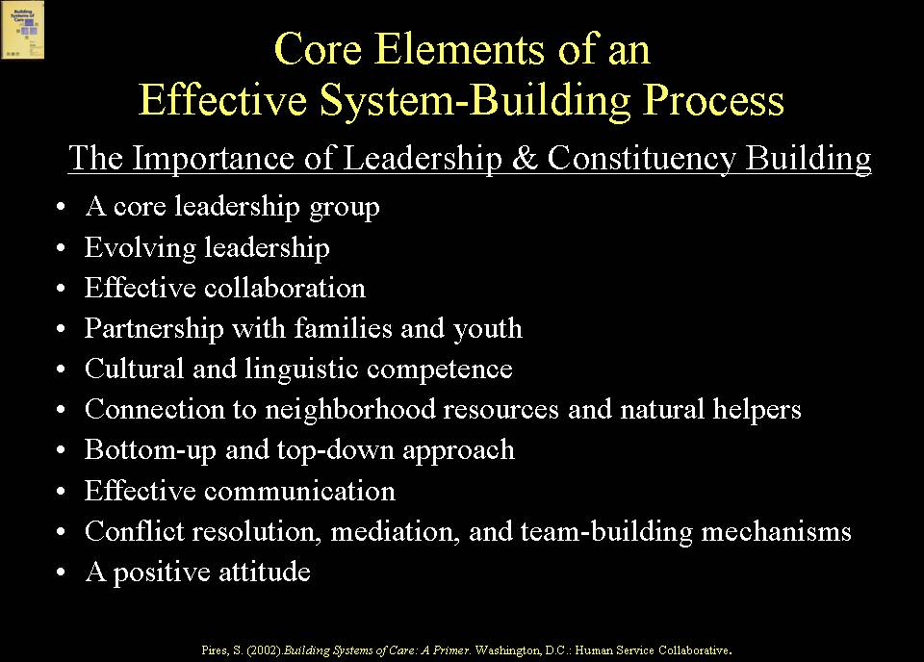  Typically, effective system building processes have a core leadership group representing key stakeholders. The group may change over time, but there is consistently a core group of leaders driving the process. Leadership capacity development across stakeholder groups also is critical, that is, identifying and building family and youth leaders, judges who will play leadership roles, county managers and state administrators, supervisors, providers, line staff, service coordinators, researchers, evaluators, policy makers, legislators, etc. Such leadership capacity development is essential to the growth of systems of care.  Effective processes also incorporate effective collaboration across systems that serve children, youth and families and with families, youth, providers and other key stakeholders. There are many formal systems important to children and families involved in child welfare or at risk for involvement, not just the child welfare system itself and the courts. For example, Medicaid, mental health and substance abuse, housing, domestic violence, child support enforcement, Temporary Assistance to Needy Families (TANF), Early Intervention (Part C) programs, education, Supplemental Security Income (SSI), vocational rehabilitation and employment – to name a few. Strategically engaging these systems is a fundamental responsibility of system builders taking the lead on behalf of populations involved or at risk for involvement in child welfare.  Effective planning processes build meaningful partnerships with families and youth and are culturally and linguistically competent. They also connect to neighborhood resources and natural helpers, drawing them into the process. Effective processes include both a “bottom up and top down” approach. They build in communication mechanisms so that stakeholders know what is going on, and rumors and misinformation can be minimized. Effective processes also build in mechanisms for conflict resolution, mediation and team-building, and seek ways of minimizing nay saying and negative attitudes.  SLIDE 9 (54)  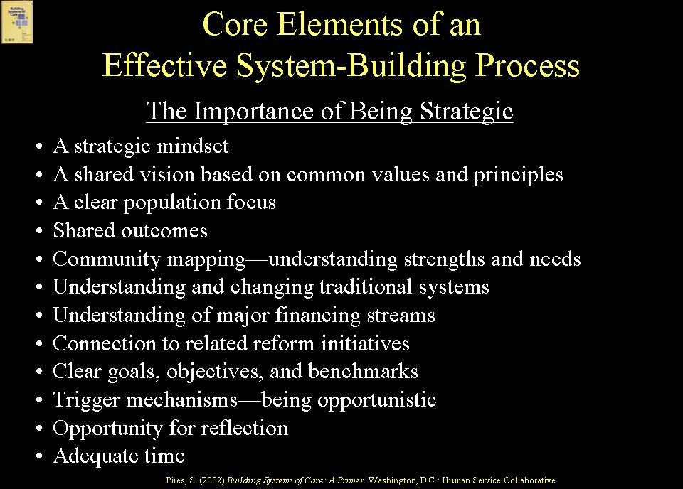  The second broad heading under which essential process elements cluster is a strategic orientation. These elements can be described as: a strategic mindset; a shared vision based on common values; a clear population focus; shared outcomes; community mapping – understanding strengths and needs; understanding the various roles played by systems serving children, youth and families and how they can be changed; understanding major financing streams across systems and how they can be mobilized; connecting related reforms; having clear goals, objectives and benchmarks; being opportunistic; building in opportunity for reflection; and allowing adequate time for systems change.  Effective strategists look for ways to create structural change objectives. Other types of objectives may be worthwhile, but structural change increases the likelihood that change will be sustained. For example, an objective to create a newsletter for families (a non-structural change objective) may be worthwhile, but it does not fundamentally change a system in the way that an objective to require family involvement on service planning teams and on governance bodies would. Similarly, a one-time allocation of monies to create new services may be worthwhile, but it does not have as enduring an impact as changing a State’s Medicaid plan to incorporate a range of home and community-based services and supports.  Components of Effective Leadership  SLIDE 10 (55)  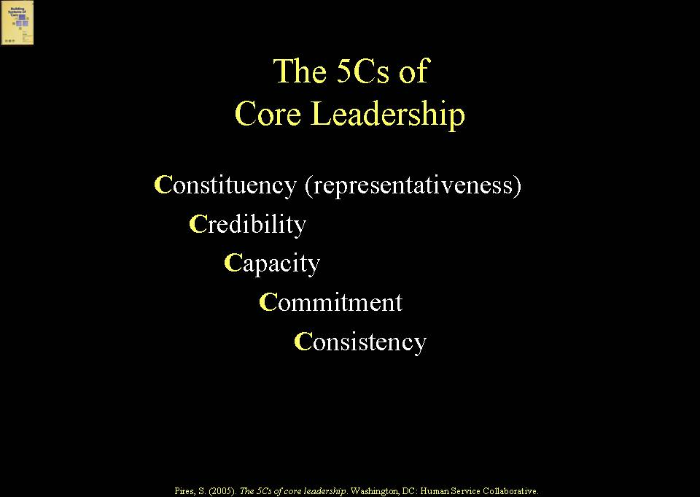  These two broad headings are intertwined because effective leaders are strategic, and operating strategically requires leadership on many different fronts at both State and local levels and across stakeholder groups. Components of effective leadership are illustrated by the five “Cs” -- constituency (i.e. representativeness), credibility, capacity, commitment, and consistency.  Leadership Styles  SLIDE 11 (56)  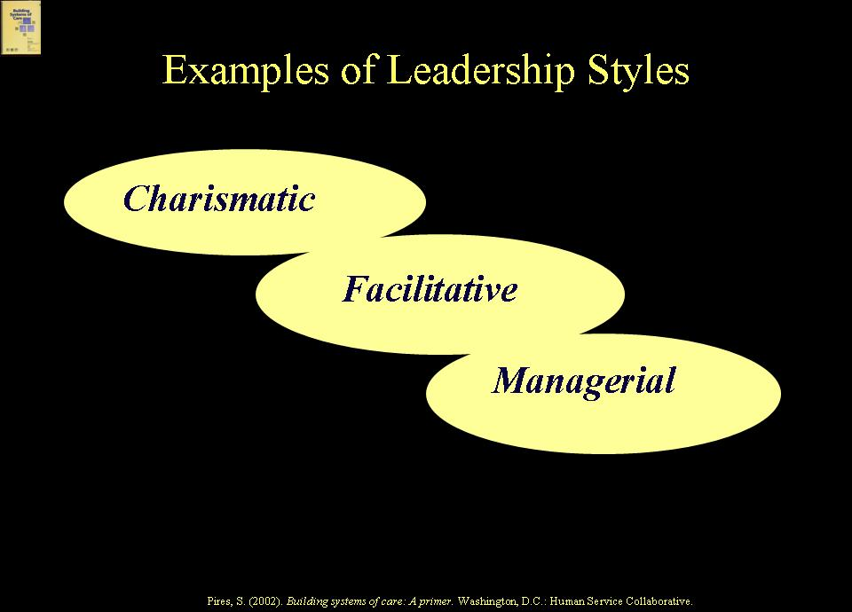  There are many types of leadership styles -- charismatic, facilitative, managerial -- and all are needed in system building at various stages. Part of the strategic thinking that system builders need to undertake is to understand the types of leadership needed at different stages, particularly in the context of the leadership that is prevailing, which may or may not be what is needed.  Elements of Partnership  SLIDE 12 (57)  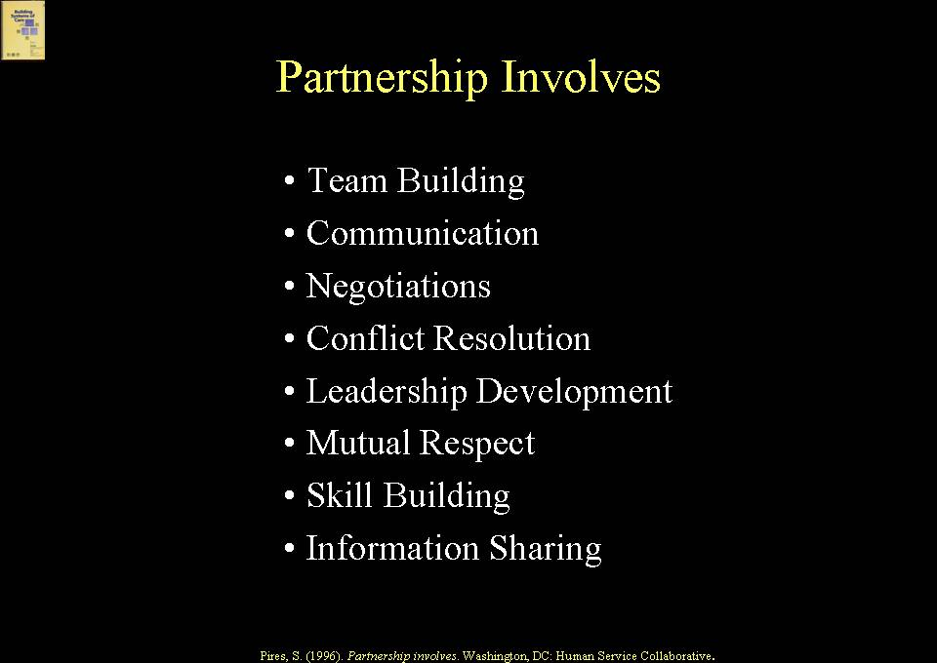  There are many elements involved in partnership across agencies and stakeholders, including team building, communication, negotiation, conflict resolution, leadership development, mutual respect, skill building, and information sharing.  SLIDE 13 (58)  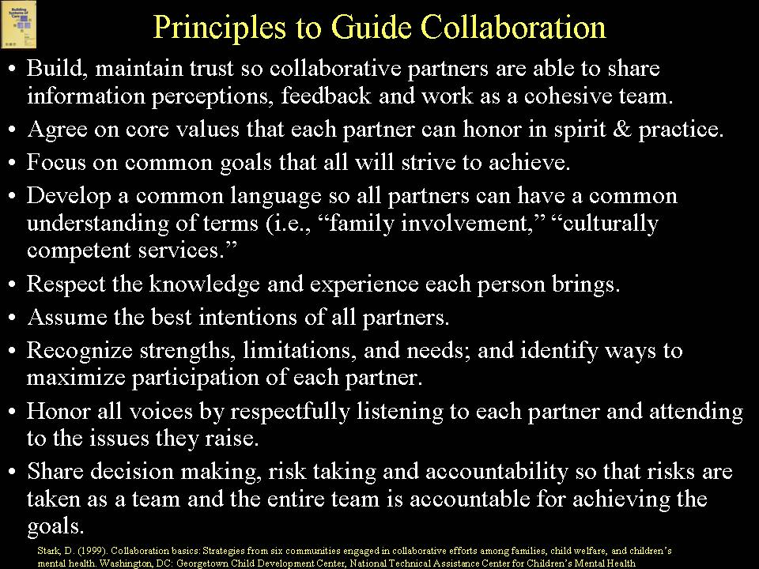  The first hurdle in a collaborative process is getting stakeholders to actually commit to collaboration. The second is for stakeholders to agree on a set of principles to guide their collaboration. Such principles include: building trust to work as a team; agreeing on values that partners will honor; agreeing on goals and concrete objectives; developing a common language so that there is not confusion about important terms, such as family-centered practice or cultural and linguistic competence; respecting the knowledge and experience partners bring, including that of families and youth; assuming the best intentions of all partners; recognizing strengths and limitations partners have; honoring all voices by being respectful; and sharing decision making, risk taking and accountability. These are not simply “nice words”. They can actually draw out the best in system building partners if they are adhered to in practice.  Challenges to and Strategies for Collaboration  SLIDE 14 (59)  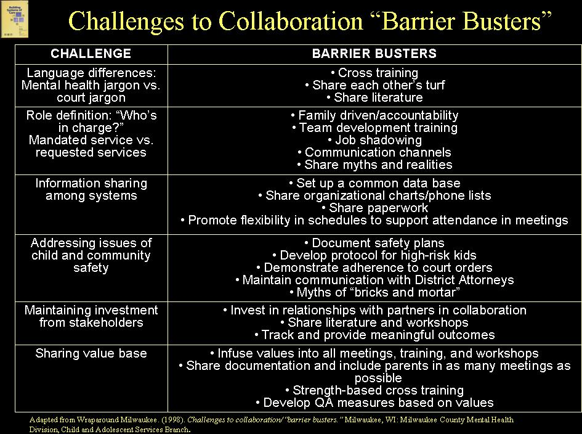  There are obviously numerous challenges to collaboration, but there also are “barrier busters” developed by system builders over time to address these challenges. Time invested in team building, conflict resolution, information sharing, and putting effective communication structures in place is time well spent. On the other hand, collaboration for the sake of collaboration is ultimately destructive as stakeholders lose interest in the process. Collaboration needs to have a purpose and concrete objectives, which change over time as objectives are achieved or new circumstances arise. Part of being strategic is to understand how to use collaborative processes to drive toward concrete systems change.  Catalysts for Reform  SLIDE 15 (60)  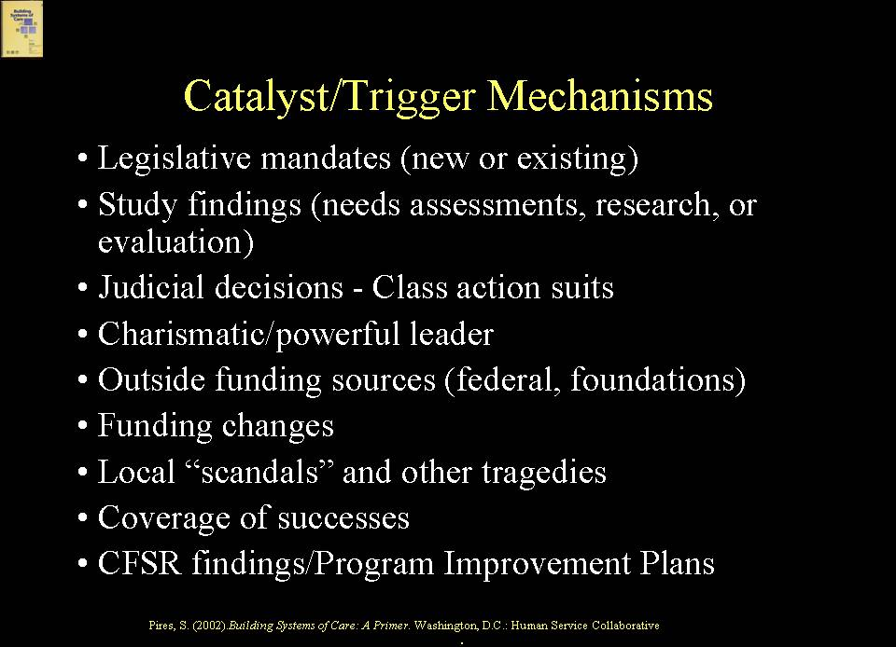  Often, system building leaders use catalysts or trigger mechanisms to start or jump-start a system building process, either one that needs to be launched or an existing one that has stalled. There are various types of “trigger mechanisms” that can be employed, such as legislative mandates (new or existing), study findings, class action suits, charismatic leaders, outside funding sources such as a federal grant, funding changes such as budget shortfalls or new revenue streams, local scandals or tragedies, such as a child’s death, and coverage of successes. A major catalyst in child welfare is findings from the Child and Family Services Reviews (CFSR) and Program Improvement Plans (PIPs).  Managing Complex Change  SLIDE 16 (61)  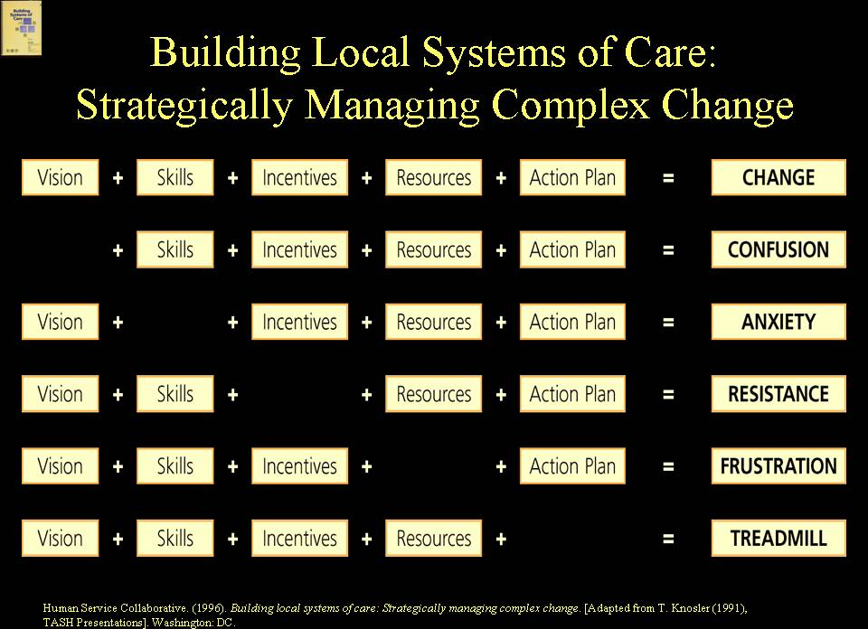  Strategic system building has to do with managing complex change. Effective strategists are continually scanning the environment looking for opportunities on which to build. Being strategic is both a science and an art, and the list of potential strategic alliances and opportunities is constrained only by limited vision, creativity or capacity to think strategically.  EXAMPLE  Cuyahoga County, Ohio (Cleveland) is an example of a system building process supported by a core leadership group operating strategically, which is leading to key structural changes on behalf of children involved or at risk for involvement in child welfare. The Cuyahoga County reform is bringing together related reform initiatives into one system of care approach, including Family-to-Family neighborhood collaboratives that initiated in child welfare with system of care initiatives in mental health and in substance abuse.  SLIDE 17 (62)  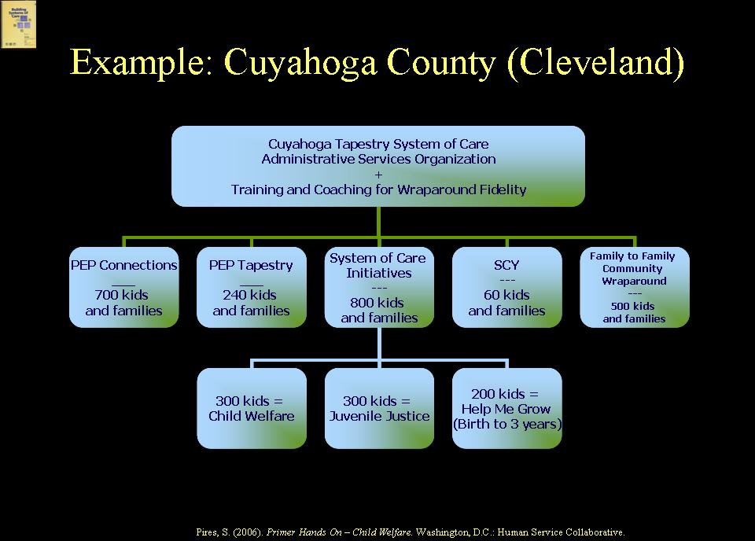  EXAMPLE  At a frontline practice level, Cuyahoga County, Ohio is utilizing high fidelity wraparound as a common practice approach and bringing together Family-to-Family community wraparound and clinical care coordinators in co-located neighborhood collaborative settings. At a system management level, the County is creating an “administrative services organization”, which is called a System of Care Office, to manage multiple braided funding streams, and at a policy-making or governance level, there is a multi-stakeholder system of care oversight body.  SLIDE 18 (63)  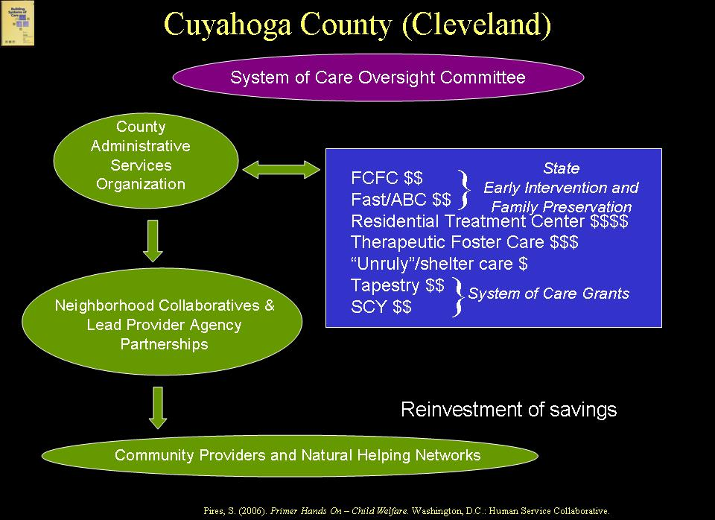 | Trainer’s Notes  Goals  This Module addresses Process and Structure in systems of care. You want your audience to understand that system building involves both process, i.e., how system builders conduct themselves, and structure, i.e., what gets built and how.  Method  PowerPoint Presentation; Didactic; Large Group Discussion  Training Aids  Microphone if necessary; projector, laptop computer, screen; slides #1-18 (slides #47-63 if utilizing the complete curriculum version with no module cover slide).  Approximate Time  30 min.  Expected Outcomes  At the end of Module 3, participants should be familiar with:  - Definition of structure  - Importance and examples of the impact of structure on the system  - Functions requiring structure  - Core elements of the system building process  - Leadership styles and components of effective leadership  - Elements of effective partnerships  - Challenges to and strategies for collaboration  - Catalysts for reform  - Elements in managing complex change  This Module begins with a discussion of Structure and then moves to the topic of Process.  Trainer’s Notes  This example illustrates how the structures in place for the function of services/supports planning are unlikely to lead to the goal of one plan of services and supports coordinated across systems.  You may have other examples of structures for particular functions that will make it difficult to achieve desired goals.  Trainer’s Notes  Wraparound Milwaukee provides one example of a county that re-structured its services/supports planning to ensure that children, youth and families involved in multiple systems would have one plan of services and supports coordinated across systems. For further information about Wraparound Milwaukee, see: www.milwaukeecounty.org/WraparoundMilwaukee7851.htm  You may wish to share other examples from your own experience about States or communities that re-structured certain functions to achieve desired goals.  Trainer’s Notes  Point out to participants that the approach to structuring (or re-structuring) functions within systems of care needs to be a strategic one that takes into account such issues as capacity to change existing structures, how critical a new structure is, how different stakeholders feel about different structures, etc.  This example illustrates the importance of system builders determining the viability of certain structures, (i.e., is it feasible politically, technically, etc.?).  You may have other examples from your own work to illustrate this point.  Trainer’s Notes  The two-day intensive Primer Hands On-Child Welfare training is not intended to go into depth on each of the functions that need to be structured within systems of care. Rather, the training utilizes several key functions to explore strategic considerations related to system of care structures. The purpose is to give participants a way of thinking about the role of structure and pros and cons of different structural approaches – a way of thinking that can be applied to any particular system of care function.  Topical trainings on individual modules can be used to go into greater depth about particular functions.  Trainer’s Notes  Now we are turning to the topic of the importance of process in system building. Research has suggested that elements of effective system-building processes cluster into two broad areas: leadership and constituency building and being strategic.  Trainer’s Notes  Point out to participants that, in a strategic approach, knowledge is key: knowledge about the populations of focus, strengths and resources of the community, what traditional systems control and could contribute, etc. The more stakeholders know, the more strategic they can be.  Point out the importance of strategizing structural change objectives, i.e., those that will fundamentally change the way that systems do business and are more likely to endure.  Trainer’s Notes  The following slides return to the issue of leadership. You might want to use examples from your own experience of situations in which leaders lacked capacity, for example, (e.g., staff, equipment, technical knowledge, etc.) and, therefore, could not lead an effective process. Another common example is when leadership continually changes, and new leaders are not selected based on a commitment to system building (i.e., lack of consistency). Another example is when leadership is seen as representing only certain special interests (i.e., lack of constituency).  Trainer’s Notes  Point out that systems of care need the benefit of many different leadership styles, but may need them at different times and in different roles. For example, a charismatic leader may be essential to build momentum for a system building process, but a strong management leader may be needed when the system begins to operate.  Emphasize with participants that partnership does not simply happen; it requires time and energy.  Trainer’s Notes  It is important to acknowledge the central role that collaboration plays in building systems of care and that it can be frustrating and difficult. It helps when system partners can agree on a set of principles to guide their collaboration. One over-arching principle should be that “collaboration for the sake of collaboration” is damaging; collaboration needs to have a clear purpose, goals, and concrete objectives, which may evolve over time as collaboration matures and leads to systemic change.  Trainer’s Notes  These are examples of challenges to collaboration and strategies for overcoming barriers. You may have other examples from your own experience that you wish to share.  Trainer’s Notes  Point out to participants that there is any number of ways to initiate a system building process (or jump-start one that has stalled). One obvious catalyst is findings from the Child and Family Services Reviews (CFSR).  Trainer’s Notes  This is a template that system builders might find helpful as they think about the elements that will create change and the factors that may be impeding change. For example, if system partners seem confused, perhaps the vision is not clear. If staff or providers are anxious, perhaps they have not been provided the training that would give them the skills to do what is being asked.  Cuyahoga County provides a good example of a system of care effort with a collaborative process that is leading to structural change. You may have other examples you wish to share from your own experience.  Trainer’s Notes  ,

