PRIMER HANDS ON -

CHILD WELFARE

TRAINING FOR CHILD WELFARE STAKEHOLDERS

IN BUILDING SYSTEMS OF CARE

TRAINING GUIDE

MODULE 9
Care Management

A Skill Building Curriculum

By Sheila A. Pires

In Partnership with Katherine J. Lazear, University of South Florida, and Lisa Conlan, Federation of Families for Children’s Mental Health

Based on
Building Systems of Care: A Primer
By Sheila A. Pires

Human Service Collaborative
Washington, D.C.

Sponsored by the National Child Welfare Resource Center for Organizational Improvement, University of Southern Maine, in partnership with the National Technical Assistance Center for Children’s Mental Health, Georgetown University, and the National System of Care Technical Assistance and Evaluation Center, Caliber/ICF, with funding from the Administration for Children and Families, U.S. Department of Health and Human Services.

Table of Contents

Table of Contents 9.2

Module 9 – Care Management, Utilization and Quality Management 9.3

Function: Care Management 9.3
Service Coordination versus Care Management 9.3
Nebraska – Integrated Care Coordination Units 9.5
Care Management Principles 9.6
Importance of Structuring Care Management 9.7
A Continuum of Service Coordination/Care Management 9.7
Types of Care Managers 9.8
Pros and Cons of Different Structures 9.8
Function: Utilization Management (UM) 9.10
Utilization Management (UM) 9.10
Principles for Utilization Management 9.11
Aligning UM Interests and Responsibilities 9.12
Pennsylvania – Early Warning System 9.13
Function: Quality Management (Continuous Quality Imropvement) 9.13
Quality Management 9.13
Handout 9.1 – Massachusetts Department of Social Services 9.14
Continuous Quality Improvement Program
(Discussion Guide for Learning Forums) and
CQI Process Scenario
Contra Costa County, California 9.14
Missouri – Quality Assurance Practice Development 9.15
Reviews
Purposes of UM and Evaluation Data 9.15
Types of Data Reports and Their Use 9.16
Example of Use of Data for Continuous Quality Improvement 9.16
Michigan – Child and Adolescent Functional 9.16
Assessment Scale
Examples of Outcomes Measures Related to CFSR 9.17
Integrated Care Coordination Unit 9.19
Early Integrated Care Coordination Unit 9.19
Wraparound Milwaukee 9.20
Large Group Discussion 9.21

MODULE 9  Care Management, Utilization and Quality Management  This section draws primarily on material from Section I of Building Systems of Care: A Primer (pages 63-68 and 124-132).  Function: Care Management  Service Coordination Versus Care Management  Children and families in or at risk for involvement in child welfare often have multiple issues and stressors in their lives and involvement with multiple agencies. Many need support to manage and coordinate their involvement with many systems and providers. Some need a basic level of support in managing and coordinating service requirements, which may be court-ordered or other types of needed services; other families require far more intensive service coordination or “care management” support. System builders need to define what they, collectively, mean by service coordination or care management before they can implement effective service coordination/care management structures, and this will be driven by the characteristics and needs of the defined target population(s).  SLIDE 2 (213)  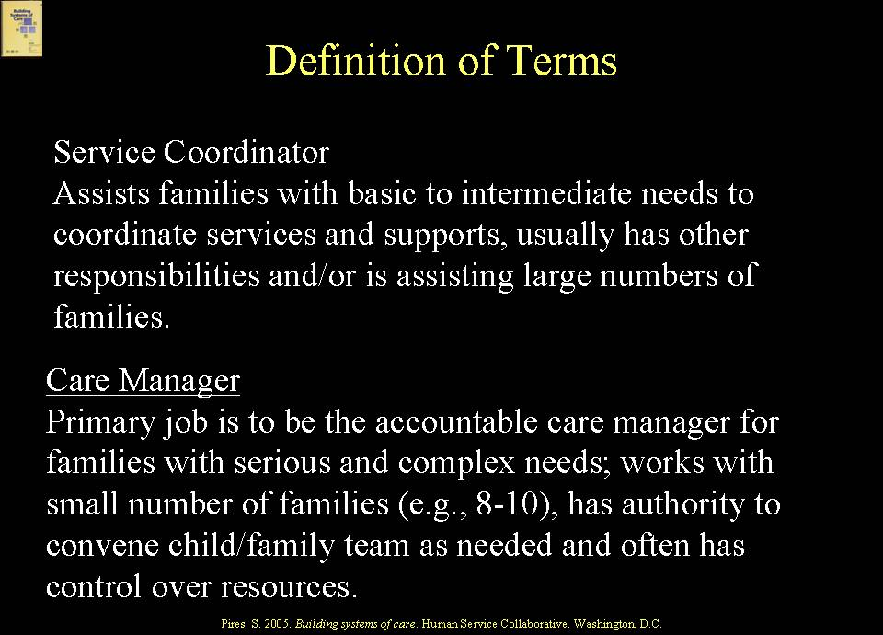  The Primer makes a distinction between service coordination and care management. Service coordination is defined as assisting families with basic to intermediate needs to coordinate services, where the service coordinator has other responsibilities or is responsible for relatively large numbers of families – for example, a child welfare worker with fairly large caseloads may be providing service coordination along with other responsibilities. In contrast, the role of a care manager as used here is that of working with only a few families (for example, on a 1:10 ratio), who have multiple, complex needs, where the care manager is closely involved with the family and youth and with the array of providers and natural helping networks to ensure that the family can access needed services and that the services and supports continue to be helpful. The care manager often controls flexible resources and has the authority to convene child and family teams. The care manager also is available to the family on a 24/ hour/7 day a week basis and is not performing other functions, except that of care manager.  SLIDE 3 (214)  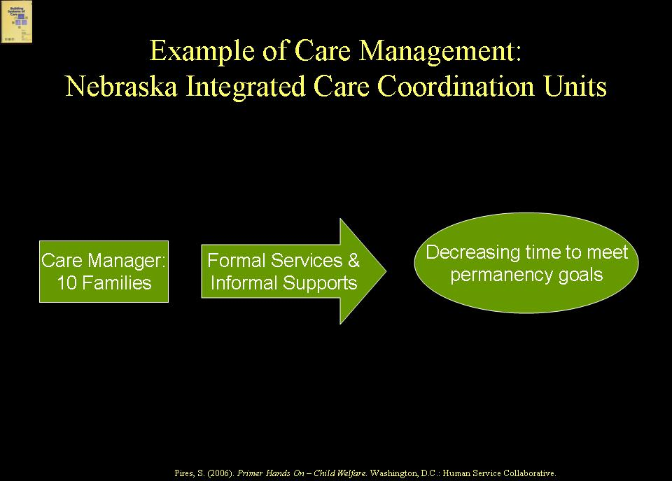  EXAMPLE  Nebraska has developed Integrated Care Coordination Units in which care managers work with only 10 families each and utilize informal supports as well as formal services, an approach that is decreasing the time it takes to meet the permanency goals of children with multiple and serious issues.  The Primer intentionally does not use the term, “case management”. Many families, youth and other stakeholders find the term, “case management” off-putting since no one likes to be thought of as a “case”. The Primer uses the term, “care management”, but others also use the term, “care coordination”.  Care Management Principles  SLIDE 4 (215)  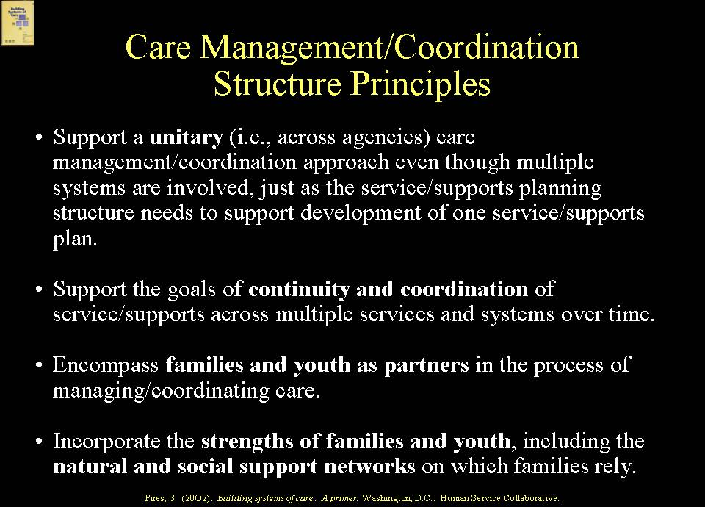  There is no one “correct” care management or service coordination structure, but there are principles that need to underpin these structures. These principles include:  - Support one plan of services/supports, even when multiple agencies and systems are involved;  - Support the goals of continuity and coordination of services/supports over time and across systems;  - Encompass families and youth as partners in managing services/supports;  - Utilize a strengths-based focus that incorporates use of natural helpers and social support networks on which families rely and cultural and linguistic competence.  Importance of Structuring Care Management  SLIDE 5 (216)  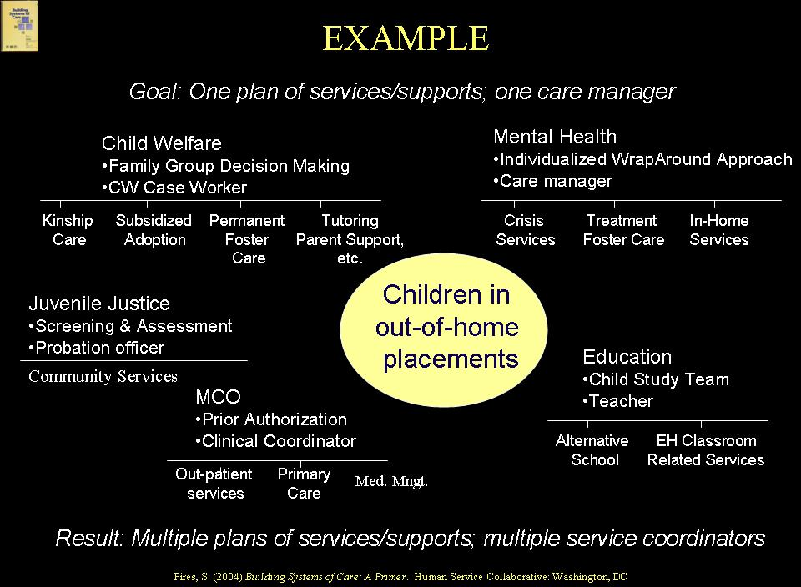  If care management is not deliberately structured across systems for children and families involved in multiple systems but left to each agency to design its own, regardless of whether the system of care has a goal of “one plan of services/supports”, the result is likely to be multiple plans and multiple service coordinators – with no one accountable “care manager” as the term is being used here. The above graphic illustrates this point, showing multiple systems involved in developing plans of services/supports with no one accountable care manager.  A Continuum of Service Coordination/Care Management  SLIDE 6 (217)  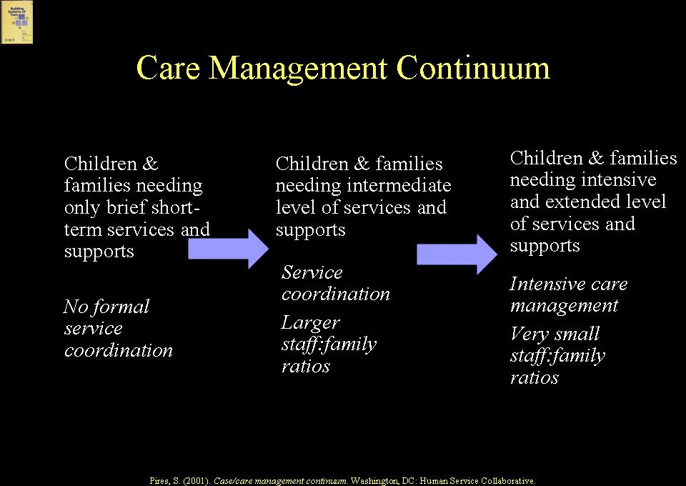  Depending on the population focus, a system of care may incorporate both service coordination and a care management structure. For example, it may have an intensive care management structure for children and families with serious, complex problems and more of a service coordination structure for children and families using fewer services or services intermittently.  Types of Care Managers  SLIDE 7 (218)  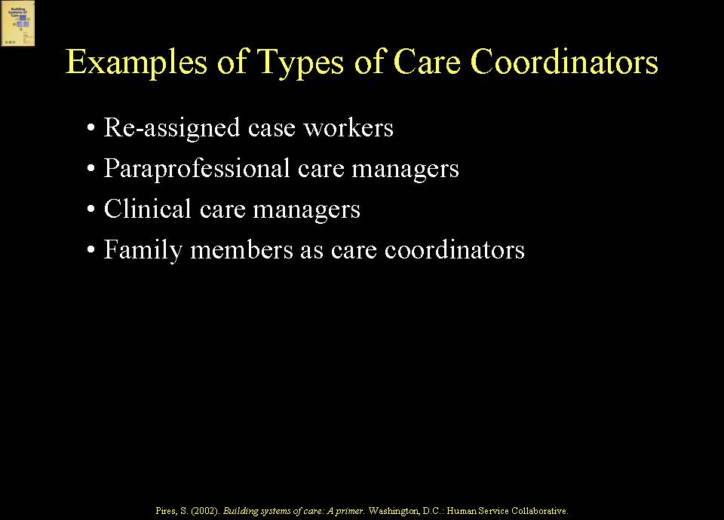  Systems of care utilize many different types of individuals in care management structures, including family members, those with professional social work or other clinical training, and paraprofessionals.  Pros and Cons of Different Structures  The following graphic can be used to illustrate the pros and cons of different care management structures.  SLIDE 8 (219)  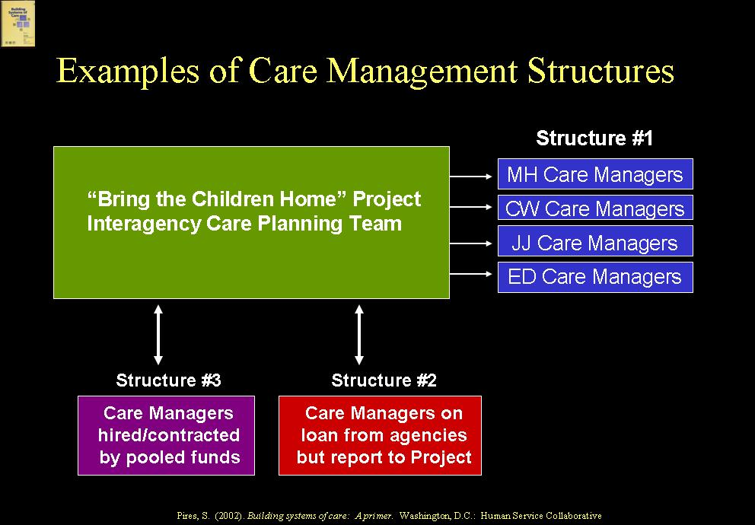  This illustration shows three structures: one in which care managers remain in their home agencies, such as child welfare and mental health; one in which care managers are detailed from the home agency to the system of care; and one in which the care managers are hired directly by the system of care. There are pros and cons to each of these. For example, care managers staying in their home agencies might find it difficult to implement a new practice model if their surrounding agency culture is very different; on the other hand, they might become catalysts for change within their home agencies. Care managers on detail to the system of care may be more likely to implement the new practice model, but they also might feel like they are serving two masters. Newly hired care managers can be hand-selected by the system of care for their adherence to the practice model, but their positions could be vulnerable if their role is not embraced by the other agencies. There is no one perfect structure, but system builders need to think strategically about the structures that best fit their particular communities.  Function: Utilization Management  Utilization Management  SLIDE 9 (220)  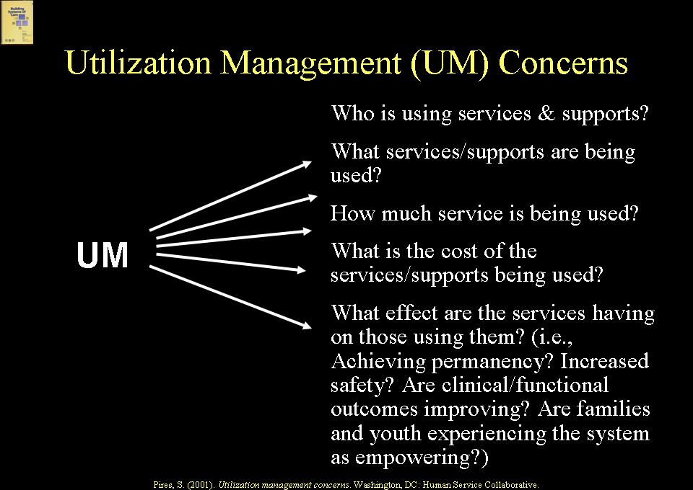  Utilization management (UM) has to do with the system of care’s paying attention to how services are being used by children and families, both at an individual level and at a system’s level, how much service is being used, what services are being used, the cost of those services, the effect those services are having on those using them in areas such as achieving permanency and increased safety, and whether children and families are satisfied with what they are using and experience the system as empowering. UM’s areas of concern are essential to address from both a quality and a cost standpoint, and at a systems level, UM data can guide quality improvement. Monitoring and review of service provision at the level of individual children and families, i.e. managing utilization, ensures that children do not remain “stuck” in placements, for example, or that families do not have to continue using services that are no longer appropriate or helpful, and that costs do not escalate. Family representatives are key partners in this review process to ensure that family and youth views are part of the service decision making process.  Principles for Utilization Management  SLIDE 10 (221)  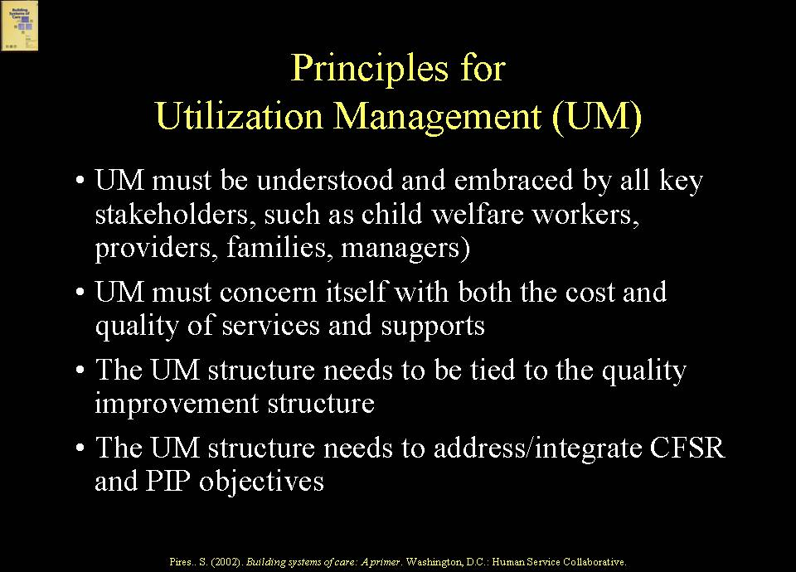  There are different ways to structure UM. For example, a system of care may do its own in-house UM, or it may contract with an external entity, such as a managed care organization, a provider agency, or a family or neighborhood organization, to handle some or all UM functions. The pros and cons to these different structures have to do with technical capacity, values, readiness, interest, etc. However UM is structured, it needs to be informed by certain key principles, including being understood as an important function by all stakeholders, such as child welfare workers, providers, families, and managers, focusing on both cost and quality issues, and being tied to the quality improvement structure and to CFSR and PIP objectives.  Aligning UM Interests and Responsibilities  SLIDE 11 (222)  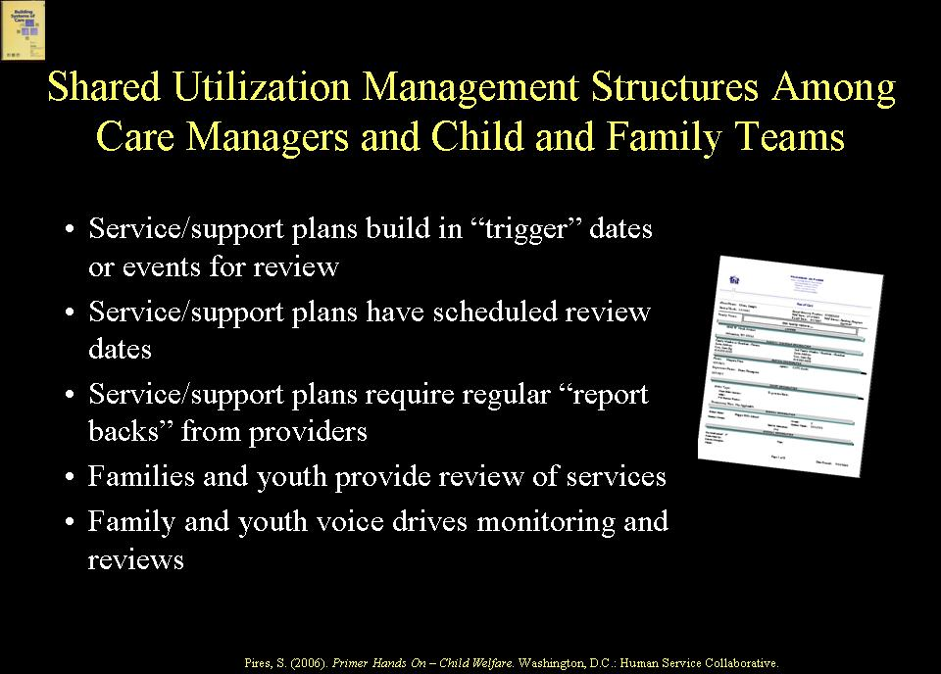  Utilization management may be structured as a shared responsibility among care managers, child and family teams that conduct service/support planning, providers, families, and system managers. Service/support planners, for example, may build “trigger dates or events” into service/support plans to ensure timely review; care managers or providers may be charged with reporting back on some regular basis to service/support planning teams; families and youth as active partners often know when a service has outlasted its usefulness or it is time for a change, and monitoring and review functions can be structured to ensure that the family and youth voice is heard.  Utilization management structures need to respect the circumstances and cultural diversity within families. When service/support plans are not authorized and service barriers and gaps arise as a result, or when children are stuck in inappropriate placements, monitoring and review structures need to ensure appropriate changes in service authorization and service provision procedures. To be culturally competent, UM structures need to pay particular attention to service utilization among diverse children and families to ensure that there is not a perpetuation of either the under-service (i.e., lack of access to supportive services) or over- service in restrictive services such as residential treatment or other out-of-home placements that has characterized traditional service delivery to diverse populations. This may require a change in the way service data are collected and analyzed and outreach to diverse populations regarding service utilization issues.  EXAMPLE  Pennsylvania’s managed care system, for example, has an “Early Warning System” that, among other things, flags disparities and disproportionality in use of behavioral health services by racially and ethnically diverse members.  Function: Quality Management (Continuous Quality Improvement)  Quality Management  Quality management has to do with putting structures in place that are capable of telling system builders and other key stakeholders whether what is being done is making any difference for the better in the lives of the children and families being served, the taxpayers who support the system, and for the community in which the system operates. It is especially critical to partner with families and culturally diverse constituencies in the design and implementation of Continuous Quality Improvement (CQI) structures because definitions and perceptions about “quality” vary, and these stakeholders are directly impacted by the system’s expectations about quality service provision. Also, it is important to understand families’ experiences, not only as ultimate outcome issues, but as quality of life issues; family and youth voice is critical to this understanding and, therefore, to any CQI activity. CQI structures and methods need to include both quantitative and qualitative data collection and entail a participatory evaluation framework.  SLIDE 12 (223)  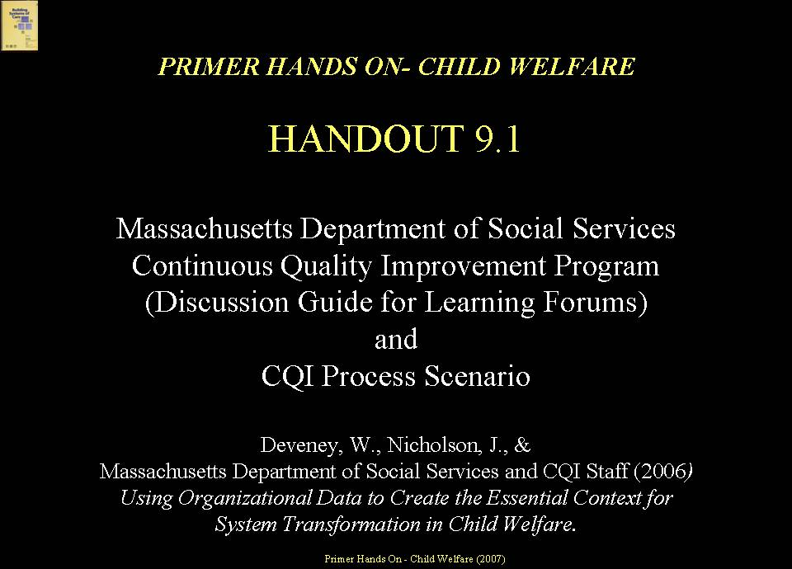  HANDOUT 9.1  Handout 9.1 provides an example of the Massachusetts child welfare system CQI structure that uses both qualitative data – e.g., foster parent satisfaction survey - and quantitative data – e.g., Family-Centered Behavior Scale and Child and Adolescent Needs and Strengths (CANS) assessment tools. The handout also includes a CQI process scenario developed by Massachusetts that illustrates how use of data can lead to a better understanding of what is actually occurring in the system and to more effective implementation strategies to improve the system.  SLIDE 13 (224)  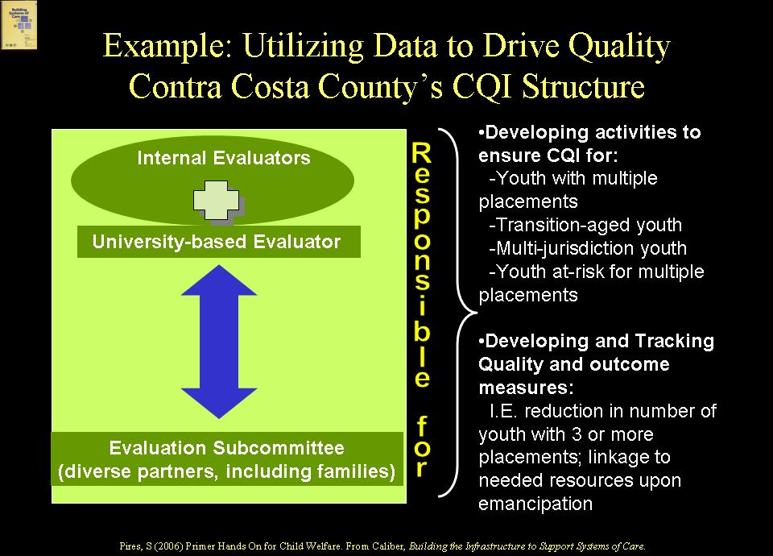  EXAMPLE  Contra Costa County, California, a child welfare system of care grantee, is an example of a jurisdiction that has developed structures for utilizing data to drive quality. It formed an in-house team of “internal evaluators”, contracted with an external, university-based evaluator, and created an evaluation subcommittee representing diverse stakeholder partners, including families. These entities are responsible for developing activities to ensure CQI with respect to their identified target populations, which include youth with multiple placements, transition-aged youth, multi-jurisdictional youth, and youth at risk for multiple placements. The CQI partnership has developed and is tracking quality and outcome measures specific to these populations, such as reduction in the number of youth with three or more placements and linkage of youth to needed resources upon emancipation.  CQI systems are strengthened by the involvement of stakeholders affected by or involved in child welfare, such as families and providers.  EXAMPLE  The Missouri child welfare system involves community partners in conducting Quality Assurance Practice Development Reviews, which mirror the CFSR reviews.  Purposes of UM and Evaluation Data  SLIDE 14 (225)  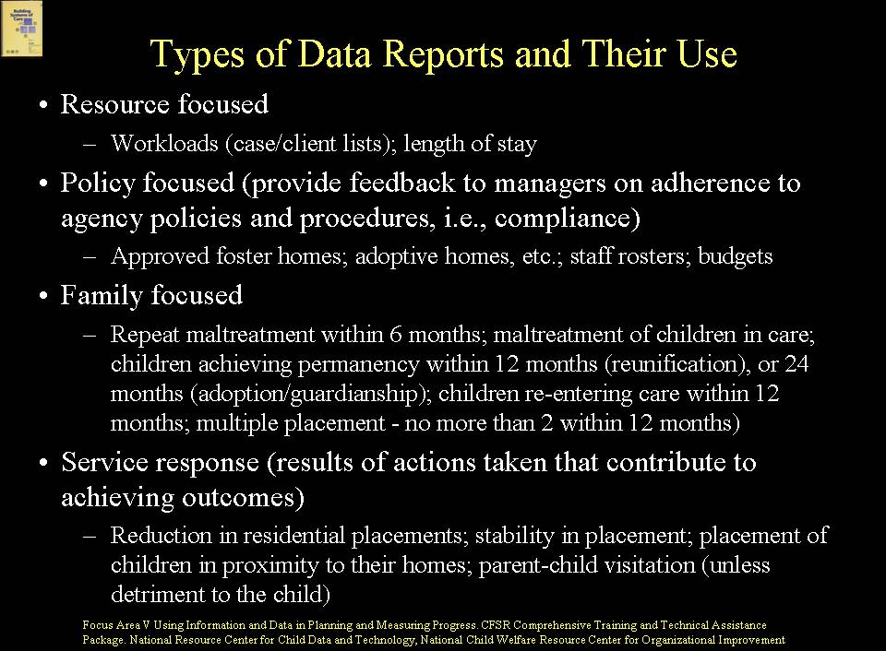  Effective systems of care use UM and other types of evaluation data for many reasons, including: planning and decision support; changing practice, supporting a continuous quality improvement (CQI) structure, for cost monitoring, and for media and marketing results to legislators, the community and others. Data, of course, also are critical to inform CFSR reviews and PIPs.  Types of Data Reports and Their Use  SLIDE 15 (226)  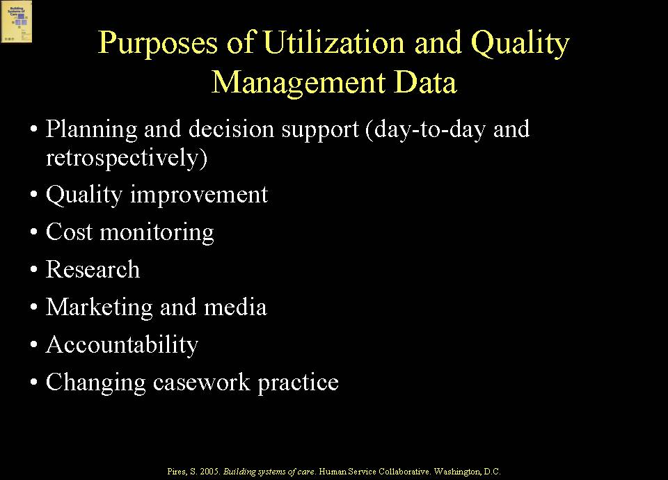  The CFSR Comprehensive Training and Technical Assistance Package Focus Area – Using Information and Data in Planning and Measuring Progress - includes a section on “Using Reports as Tools” and identifies various types of reports and the information each may convey.  Example of Use of Data for Continuous Quality Improvement  EXAMPLE  Michigan requires its local community mental health authorities to use the Child and Adolescent Functional Assessment Scale (CAFAS), including for children in child welfare, and uses data from the CAFAS to inform quality improvement and use of evidence-based and effective practices (e.g., Cognitive Behavior Therapy for depression).  SLIDE 16 (227)  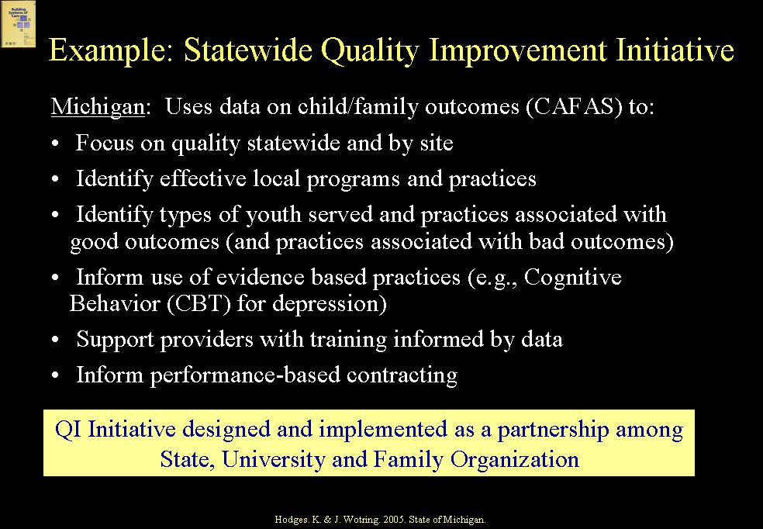  Examples of Outcomes Measures Related to CFSR  SLIDE 17 (228)  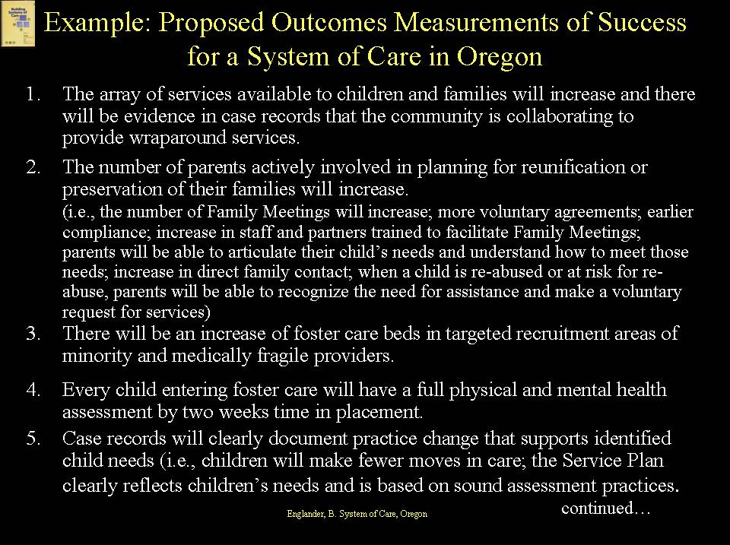  SLIDE 18 (229)  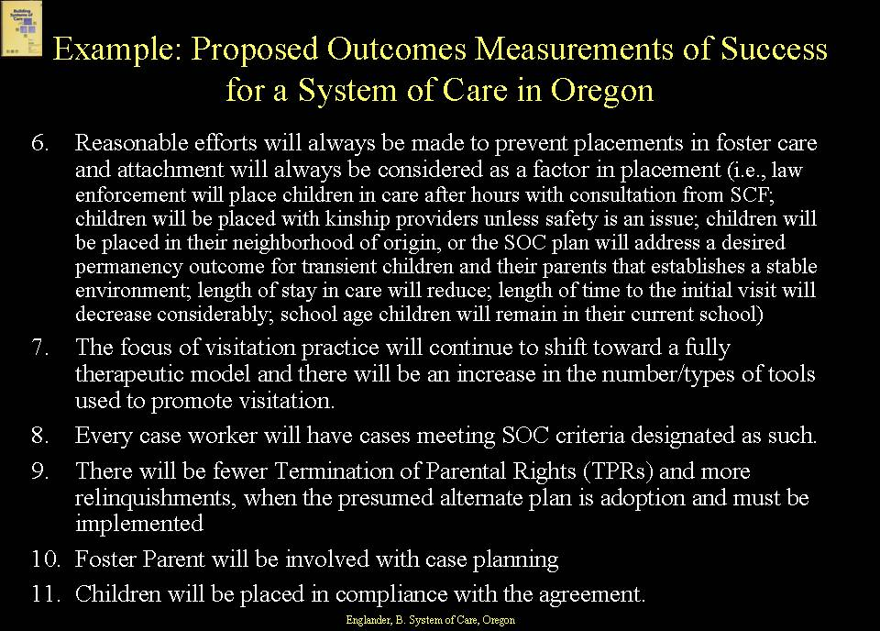  The Oregon system of care approach was a voluntary settlement agreement to a law suit that kept child welfare out of court, but included close monitoring and involvement from the plaintiff attorneys. According to Beth Englander, who was the first multi-field administrator and then the system of care manager, a major reason for the success of the implementation of the system of care in the pilot district was developing buy-in from the community throughout the process. The pilot district also implemented system of care at the same time it was selected as a demonstration for Oregon’s IV-E Waiver, which created financial flexibility. The state eventually rolled out system of care implementation statewide, which reached about 75% of the state’s foster care caseload, connecting the system of care to Oregon’s initial CFSR and the PIP. The PIP was heavily built around system of care for the well-being objectives and a good portion of the permanency actions and benchmarks.  Nebraska provides another example of a system of care approach to achieve CFSR-related outcomes.  SLIDE 19 (230)  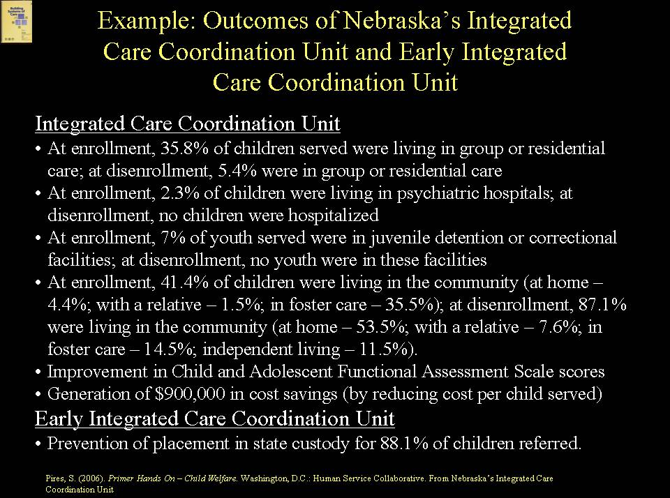  Integrated Care Coordination Unit  - At enrollment, 35.8% of children served were living in group or residential care; at disenrollment, 5.4% were in group or residential care  - At enrollment, 2.3% of children were living in psychiatric hospitals; at disenrollment, no children were hospitalized  - At enrollment, 7% of youth served were in juvenile detention or correctional facilities; at disenrollment, no youth were in these facilities  - At enrollment, 41.4% of children were living in the community (at home – 4.4%; with a relative – 1.5%; in foster care – 35.5%); at disenrollment, 87.1% were living in the community (at home – 53.5%; with a relative – 7.6%; in foster care – 14.5%; independent living – 11.5%).  - Improvement in Child and Adolescent Functional Assessment Scale scores  - Generation of $900,000 in cost savings (by reducing cost per child served)  Early Integrated Care Coordination Unit  - Prevention of placement in state custody for 88.1% of children referred.  EXAMPLE  Wraparound Milwaukee reports and collects outcome data related to children involved in child welfare as well as the experience of families. They then use these results to track progress, inform CQI internally, and inform legislators and others.  SLIDE 20 (231)  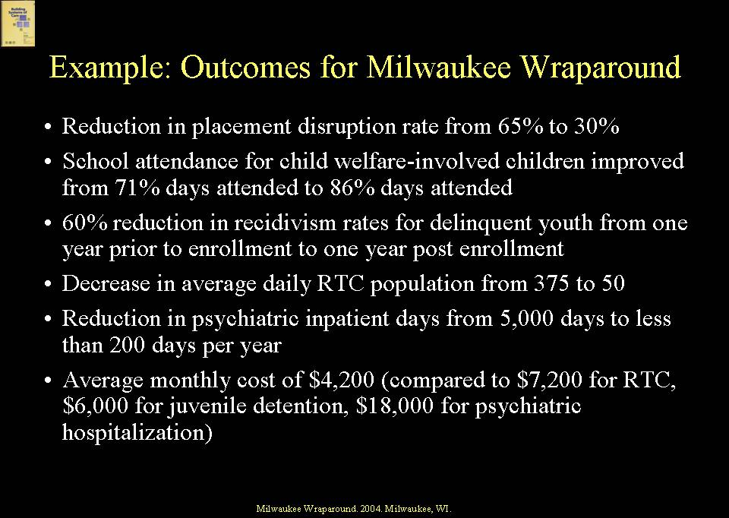  SLIDE 21 (232)  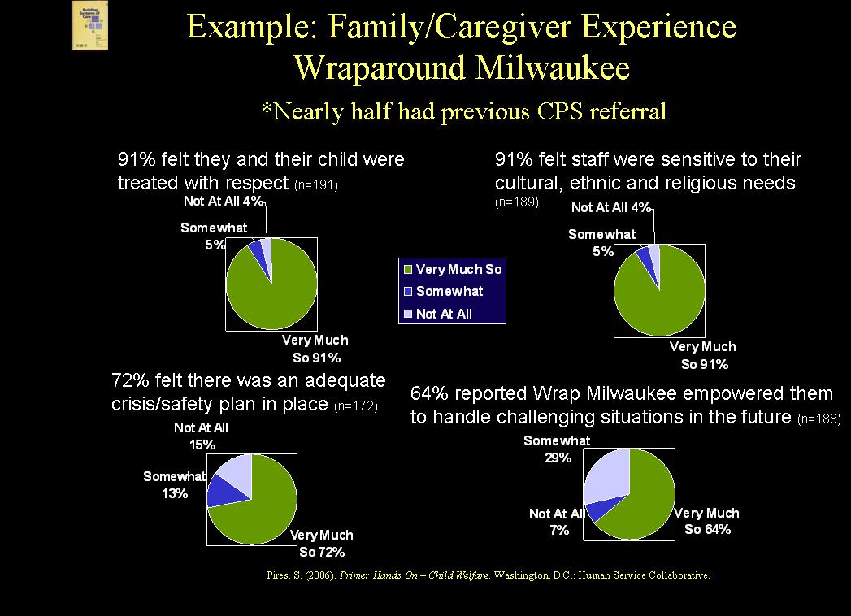  LARGE GROUP DISCUSSION  You have an opportunity during the large group discussion to ask questions and make contributions about the covered topics. The large group discussion provides an opportunity as well for peer learning and exchange, taking advantage of the collective “best thinking” of participants. | Trainer’s Notes  Goals  This is a didactic presentation of material from Primer Hands On-Child Welfare: A Skill Building Curriculum. It provides a brief introduction to the topics of care management, utilization and quality management in systems of care. While these functions and the others discussed in the remaining Modules lend themselves to team meeting deliberations, due to time constraints in the two-day Primer Hands On-Child Welfare training, these and remaining functions are dealt with in a large group discussion format only, rather than in team meetings. However, trainers that may be training this as an individual Module (and not within the two-day training) may wish to add a team meeting component.  Method  PowerPoint Presentation; didactic; large group discussion  Training Aids  Microphone if necessary; projector, laptop computer, screen; Slides #2-21 (slides #213-232 if utilizing the complete curriculum version with no module cover slide).  Approximate Time  30 min.  Expected Outcomes  At the end of Module 9, participants should be familiar with:  - Service coordination versus care management  - Care management principles  - Importance of structuring care management  - A continuum of service coordination/care management  - Types of care managers  - Pros and cons of different structures  - Principles of utilization management  - Utilization management with respect to stakeholder interests and system responsibilities  - Quality management  10) Uses for and examples of utilization management and quality data  Child welfare stakeholders may not be familiar with, or use differently, the terminology used in this section. The Primer is not wedded to its terminology but is trying to make a distinction between “service coordination” and what we are referring to here as “care management”. Increasingly, systems of care are demonstrating that, for families who have multiple needs with involvement in many systems, when the system of care creates a “locus of care management responsibility”, with dedicated care managers who actively work with families and have no other assignments except to help families access services and supports and ensure that the services remain helpful, outcomes for these families are better. Other families may need help coordinating services, but not with the same intensity level or dedicated use of resources. For these families, service coordination (as used here) makes sense.  Trainer’s Notes  You may want to share an example from your own experience of a system of care that is utilizing one accountable care management structure for populations of children, youth and families involved in multiple systems.  Trainer’s Notes  You may want to share principles governing care coordination from systems of care with which you are familiar.  Trainer’s Notes  A purpose of this discussion is to help participants think strategically about the types of service coordination/care management assistance that will be needed by their population(s) of focus. Not all families need or want a dedicated care manager (as the term is used here), nor can the system of care afford to provide a dedicated care manager for every family. Some families only need a basic level of service coordination help, and families using very few services may not need any service coordination help per se, but only information and assistance to find the right services.  Trainer’s Notes  You may want to share examples of care management structures utilizing different types of care coordinators.  Trainer’s Notes  This slide is used to illustrate pros and cons of different care management structures. It is not intended to show the only possible arrangements but, rather, to demonstrate the importance of thinking strategically about the various arrangements under consideration.  Trainer’s Notes  “Utilization management” may not be a term familiar to child welfare stakeholders and, in fact, child welfare systems, historically, have not managed the use of services and supports by families and children involved in the system. Systems of care, however, which are data-driven systems with an understanding that dollars are finite, do pay attention to this function. Utilization management pertains directly to achievement of CFSR outcomes as well. If systems do not know who is using services at any given time or over the course of time, how much the service is costing, and what effects or results use of services/supports is creating, the system will not know if it is achieving outcomes such as increasing permanency, reducing out-of-home placements, or improving functional outcomes in families and children.  Trainer’s Notes  You might want to share an example from your own experience of a system that is using utilization management practices to support PIP objectives, such as reduced use of out-of-home placements.  Trainer’s Notes  A point to be made in this discussion is that all stakeholders in a system of care can play a role in utilization management, including care managers, service coordinators, and families and youth. Also, particular attention needs to be paid to the use of services and supports by racially and ethnically diverse families, who often do not have access to supportive services and whose children are more likely to be in out-of-home placements. Point out to participants that utilization management practices can help to identify where children may be “stuck” in inappropriate placements, as well as where families may not be getting sufficient supportive services.  Trainer’s Notes  The discussion is now turning to quality management, or putting in place structures for continuous quality improvement.  Trainer’s Notes  You may want to share examples from your own experience of systems that have CQI structures in place to support system of care goals.  Trainer’s Notes  The next two slides provide examples of types of data and how data from utilization and quality management structures (as well as data from other sources, such as evaluations) can be utilized in systems of care, including to inform CFSR reviews and PIPs.  Trainer’s Notes  For more information about using data see the CFSR Comprehensive Training and Technical Assistance Package Focus Area – Using Information and Data in Planning and Measuring Progress, which can be viewed at: www.nrcoi.org  You may want to share other examples from your own experience of how systems use data to improve quality.  Trainer’s Notes  The following two slides present Oregon’s Proposed Outcomes: Measurement of Success for a System of Care. Emphasize the ability of the system to measure each of the identified outcomes.  Trainer’s Notes  You may want to share other examples from your own experience of outcomes measures used in systems of care that are relevant to children, youth and families in child welfare.  Trainer’s Notes  Information about Nebraska’s Integrated Care Coordination Units can be found at: www.regionsix.com/iccu.htm  Trainer’s Notes  Emphasize that outcomes for system of care are about system outcomes, but more importantly, must reflect child and family outcomes and experience as well.  For more information about Wraparound Milwaukee, go to: www.milwaukeecounty.org  Trainer’s Notes  Goal  The goal of this session is to provide participants with the opportunity to ask questions or contribute examples from their own communities. The large group discussion provides an opportunity for the group as a whole to explore some of the issues and strategies raised by the didactic presentation related to Care Management, Utilization Management, and Quality Management in systems of care.  ,

